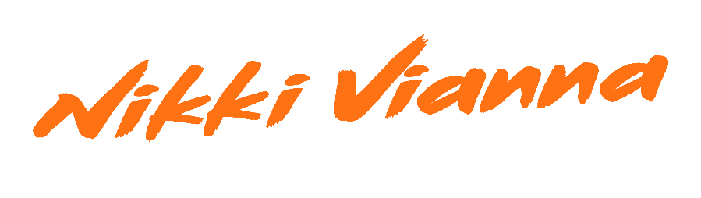
Oftentimes, purpose becomes clear much later in life. Most of us spend years searching and pondering before we find our path.
Nikki Vianna always knew her purpose. The Queens-born singer, songwriter, and pop force of nature first picked up a microphone as a child and never took “No” for an answer—or looked back for that matter. Instead, she tirelessly pushed forward and quietly attracted an international fan base through sharing a resonant, relatable, and real truth by way of traffic-stopping vocal delivery, sly swagger, and seductive soul.
“It’s an ongoing journey,” exclaims the songstress. “I speak up for what I believe in, I tell my story, and I do my best to inspire anybody that I can. I’ve been doing this since day one. Music was always the focal point. It’s my only reason for anything. That’s a really important message for me.”
Born and raised in Queens, NY as part of a musically inclined Italian family, she can vividly recall belting along to the Titanic soundtrack at three-years-old. The family’s musical roots ran deep as great grandma became a renowned classical singer in Italy and mom carried on a passion for music. Between entertaining relatives for hours on end at family gatherings, the budding talent took lessons from industry-leading vocal coaches, including Danny Madden [Mariah Carey, Whitney Houston] and more.
At twelve-years-old, Nikki made headlines on American Idol Juniors, while attending Brooklyn’s Mark Twain Middle School for the Gifted & Talented. Upon graduating, she enrolled in the prestigious LaGuardia High School. In the midst of rigorous academic training, she found herself recording in sessions alongside legends and influential songwriters, namely Scott Storch [Dr. Dre, Christina Aguilera], Toby Gad [Beyoncé, John Legend], Poo Bear [Justin Bieber, Sam Smith], and more.
Turning down Julliard, she dove headfirst into a career in music at eighteen-years-old and organically grew a devout following under the name Nikki Valentine. Independent releases a la “Let It Go” crossed 20 million views on YouTube as she amassed over 3.3 million Instagram followers by 2018.
Throughout this journey, she cultivated and crafted a singular style, drawing inspiration from the likes of Amy Winehouse, Sia, Beyoncé, and Billie Holiday. She translates this raw soul into ambitious pop.
“My sound has a lot of passion and soul,” affirms the singer. “I want to bring that into catchy songs.”
That’s exactly what she has consistently done. Her voice powered the fan favorite “Show Me Love” [feat. Flo Rida]. During 2018, Cash Cash enlisted her talents for the dance hit “Jewel,” which eclipsed 7 million cumulative streams and staked out a spot in the Top 40 of the Billboard Top Dance Songs chart. Meanwhile, Poo Bear showcased her on “From Here” [feat. LAZR] a standout from his 2018 debut, Poo Bear Presents: Bearthday Music. She joined an A-list guest list of collaborators such as Justin Bieber, Jennifer Lopez, Ty Dolla $ign, J Balvin, and more. Along the way, Atlantic Records Chairman and C.E.O. Craig Kallman personally signed Nikki.
Now, she kicks off her next chapter with the upbeat, unpredictable, and undeniable single “Done.” The track slips from a breathy verse and soaring bridge into the catchy and confessional hook, “We keep on saying we’re done, but that’s something we say when we’re drunk…ya know we ain’t done.”
“Lyrically, it’s about being with somebody who you’re constantly on an emotional rollercoaster or carousel ride with,” she explains. “No matter what, you always find a way back to each other. You have so much history that you’re never done. There’s an underlying meaning about not giving up on other situations beyond relationships. In life, you might want to give up, but you’re never going to. I definitely don’t!”
Never giving up, Nikki ultimately delivers pop with a purpose.
“I’ve been through a lot on my road to get here,” she leaves off. “I put all of that into my lyrics and words. Music helped me get past so many situations. I hope I can affect and help listeners in the same way. You can jam to what I’m putting out, but it might touch you too. I’d love to inspire. That’s what I’m here to do.”

###
