Nikki Vianna & Matoma team up for “When You Leave”

nEW Collaborative single AVAILABLE now

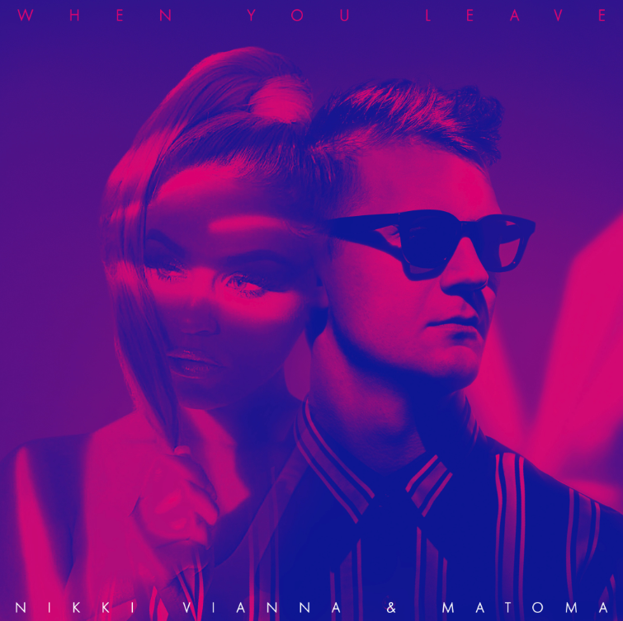
DOWNLOAD HIGH-RES ART + IMAGES

STREAM “WHEN YOU LEAVE”: https://Atlantic.lnk.to/WhenYouLeavePR

Atlantic singer-songwriter Nikki Vianna has teamed up with Matoma for an explosive new collaborative single “When You Leave,” available now via all DSPs. “When You Leave” marks the follow-up to Vianna’s debut single “Done,” which has amassed over 6 million worldwide streams and was deemed an “undeniable banger” by Billboard upon release.

An alum of LaGuardia High School for Performing Arts, Vianna is an avid performer who can command the attention of any room. Working tirelessly in the studio on material for her major label debut due later this year, she has already appeared on the dance hit “Jewel” with EDM trio Cash Cash – accumulating over 12 million streams and cracking Top 40 on the Billboard Top Dance Songs chart. Vianna also teamed up with long-time collaborator Poo Bear on the track “From Here” (feat. LAZR) off his album Poo Bear Presents: Bearthday Music – appearing alongside a group of A-list collaborators on the album including Justin Bieber, Jennifer Lopez, Ty Dolla $ign, J Balvin and more.
The Queens-born singer, songwriter, and pop force of nature first picked up a microphone as a child and never took “No” for an answer—or looked back for that matter. Vianna took lessons from industry-leading vocal coaches, including Danny Madden (Mariah Carey, Whitney Houston), before appearing on American Idol Juniors. Having signed her first record deal at 13, she organically grew a devout following. “I’ve been through a lot on my road to get here,” she explains. “I’ve been doing this since day one. Music was always the focal point. It’s my only reason for anything. That’s a really important message for me.”

About Matoma:
Matoma has cemented himself as a powerhouse in the electronic music community, creating collaborations and remixes of the who’s who of modern pop including One Direction, Coldplay, Jason Derulo, Dua Lipa, Jennifer Lopez, Sean Paul, The Notorious B.I.G. and more. Most recently, his journey hits a new landmark moment with the release of his debut album ONE IN A MILLION. The critically-acclaimed album is brimming with all new collaborations with the likes of James Newman, Yashua and Nina Nesbitt as well as four of his biggest tracks to date, “False Alarm” (with Becky Hill), “Lonely” (with MAX), “Slow” (with Noah Cyrus) and “All Night” (with The Vamps), which have amassed over half a billion streams to date.

Matoma first made a huge impression with his ground-breaking playlist-meets-album concept, Hakuna Matoma. The dynamic collection acted as an evolving body of work, allowing fans to choose the singles based on streams. Featuring collaborations with a variety of global music stars – One Direction, Coldplay, Snoop Dogg, Jason Derulo, Jennifer Lopez, Dua Lipa, Sean Paul and more – its tracks have accumulated a staggering one billion streams. The collection also featured his first two mainstream hits which both received extensive airplay at Radio 1 in the UK. “All Night,” his collab with The Vamps, has been streamed over 380 million times and is featured on their #1 album Night & Day. The track followed Matoma’s first chart hit, “False Alarm” (with Becky Hill), which has since gone on to garner nearly 200 million streams.

Connect with Nikki Vianna:
NikkiViannaMusic.com | Instagram | Twitter | Facebook | AtlanticRecords.com

Connect with Matoma:
HakunaMatoma.com | Instagram | Twitter | Facebook | WeAreBigBeat.com

