FOR IMMEDIATE RELEASE
APRIL 7, 2020

OLIVER TREE DROPS SURPRISE COMEBACK SINGLE “LET ME DOWN”

GENRE-DEFYING SINGER/SONGWRITER/PRODUCER/PROFESSIONAL SCOOTER RIDER
UNVEILS LATEST HIGH-ENERGY SINGLE + HILARIOUS OFFICIAL VIDEO
JUST DAYS AFTER ANNOUNCING HIS RETIREMENT

WATCH THE “LET ME DOWN” VIDEO HERE
LISTEN TO “LET ME DOWN” HERE
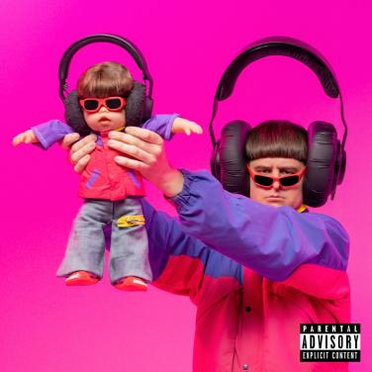
DOWNLOAD ARTWORK HERE

“Oliver Tree is outlandish, and it’s working..”
- ROLLING STONE

“A music-making meme machine…”
- VICE

“Alt-pop’s merry prankster…”
-BILLBOARD

“Without a doubt, Oliver Tree is the pop star America (and possibly the world) needs...he is changing the game…”
-ALTERNATIVE PRESS

“Strong new sound from the Bowled Wonder himself…”
-ZANE LOWE

Just days after announcing his retirement, genre-defying singer/songwriter/producer/professional scooter rider, Oliver Tree, has returned with his latest hard-hitting single, “Let Me Down.” The dynamic new song was produced by Tree and esteemed DJ/Producer Whethan. The surprise comeback track arrives today alongside a hysterical companion video, streaming now on Oliver’s official YouTube channel HERE. “Let Me Down” is available now at all DSPs and streaming services HERE via Atlantic Records.
”I wrote ‘Let Me Down’ the day after I canceled my album due to corona virus” Tree says about the new track. “Canceling the release was devastating after working on this album for 5 years. Even though it was completely out of my control, I felt like I let a lot of people down so I made them this song as an apology. Even if I can’t drop the album, I still want my fans to know I care about them. This week I decided to film a DIY music video in my buddy’s warehouse with the help of some close friends and family. To anyone who feels let down or hurt, I ask for your forgiveness..."

The new track follows the bowl-cutted singer’s acclaimed single, “Cash Machine” and critically acclaimed EP DO YOU FEEL ME?, which features hit singles “Miracle Man,” “Hurt,” and the RIAA gold-certified hit single, “Alien Boy.”

Last month, Oliver was seen jet-skiing with his “twin” bird on the cover of Alt Press – check it out HERE. The acclaimed magazine stated “Without a doubt, Oliver Tree is the pop star America (and possibly the world) needs...he is changing the game. And you know you want to watch him play it..." Tree recently wrapped his impressive sold-out headline “Goodbye, Farewell Tour” which included stops in over 35 cities across North America and Europe, alongside jam-packed sets at major festivals including Austin City Limits and Life Is Beautiful.

Now boasting over 100 million worldwide streams and counting, Tree’s smash hit single, “Hurt” has proven a multi-format radio smash, reaching the top 5 at Alternative outlets nationwide. The track’s gripping companion video has over 32 million individual views.

Furthermore, Oliver made his solo late night television debut last fall with a groundbreaking rendition of “Hurt” – performed from atop a tall set of stilts – on CBS’ The Late Late Show With James Corden, hailed by Alternative Press as “an incredible performance that only Tree himself could pull off.”

CONNECT WITH OLIVER TREE:
OFFICIAL WEBSITE | TWITTER | INSTAGRAM | FACEBOOK | SOUNDCLOUD

FOR PRESS INQUIRIRES, PLEASE CONTACT:
Jessica Nall / Jessica.nall@atlanticrecords.com

