FOR IMMEDIATE RELEASE
JULY 24, 2020

OLIVER TREE RELEASES “LET ME DOWN” FEAT. BLINK-182
+ OFFICIAL VIDEO FOR “I’M GONE”

NEW ALBUM ‘UGLY IS BEAUTIFUL’ OUT NOW ON ATLANTIC RECORDS

WATCH THE VIDEO FOR “I’M GONE”: https://olivertree.lnk.to/ImGoneVideo
LISTEN TO “LET ME DOWN” FEAT. BLINK-182: https://olivertree.lnk.to/blink182

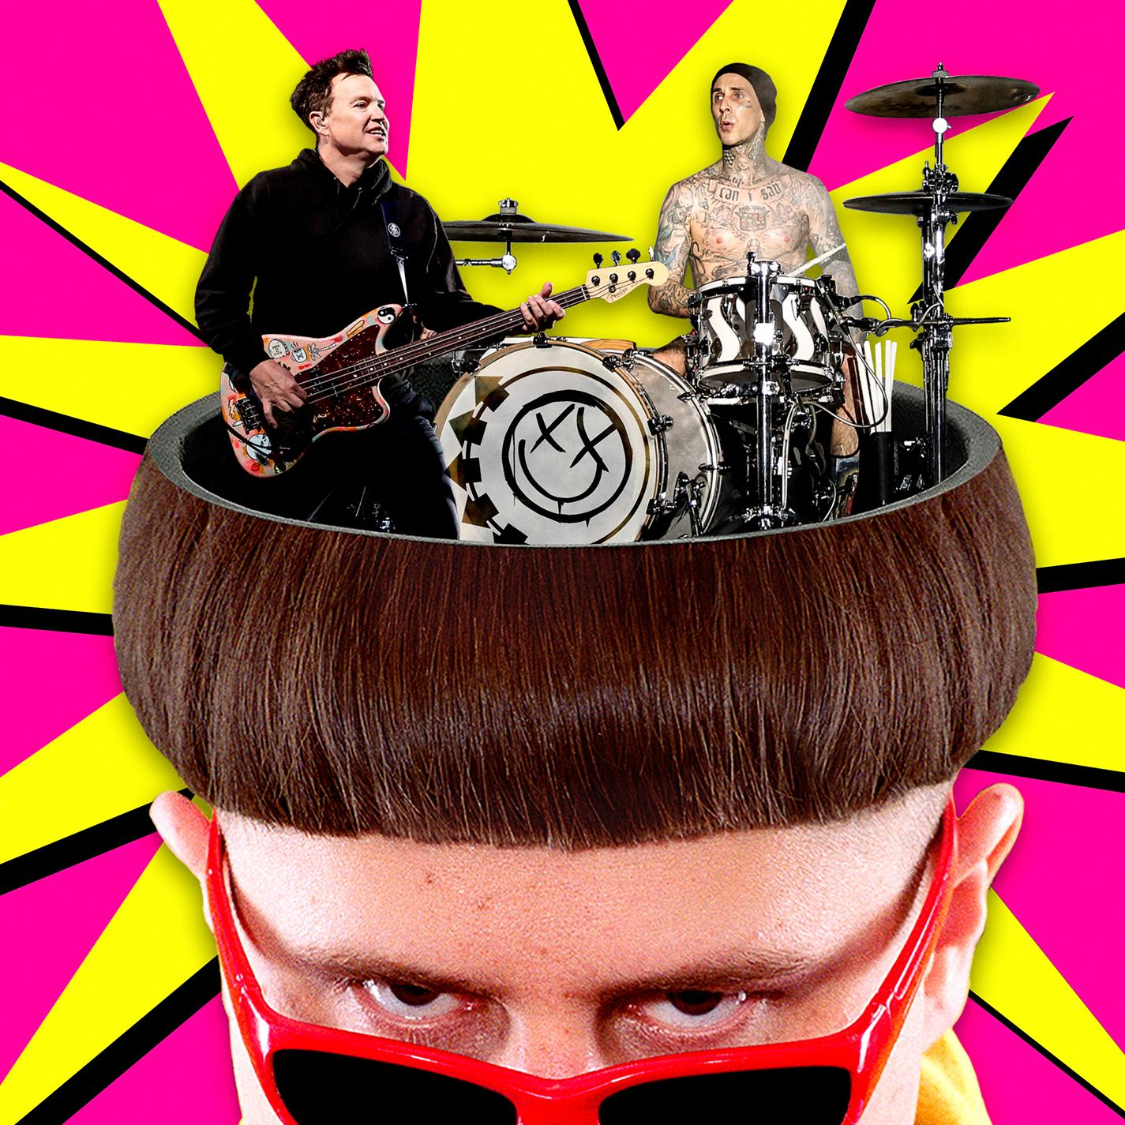

Oliver Tree and his bad haircut have collaborated with their childhood heroes blink-182 for an exclusive re-working of Tree’s “Let Me Down,” out today via Atlantic Records. Listen: HERE

“Let Me Down” is a highlight from Oliver’s debut album ‘Ugly is Beautiful,’ which, since being released this past Friday, already has made history. The album debuted as the #1 Alternative Album on iTunes & Apple Music, and in the top 10 album list overall on iTunes. It even earned a rare 2020 Pitchfork pan, declaring: “Oliver Tree's persona is dense and unappetizing, like a Twinkie squashed under hot car cushions for weeks.”

Oliver celebrated the release of ‘Ugly is Beautiful’ by achieving his lifelong dream of breaking the Guinness World Record for building the world’s largest kick scooter - which he proceeded to crash in epic fashion. (Watch Oliver take the scooter on its disastrous inaugural ride.) Oliver also graced the world through Interview Magazine the secret to achieving the perfect bowl cut. If you’re in a rush, Oliver is proud to announce that there’s now also a Oliver Tree social media filter; now anyone can have their own signature Oliver Tree bowl cut.

In addition to blink-182’s addition to “Let Me Down,” Oliver also reveals the official video for another Ugly is Beautiful highlight “I’m Gone. Watch the video for “I’m Gone” HERE.

‘Ugly is Beautiful’ is the culmination of Oliver’s life’s work as a “music-making meme machine" (Vice). Watch Oliver’s heated interview with The Needle Drop’s Anthony Fantano, who also recently gave the album a 7/10, here: https://www.youtube.com/watch?v=tPpsNTAhpUE

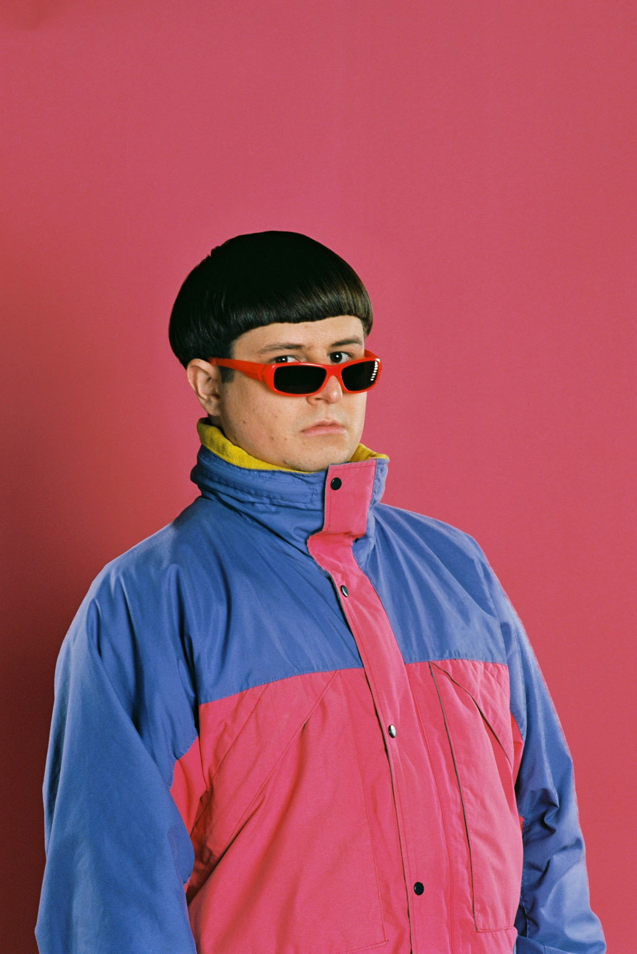

PRAISE FOR ‘UGLY IS BEAUTIFUL’

“Injecting humour into everything he does while offering a surrealist escape from the mundane everyday – it’s easy to see how Tree’s outlandishness has made him the digital age’s definitive rockstar.”
-NME

“With ‘Ugly is Beautiful’...the Gen-Z jester has declared his arrival onto the internet’s airwaves.”
-Interview

“The trickster laureate of pop's viral era…”
-MTV

“...somewhere between a meme and creative polymath.”
-HYPEBEAST

“‘Ugly is Beautiful’ is brimming with such nostalgia-inducing yet daring flashes of genius.”
-Ones To Watch

BUY/STREAM ‘UGLY IS BEAUTIFUL’
https://olivertree.lnk.to/UglyisBeautiful

‘UGLY IS BEAUTIFUL’ TRACK LIST
1. Me, Myself and I
2. 1993 (feat. Little Ricky ZR3)
3. Cash Machine
4. Let Me Down
5. Miracle Man
6. Bury Me Alive
7. Alien Boy
8. Joke’s On You!
9. Again & Again
10. Waste My Time
11. Jerk
12. Hurt
13. Introspective
14. I’m Gone

MORE INFO ON OLIVER TREE
Website: https://www.olivertreemusic.com
Facebook: https://www.facebook.com/OliverTreemusic
Twitter: https://twitter.com/olivertree
Instagram: https://www.instagram.com/OliverTree

