FOR IMMEDIATE RELEASE

JULY 3, 2019

**PNV JAY IS *FLEXIN’***

***“FLEXIN” ARRIVES TODAY AT ALL DSPS AND STREAMING SERVICES***

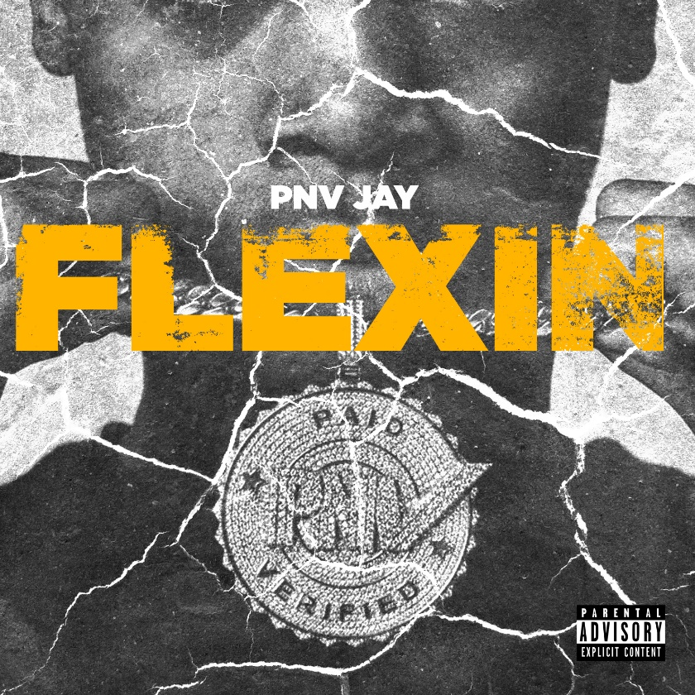

Atlantic Records recording artist PNV Jay has announced the release of a new hit single, ”Flexin” is available today at all DSPs and streaming services [HERE](https://pnvjay.lnk.to/Flexin). The track is accompanied by an energetic visual that showcases the grit of New York streets, directed by _______ which can be viewed [HERE](https://pnvjay.lnk.to/FlexinVideo).

The track follows the release of his debut tape, “PAID N VERIFIED” which included standout tracks such as  “[Level Up](https://www.youtube.com/watch?v=RlqdEIdt6-s),” “[Rich](https://www.youtube.com/watch?v=Oam66fut1Ig),” “[Duck Duck](https://www.youtube.com/watch?v=_WA9thUo1E8),” and “[Out The Hood](https://www.youtube.com/watch?v=bJjvY8XFHT0).” The latter was named among [Pitchfork](https://pitchfork.com/levels/the-ones-5-best-new-rap-songs-from-youngboy-never-broke-again-pnv-jay-adollarap-ant-q-money-and-the-outfit-tx/)’s “The Ones: 5 Best New Rap Songs,” writing “(PNV Jay) has all the swag and the cadence of his peers, but without the grime. ‘Out the Hood’ feels polished; everything from his flow to the piano-heavy instrumental is easily accessible. It’s the major-label-ready version of a subgenre looking to reach beyond the underground.” “Flexin” is a vibrant record that personifies the essence of NYC drill music, brought to life by PNV Jay’s thrilling bars.

There are only a handful of artists who really embody the energy, sounds, and flow of the NY Streets. Some of which are already on the journey to stardom and others who are still working their way out of the underground music space but are leaving some serious impressions along the way.

PNV Jay (Jalen Stevens) is a 16-year-old, Bronx, NY-based rapper building a lane of his own among the leading lights of NYC’s rising drill music scene. Though born in the Bronx, Jay has been hailed for his contributions to the Brooklyn-based scene, with [Pitchfork](https://pitchfork.com/levels/zones-northeast-brooklyn-with-mr-muthafuckin-exquire/) noting that the teenaged rapper “possesses the no nonsense…cocky swag. And a deep arsenal of bars, that historically, a rapper needs to really rep.”

An array of track releases in recent years have earned Jay worldwide streams into the millions, including “[OMBK](http://www.youtube.com/watch?v=S9LaPgF-E5o),” the companion visual which now exceeds 2.4 million individual views via YouTube alone.

_ _ _

CONNECT WITH PNV JAY:

[INSTAGRAM](https://www.instagram.com/pnvjay) I [YOUTUBE](https://www.youtube.com/channel/UC3HuN3Vw6UG9XUqPTFGmuUA) I [FACEBOOK](https://www.facebook.com/PNV-Jay-1019054254913845/)

FOR ALL PRESS INQUIRIES, PLEASE CONTACT:

[ARIANA.WHITE@ATLANTICRECORDS.COM](mailto:ARIANA.WHITE@ATLANTICRECORDS.COM)

