FOR IMMEDIATE RELEASE
MARCH 26, 2020

PNV JAY ISSUES A “WARNING”

“ZOOM ZOOM” AVAILABLE NOW

“YES REMIX” AVAILABLE NOW

ACCLAIMED DEBUT PAID N VERIFIED AVAILABLE NOW

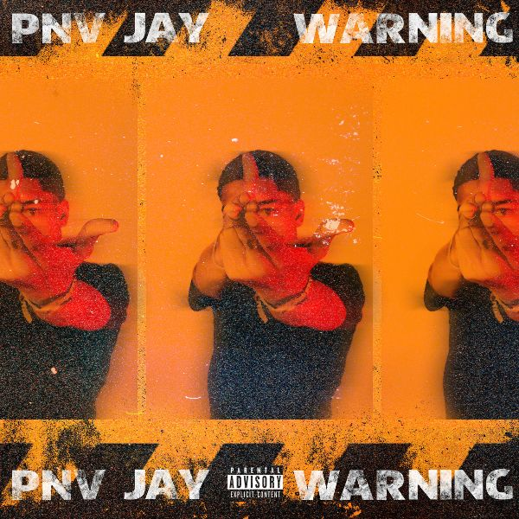

Bronx, NY rapper PNV Jay is only 17, but he’s making his mark as a one to watch in the drill-rap scene. With each release he continues to pave a lane of his own. He kicked off the year with a fiery record, “Zoom Zoom (feat. SimXSantana)” and is back to deliver a brand new single, “Warning,” available now via all DSPs and streaming services now HERE; watch the official companion video HERE.

The release of “Zoom Zoom” followed PNV Jay’s official “Yes (Remix)” visual, a strong follow up to 2019’s standout singles “Glizzy 2,” “Best of Me” and “Flexin.” His debut tape, “PAID N VERIFIED” included buzz worthy tracks such as “Level Up,” “Runnin’ Man” (featured in Madden 19), “Rich,” and “Out The Hood,” which Pitchfork highlighted as one of the Best New Rap Songs upon release. The mixtape was the perfect 1st impression for this young king – accumulating over 5.6 MILLION streams worldwide to date.

Though born in the Bronx, Jay has been hailed for his contributions to the Brooklyn-based drill music scene, with Pitchfork noting that the teenaged rapper “possesses the no nonsense…cocky swag. And a deep arsenal of bars, that historically, a rapper needs to really rep.” At the age of 17, PNV Jay is shaking up the streets with what he has to offer.

_ _ _

CONNECT WITH PNV JAY:
INSTAGRAM I YOUTUBE I FACEBOOK

FOR ALL PRESS INQUIRIES, PLEASE CONTACT:
ARIANA.WHITE@ATLANTICRECORDS.COM

