FOR IMMEDIATE RELEASE
AUGUST 2, 2019

PNV JAY SHOWS YOU HIS BEST SIDE IN NEW VISUAL FOR “BEST OF ME”
“BEST OF ME” AVAILABLE NOW AT ALL DSPS AND STREAMING SERVICES

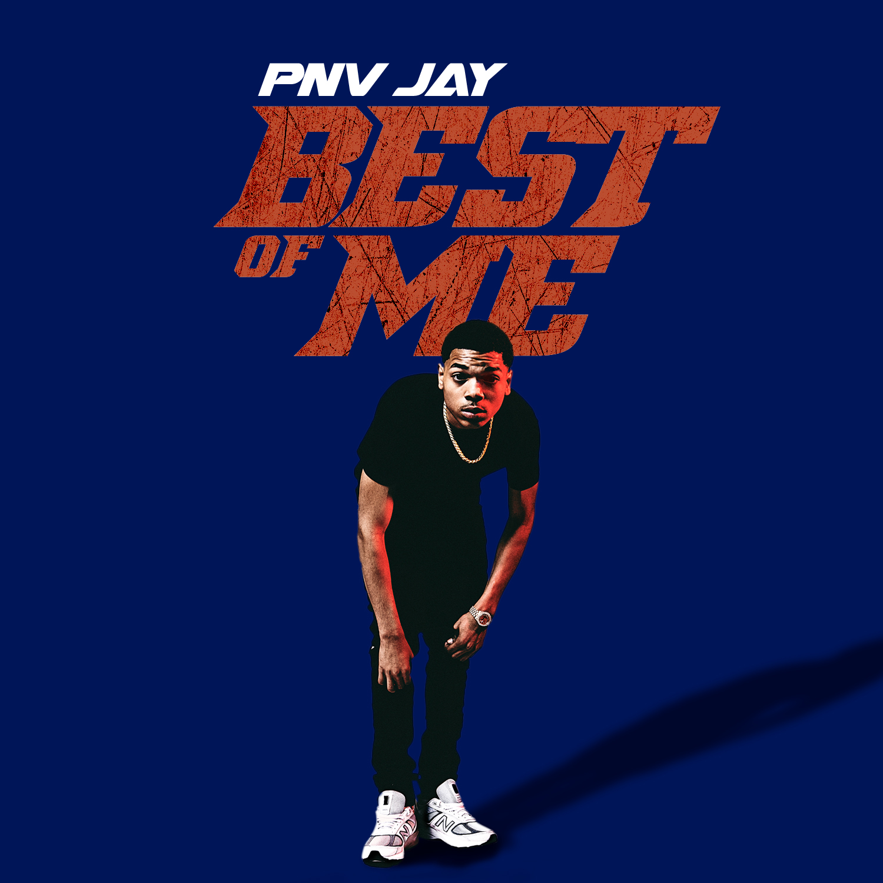

16-year-old, Bronx, NY-based rapper PNV Jay has announced the release of a colorful visual to his newly-released track “Best of Me,” view HERE. The standout track is now available at all DSPs and streaming services HERE.

“Best of Me” is a rhythmic follow-up to the rapper’s release of his thrilling track “Flexin” earlier this summer. His debut tape, “PAID N VERIFIED” which included standout tracks such as “Level Up,” “Rich,” “Duck Duck,” and “Out The Hood,” has accumulated over 5.6 MILLION streams worldwide. In addition, the star project was named among Pitchfork’s “The Ones: 5 Best New Rap Songs,” writing “(PNV Jay) has all the swag and the cadence of his peers, but without the grime. ‘Out the Hood’ feels polished; everything from his flow to the piano-heavy instrumental is easily accessible. It’s the major-label-ready version of a subgenre looking to reach beyond the underground.”

Though born in the Bronx, Jay has been hailed for his contributions to the Brooklyn-based scene, with Pitchfork noting that the teenaged rapper “possesses the no nonsense…cocky swag. And a deep arsenal of bars, that historically, a rapper needs to really rep.”

An array of track releases in recent years have earned Jay worldwide streams into the millions, including “OMBK,” the companion visual which now exceeds 2.4 million individual views via YouTube alone.

PNV Jay (Jalen Stevens) personifies the essence of NYC drill music, with his razor sharp bars and energetic flow. He embodies the unique sound of the NY streets and his “born to win” attitude puts him in a position to run with the best of them. Some of which are already on the journey to stardom and others who are still working their way out of the underground music space but are leaving some serious impressions along the way. At the age of 16, PNV Jay is shaking up the streets with what he has to offer.

_ _ _

CONNECT WITH PNV JAY:
INSTAGRAM I YOUTUBE I FACEBOOK

FOR ALL PRESS INQUIRIES, PLEASE CONTACT:
ARIANA.WHITE@ATLANTICRECORDS.COM

