FOR IMMEDIATE RELEASE

DECEMBER 17TH, 2020

**PNV JAY RELEASES “BUST IT”**

**NEW VIDEO now LIVE via his OFFICIAL YOUTUBE channel** [**HERE**](https://nam04.safelinks.protection.outlook.com/?url=https%3A%2F%2Fpnvjay.lnk.to%2FBustItVideo&data=04%7C01%7CAriana.White%40atlanticrecords.com%7Cf172b05ff8674ac47bfe08d8a2ce3100%7C8367939002ec4ba1ad3d69da3fdd637e%7C0%7C0%7C637438353802159870%7CUnknown%7CTWFpbGZsb3d8eyJWIjoiMC4wLjAwMDAiLCJQIjoiV2luMzIiLCJBTiI6Ik1haWwiLCJXVCI6Mn0%3D%7C1000&sdata=Uwf3pb6LgfOYo4fMDFkDRm1HlDkOrY6y8Pmq46Fl%2Bys%3D&reserved=0)

**“**[**BUST IT**](https://nam04.safelinks.protection.outlook.com/?url=https%3A%2F%2Fpnvjay.lnk.to%2FBustIt&data=04%7C01%7CAriana.White%40atlanticrecords.com%7Cf172b05ff8674ac47bfe08d8a2ce3100%7C8367939002ec4ba1ad3d69da3fdd637e%7C0%7C0%7C637438353802169866%7CUnknown%7CTWFpbGZsb3d8eyJWIjoiMC4wLjAwMDAiLCJQIjoiV2luMzIiLCJBTiI6Ik1haWwiLCJXVCI6Mn0%3D%7C1000&sdata=NJmjX1JLpaNSKDBowKm8F2hTHHlwLqoCmQ1YwNQVmLY%3D&reserved=0)**” AVAILABLE NOW AT ALL DSPS**

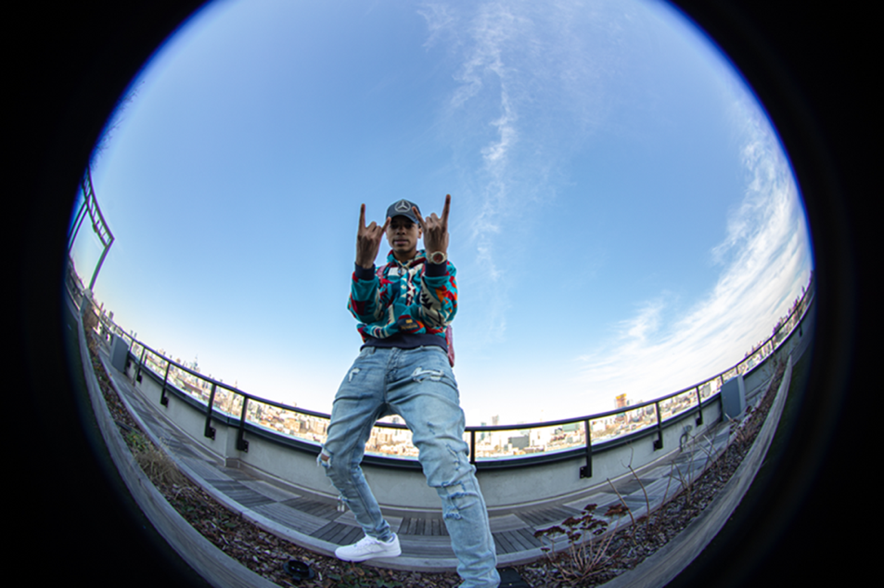

Bronx, NY rapper PNV Jay is back to deliver a brand new music video as we close out 2020. “Bust It” the catchy new record speaks to PNV Jay’s interest in a woman, and mission to prove his doubters wrong, with cool lyrics accentuated by a classic drill-infused beat. At 18 years old, he is making his mark as a one to watch in the drill-rap scene. With each release he continues to pave a lane of his own. The video, directed by Cult Classic, is now streaming via his official YouTube channel [HERE](https://nam04.safelinks.protection.outlook.com/?url=https%3A%2F%2Fpnvjay.lnk.to%2FBustItVideo&data=04%7C01%7CAriana.White%40atlanticrecords.com%7Cf172b05ff8674ac47bfe08d8a2ce3100%7C8367939002ec4ba1ad3d69da3fdd637e%7C0%7C0%7C637438353802169866%7CUnknown%7CTWFpbGZsb3d8eyJWIjoiMC4wLjAwMDAiLCJQIjoiV2luMzIiLCJBTiI6Ik1haWwiLCJXVCI6Mn0%3D%7C1000&sdata=q4d4Q1bb7y%2FWcL6mC5NWtyu7LQ%2B1X0X78u%2FSKoMKwLc%3D&reserved=0). This latest release is a continuation of PNV Jay’s unspoken talent, following standouts like [“OMBK2,”](https://nam04.safelinks.protection.outlook.com/?url=https%3A%2F%2Fwww.youtube.com%2Fwatch%3Fv%3Dmn-ehiGcnZg&data=04%7C01%7CAriana.White%40atlanticrecords.com%7Cf172b05ff8674ac47bfe08d8a2ce3100%7C8367939002ec4ba1ad3d69da3fdd637e%7C0%7C0%7C637438353802179862%7CUnknown%7CTWFpbGZsb3d8eyJWIjoiMC4wLjAwMDAiLCJQIjoiV2luMzIiLCJBTiI6Ik1haWwiLCJXVCI6Mn0%3D%7C1000&sdata=0XcmXLjjjHYlMqTs3iXrMAhPzopQovaUJ6RFHZFK%2BMA%3D&reserved=0) “[Warning](https://nam04.safelinks.protection.outlook.com/?url=https%3A%2F%2Fwww.youtube.com%2Fwatch%3Fv%3DBqhO6wbjOdc&data=04%7C01%7CAriana.White%40atlanticrecords.com%7Cf172b05ff8674ac47bfe08d8a2ce3100%7C8367939002ec4ba1ad3d69da3fdd637e%7C0%7C0%7C637438353802189853%7CUnknown%7CTWFpbGZsb3d8eyJWIjoiMC4wLjAwMDAiLCJQIjoiV2luMzIiLCJBTiI6Ik1haWwiLCJXVCI6Mn0%3D%7C1000&sdata=6LvNLLZ2Sp75tagiL%2BrEkppUV5kms1vgxJdHSZuX5mA%3D&reserved=0)” and “[Zoom Zoom (feat. SimXSantana](https://nam04.safelinks.protection.outlook.com/?url=https%3A%2F%2FPNVJay.lnk.to%2FZoomZoomVideo&data=04%7C01%7CAriana.White%40atlanticrecords.com%7Cf172b05ff8674ac47bfe08d8a2ce3100%7C8367939002ec4ba1ad3d69da3fdd637e%7C0%7C0%7C637438353802189853%7CUnknown%7CTWFpbGZsb3d8eyJWIjoiMC4wLjAwMDAiLCJQIjoiV2luMzIiLCJBTiI6Ik1haWwiLCJXVCI6Mn0%3D%7C1000&sdata=MHWTAmh0A6lrCgcXDUm6Wnu543%2FyASzVcBBEqCeCRRE%3D&reserved=0)).”

The aforementioned singles were preceded by PNV Jay’s official “[Yes (Remix)](https://nam04.safelinks.protection.outlook.com/?url=https%3A%2F%2Fwww.youtube.com%2Fwatch%3Fv%3DJc7EGlMKGqs&data=04%7C01%7CAriana.White%40atlanticrecords.com%7Cf172b05ff8674ac47bfe08d8a2ce3100%7C8367939002ec4ba1ad3d69da3fdd637e%7C0%7C0%7C637438353802199851%7CUnknown%7CTWFpbGZsb3d8eyJWIjoiMC4wLjAwMDAiLCJQIjoiV2luMzIiLCJBTiI6Ik1haWwiLCJXVCI6Mn0%3D%7C1000&sdata=1lkMReTGTMCTxke7%2FZctrszEtFo9oARFs0os6m7oTRg%3D&reserved=0)” visual, a strong follow up to 2019’s standout singles “[Glizzy 2](https://nam04.safelinks.protection.outlook.com/?url=https%3A%2F%2Fwww.youtube.com%2Fwatch%3Fv%3DQSlbnhVeGrA&data=04%7C01%7CAriana.White%40atlanticrecords.com%7Cf172b05ff8674ac47bfe08d8a2ce3100%7C8367939002ec4ba1ad3d69da3fdd637e%7C0%7C0%7C637438353802209840%7CUnknown%7CTWFpbGZsb3d8eyJWIjoiMC4wLjAwMDAiLCJQIjoiV2luMzIiLCJBTiI6Ik1haWwiLCJXVCI6Mn0%3D%7C1000&sdata=q0ytFI9ksM93Va65mUhI%2F0do0mDJsf8IWF0BTALsWpw%3D&reserved=0),” “[Best of Me](https://nam04.safelinks.protection.outlook.com/?url=https%3A%2F%2Fwww.youtube.com%2Fwatch%3Fv%3DicsLDStujS8&data=04%7C01%7CAriana.White%40atlanticrecords.com%7Cf172b05ff8674ac47bfe08d8a2ce3100%7C8367939002ec4ba1ad3d69da3fdd637e%7C0%7C0%7C637438353802209840%7CUnknown%7CTWFpbGZsb3d8eyJWIjoiMC4wLjAwMDAiLCJQIjoiV2luMzIiLCJBTiI6Ik1haWwiLCJXVCI6Mn0%3D%7C1000&sdata=IoUAdMCbKgCObI5oI8qrVKGd%2BBns86oO8gXgjtpWdU8%3D&reserved=0)” and “[Flexin](https://nam04.safelinks.protection.outlook.com/?url=https%3A%2F%2Fwww.youtube.com%2Fwatch%3Fv%3DS0_-zjSr8x4&data=04%7C01%7CAriana.White%40atlanticrecords.com%7Cf172b05ff8674ac47bfe08d8a2ce3100%7C8367939002ec4ba1ad3d69da3fdd637e%7C0%7C0%7C637438353802219842%7CUnknown%7CTWFpbGZsb3d8eyJWIjoiMC4wLjAwMDAiLCJQIjoiV2luMzIiLCJBTiI6Ik1haWwiLCJXVCI6Mn0%3D%7C1000&sdata=zHkWcYmtftkHF7Js6iPp7gwYT4GZYGu9XuFYZpXGNVI%3D&reserved=0" \t "_blank).” His debut tape, “PAID N VERIFIED”included buzz worthy tracks such as  “[Level Up](https://nam04.safelinks.protection.outlook.com/?url=https%3A%2F%2Fwww.youtube.com%2Fwatch%3Fv%3DRlqdEIdt6-s&data=04%7C01%7CAriana.White%40atlanticrecords.com%7Cf172b05ff8674ac47bfe08d8a2ce3100%7C8367939002ec4ba1ad3d69da3fdd637e%7C0%7C0%7C637438353802229833%7CUnknown%7CTWFpbGZsb3d8eyJWIjoiMC4wLjAwMDAiLCJQIjoiV2luMzIiLCJBTiI6Ik1haWwiLCJXVCI6Mn0%3D%7C1000&sdata=Pv5UGCavJAcoigvYwAVOFK4tGeTT45AAfkZqPmP9juY%3D&reserved=0),” “[Runnin’ Man](https://nam04.safelinks.protection.outlook.com/?url=https%3A%2F%2Fwww.youtube.com%2Fwatch%3Fv%3Dsly_FrASLPg&data=04%7C01%7CAriana.White%40atlanticrecords.com%7Cf172b05ff8674ac47bfe08d8a2ce3100%7C8367939002ec4ba1ad3d69da3fdd637e%7C0%7C0%7C637438353802229833%7CUnknown%7CTWFpbGZsb3d8eyJWIjoiMC4wLjAwMDAiLCJQIjoiV2luMzIiLCJBTiI6Ik1haWwiLCJXVCI6Mn0%3D%7C1000&sdata=p65oyJ7z0El2n0NNsunYGEJI3Btk%2BiXSSNQdPOqV0qA%3D&reserved=0)” (featured in Madden 19), “[Rich](https://nam04.safelinks.protection.outlook.com/?url=https%3A%2F%2Fwww.youtube.com%2Fwatch%3Fv%3DOam66fut1Ig&data=04%7C01%7CAriana.White%40atlanticrecords.com%7Cf172b05ff8674ac47bfe08d8a2ce3100%7C8367939002ec4ba1ad3d69da3fdd637e%7C0%7C0%7C637438353802239831%7CUnknown%7CTWFpbGZsb3d8eyJWIjoiMC4wLjAwMDAiLCJQIjoiV2luMzIiLCJBTiI6Ik1haWwiLCJXVCI6Mn0%3D%7C1000&sdata=QD9iOkK8MBAG6p0%2FtGTb956OW8SSBY9GbKOc5bo%2F3Pw%3D&reserved=0),” and “[Out The Hood](https://nam04.safelinks.protection.outlook.com/?url=https%3A%2F%2Fwww.youtube.com%2Fwatch%3Fv%3DbJjvY8XFHT0&data=04%7C01%7CAriana.White%40atlanticrecords.com%7Cf172b05ff8674ac47bfe08d8a2ce3100%7C8367939002ec4ba1ad3d69da3fdd637e%7C0%7C0%7C637438353802239831%7CUnknown%7CTWFpbGZsb3d8eyJWIjoiMC4wLjAwMDAiLCJQIjoiV2luMzIiLCJBTiI6Ik1haWwiLCJXVCI6Mn0%3D%7C1000&sdata=ZkCqfTeSfXkTxYm1E3wVBU0voo0meBWNcYAmOxf%2Bykc%3D&reserved=0),” which Pitchfork highlighted as one of the [Best New Rap Songs](https://nam04.safelinks.protection.outlook.com/?url=https%3A%2F%2Fpitchfork.com%2Flevels%2Fthe-ones-5-best-new-rap-songs-from-youngboy-never-broke-again-pnv-jay-adollarap-ant-q-money-and-the-outfit-tx%2F&data=04%7C01%7CAriana.White%40atlanticrecords.com%7Cf172b05ff8674ac47bfe08d8a2ce3100%7C8367939002ec4ba1ad3d69da3fdd637e%7C0%7C0%7C637438353802249822%7CUnknown%7CTWFpbGZsb3d8eyJWIjoiMC4wLjAwMDAiLCJQIjoiV2luMzIiLCJBTiI6Ik1haWwiLCJXVCI6Mn0%3D%7C1000&sdata=8utYavjehx6e19K9HvQWutoLBnHzyZLPYunYpn%2BKzpk%3D&reserved=0) upon release. The mixtape was the perfect 1st impression for this young king – accumulating over 5.6 MILLION streams worldwide to date.

Though born in the Bronx, Jay has been hailed for his contributions to the Brooklyn-based drill music scene, with [Pitchfork](https://nam04.safelinks.protection.outlook.com/?url=https%3A%2F%2Fpitchfork.com%2Flevels%2Fzones-northeast-brooklyn-with-mr-muthafuckin-exquire%2F&data=04%7C01%7CAriana.White%40atlanticrecords.com%7Cf172b05ff8674ac47bfe08d8a2ce3100%7C8367939002ec4ba1ad3d69da3fdd637e%7C0%7C0%7C637438353802259813%7CUnknown%7CTWFpbGZsb3d8eyJWIjoiMC4wLjAwMDAiLCJQIjoiV2luMzIiLCJBTiI6Ik1haWwiLCJXVCI6Mn0%3D%7C1000&sdata=28n1QYcKB%2BzxfxvJ3DnMQdda%2F%2B4mHPcSgzjABh3SX7U%3D&reserved=0) noting that the teenaged rapper “possesses the no nonsense…cocky swag. And a deep arsenal of bars, that historically, a rapper needs to really rep.” At the age of 18, PNV Jay is shaking up the streets with what he has to offer.

\_ \_ \_

**CONNECT WITH PNV JAY:**

[INSTAGRAM](https://nam04.safelinks.protection.outlook.com/?url=https%3A%2F%2Fwww.instagram.com%2Fpnvjay&data=04%7C01%7CAriana.White%40atlanticrecords.com%7Cf172b05ff8674ac47bfe08d8a2ce3100%7C8367939002ec4ba1ad3d69da3fdd637e%7C0%7C0%7C637438353802259813%7CUnknown%7CTWFpbGZsb3d8eyJWIjoiMC4wLjAwMDAiLCJQIjoiV2luMzIiLCJBTiI6Ik1haWwiLCJXVCI6Mn0%3D%7C1000&sdata=X1qb%2BVOgSwWYCS1SISw3o%2FLEQkexft7YXKlV9Qs8xMQ%3D&reserved=0) I [YOUTUBE](https://nam04.safelinks.protection.outlook.com/?url=https%3A%2F%2Fwww.youtube.com%2Fchannel%2FUC3HuN3Vw6UG9XUqPTFGmuUA&data=04%7C01%7CAriana.White%40atlanticrecords.com%7Cf172b05ff8674ac47bfe08d8a2ce3100%7C8367939002ec4ba1ad3d69da3fdd637e%7C0%7C0%7C637438353802269820%7CUnknown%7CTWFpbGZsb3d8eyJWIjoiMC4wLjAwMDAiLCJQIjoiV2luMzIiLCJBTiI6Ik1haWwiLCJXVCI6Mn0%3D%7C1000&sdata=2J2JJZxmFCxqMSCir2JrPi%2BaL3f9CfRq2M6xcPqoOdw%3D&reserved=0) I [FACEBOOK](https://nam04.safelinks.protection.outlook.com/?url=https%3A%2F%2Fwww.facebook.com%2Fpnvjay%2F&data=04%7C01%7CAriana.White%40atlanticrecords.com%7Cf172b05ff8674ac47bfe08d8a2ce3100%7C8367939002ec4ba1ad3d69da3fdd637e%7C0%7C0%7C637438353802279805%7CUnknown%7CTWFpbGZsb3d8eyJWIjoiMC4wLjAwMDAiLCJQIjoiV2luMzIiLCJBTiI6Ik1haWwiLCJXVCI6Mn0%3D%7C1000&sdata=zbQib66Pmfz0KqdBRIFM%2B6%2BRDhWZ%2B9a1tvcIOo9tDkg%3D&reserved=0)

**FOR ALL PRESS INQUIRIES, PLEASE CONTACT:**

[ARIANA.WHITE@ATLANTICRECORDS.COM](mailto:ARIANA.WHITE@ATLANTICRECORDS.COM)