Pop futurist Charli XCX announces third studio album ‘Charli,’ Charli LIVE World Tour + new official music video for single “Blame It On Your Love” ft. Lizzo!

LP features Lizzo, Christine and the Queens, HAIM, Troye Sivan, Brooke Candy, CupcakKe, Big Freedia, Sky Ferreira, Kim Petras, Clairo, Yaeji,
Pabllo Vittar and Tommy Cash!

‘Charli’ arrives September 13th via Atlantic Records

PRE-ORDER/PRE-SAVE ‘CHARLI’: https://ad.gt/charli-thealbum
PRE-ORDER Charli LIVE TOUR TICKETS: https://www.charli-the-album.co.uk/

WATCH ‘BLAME IT ON YOUR LOVE’ OFFICIAL VIDEO: https://Atlantic.lnk.to/WatchBIOYL
(Atlantic Records)

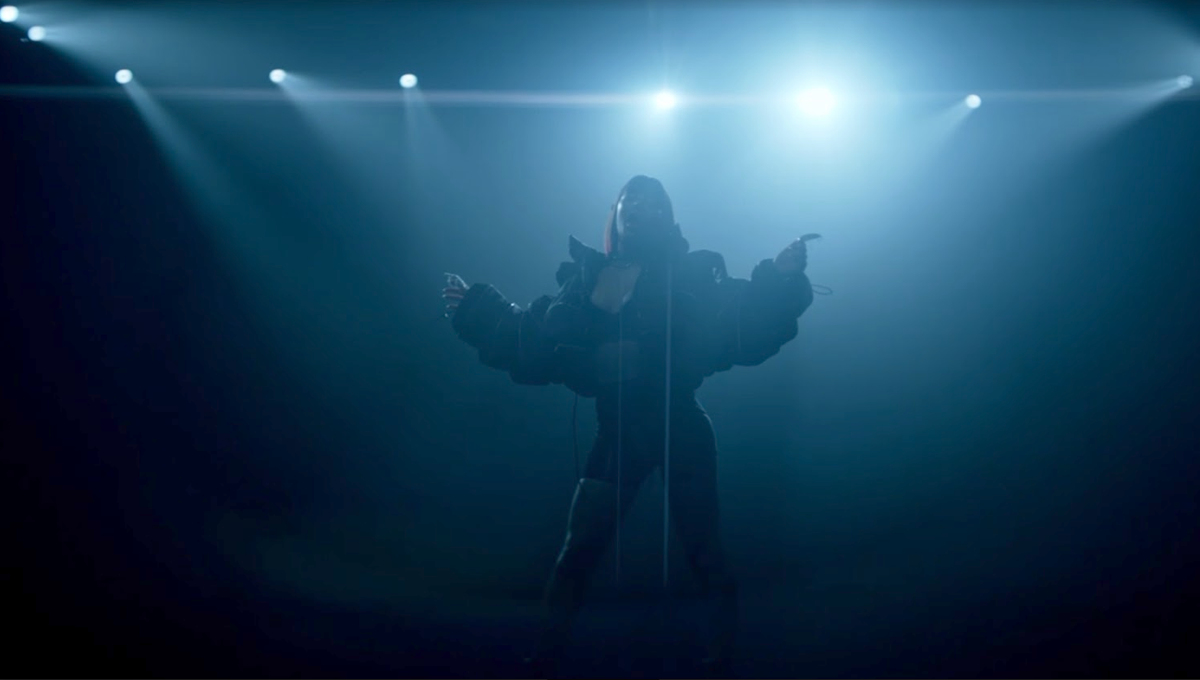

Pop futurist Charli XCX officially announces her immensely anticipated third studio self-titled album ‘Charli’, executive produced by A. G. Cook and Charli XCX. Arriving on September 13th via Atlantic Records, it can be pre-ordered/saved HERE, alongside a series of transatlantic headline Charli LIVE tour dates going on sale to the public June 21st via https://www.charli-the-album.co.uk/.

To celebrate the news, the vanguard of popular music delivers a new music video for her single ‘Blame It On Your Love’ Feat. Lizzo, filmed in New York, and directed by Bradley & Pablo. It embraces the imperfection and otherworldly, an undeniable tribute to a love with no boundaries, providing a liberating visual to complement the progressive hooks and disruptive vocals – WATCH HERE!

The art of collaboration is at the heart of the album, a verified savior of pop, Charli seamlessly binds musical genres from the vast pop spectrum. Collaborators include Lizzo, Christine and the Queens, HAIM, Troye Sivan, Brooke Candy, CupcakKe, Big Freedia, Sky Ferreira, Kim Petras, Clairo, Yaeji, Pabllo Vittar and Tommy Cash with full track listing below. Charli teamed with AR makeup artist Ines Alpha to design her artwork with a goal of dismantling classic beauty ideals, a pairing which resulted in her striking album cover.

The multi-award-winning and chart-topping Charli has accrued two Billboard Music Awards, a YouTube Music Award, two Sesac ‘Songwriter of the Year’ Awards, plus nominations at the GRAMMYs, BRIT Awards and MTV EMA’s. As the trailblazer behind the multi-platinum and global No.1’s “Fancy”, “I Love It” and the hit “Boom Clap”, Charli has also released the critically-acclaimed mixtapes ‘Number 1 Angel’ and ‘Pop 2’, released her prolific summer crush anthem “Boys” and “1999 featuring Troye Sivan”. This year Charli attended the Met Gala as a special guest of Vogue and performed for the amFAR Gala at the Cannes Film Festival.

Charli’s transatlantic headline tour Charli LIVE will open on September 20th for an impressive 21 dates in the US prior to kicking off 19 dates throughout Europe. Tommy Genesis, Brooke Candy, Dorian Electra & Allie X to support Charli on select dates – see full routing enclosed!

‘Charli’ track listing:
1. Next Level Charli
2. Gone feat. Christine and the Queens
3. Cross You Out feat. Sky Ferreira
4. 1999 feat. Troye Sivan
5. Click feat. Kim Petras and Tommy Cash
6. Warm feat. HAIM
7. Thoughts
8. Blame It On Your Love feat. Lizzo
9. White Mercedes
10. Silver Cross
11. I Don’t Wanna Know
12. Official
13. Shake It feat. Big Freedia, CupcakKe, Brooke Candy and Pabllo Vittar
14. February 2017 feat. Clairo and Yaeji
15. 2099 feat. Troye Sivan

2019 Charli LIVE US + US festival dates include:

JULY:
21 – Chicago, IL - Pitchfork Music Festival

SEPT:
20 - Atlanta, GA - Buckhead Theatre +
21 - Nashville, TN - Marathon Music Works +
23 - Houston, TX - White Oak Music Hall +
24 - Austin, TX - Emo’s +
25 - Dallas, TX - House of Blues +
27 - Phoenix, AZ - The Marquee #
28 - San Diego, CA - House of Blues #

OCT:
1 - Los Angeles, CA - The Wiltern # *
2 - Oakland, CA - Fox Theatre #
4 - Seattle, WA - Showbox Market #
5 - Vancouver, BC - Commodore #
6 - Portland, OR - Roseland Ballroom #
8 - Salt Lake City, UT - Union *
9 - Denver, CO - Ogden Theatre *
11 - Minneapolis, MN - First Avenue *
14 - Toronto, ON - Rebel
15 - Montreal, QB - Corona Theatre %
17 - Boston, MA - House of Blues %
18 - Washington, DC - 9:30 Club
19 - Philadelphia, PA - Union Transfer *
22 - New York, NY - Terminal 5 %

SUPPORTS:
+ Tommy Genesis | # Brooke Candy | * Dorian Electra | % Allie X
Phoenix: Brooke Candy Direct / Dorian Electric 1st of 3

Charli LIVE Europe + European festival dates include:
AUG:
17 - Frequency Festival, Austria
18 - Pukklepop, Belgium
21 - Zurich Open Air festival, Switzerland
23 - Reading Festival, UK
24 - Leeds Festival, UK
31 - Electric Picnic, Ireland

OCT:
27 - SWG3 Galvanisers, Glasgow UK
28 - O2 Institute, Birmingham UK
30 - Albert Hall, Manchester UK
31 - O2 Brixton Academy, London UK

NOV:
4 - Berns, Stockholm Sweden
5 - Sentrum Scene, Oslo Norway
7 - Vega, Copenhagen Denmark
9 - Astra Kulturhaus, Berlin Germany
10 - Fabrik, Hamburg Germany
12 - Stodola, Warsaw Poland
14 - Roxy, Prague Czech Republic
15 - Carlswerk Victoria, Cologne Germany
17 – Le Transbordeur, Lyon France
18 - Fabrique, Milan Italy
20 - Sala La Riviera, Madrid Spain
22 - Razzmatazz Room 2, Barcelona Spain
24 - Den Atelier, Luxembourg Luxembourg
25 - Paradiso, Amsterdam Netherlands
26 - AB Main Hall, Brussels Belgium
28 - Izvestia Hall, Moscow Russia

CONNECT WITH CHARLI:
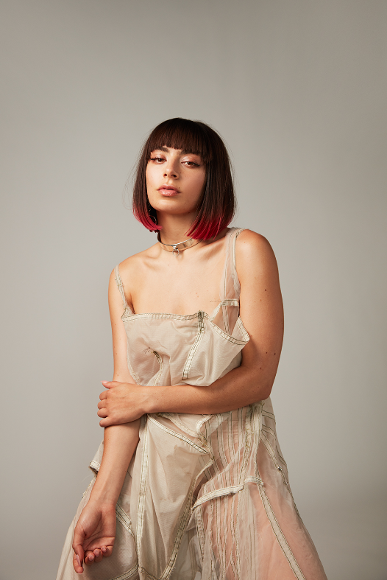
(Photo credit Marcus Cooper, Download Hi-Res here)
Website | Facebook | Twitter | Instagram | SoundCloud | YouTube | VERO
Press tools: http://press.atlanticrecords.com/charlixcx/

For more information, contact:
Ted Sullivan | Ted.Sullivan@AtlanticRecords.com

