FOR IMMEDIATE RELEASE

FRIDAY, JUNE 14, 2019

**4TH & ORANGE KICKSTART SUMMER WITH “GIRL NEXT DOOR”**

***LONG BEACH, CA-BASED POP-ROCK REGGAE OUTFIT UNVEIL LABEL DEBUT SINGLE***

***EXCLUSIVE PREMIERE ON*** [***ALT PRESS***](https://www.altpress.com/features/4th-and-orange-girl-next-door/)

***“GIRL NEXT DOOR”*** [***AVAILABLE NOW***](https://atlantic.lnk.to/GirlNextDoorPR)

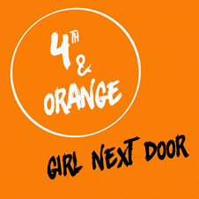

*DOWNLOAD ARTWORK* [*HERE*](https://warnermusicgroup.box.com/s/l12c246sdpdad8f6lathocj60s37ma90)

*Merging pop elements with reggae in the likes of Sublime, “Girl Next Door” introduces the band’s summery, poolside vibe along with their storytelling style that draws on relatable circumstances from real-life experiences.*

***ALT PRESS***

Latium Entertainment and Atlantic Records have announced the eagerly awaited label debut single from Long Beach, CA-based reggae pop-rock outfit 4th & Orange. [“Girl Next Door”](https://atlantic.lnk.to/GirlNextDoorPR) is available now via all digital music retailers and streaming services.

Co-produced by GRAMMY® Award-nominee DJ Flict (Sublime w/Rome, Wiz Khalifa, Lauryn Hill) and Mark Pelli (Magic!, Chris Brown, J Cole), “Girl Next Door” showcases 4th & Orange’s expert gift for crafting quintessential SoCal pop-reggae, right in time for the start of summer.

“I wrote [Girl Next Door] about six years ago. That’s when I was in the phase of learning how to write ‘stories’ in the music,” Garrett Douglas (lead vocals) tells [Alt Press](https://www.altpress.com/features/4th-and-orange-girl-next-door/). “We tell stories in our music, so it’s important for me to write words that can paint pictures in your head.”

4th & Orange was co-founded by longtime friends Garrett Douglas and Chris “DJ Irey” Garcia with a goal of merging inspiration from hometown heroes, Sublime, with their own individual style to craft something altogether new and utterly irresistible.

Douglas and DJ Irey’s friendship began while playing high school football, their shared passion for music providing solace from their troubled home lives. Each soon went on to forge their own path in the music industry – Douglas took on the moniker ‘Beach Boy’ and became a successful songwriter, DJ Irey a successful producer. The two reunited in early 2019, determined to take their decade of industry experience and put their creative energy into a project all their own.

“The goal of our music is to bring light to others in dark situations,” says Douglas. “Both Irey and I came from a rough past, but that’s how we connected and created 4th & Orange. Our music reminds others that in the dark you can be the light.”

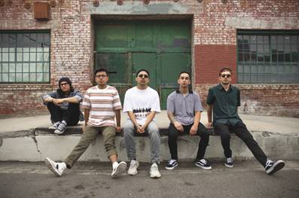

*High-res press photo download* [*here*](https://warnermusicgroup.box.com/s/12xpyv7cqtori1j1s0ger21mwloglgy1)

*Photo credit: Monique Chavez*

**4TH & ORANGE IS**

Garrett Douglas -  Lead

Chris “DJ Irey” Garcia - Keyboards / Producer

Ricardo Ramirez – Guitar

Jacob Lucero – Bass

Sam Ward – Drums

**CONNECT WITH 4TH & ORANGE**

[Instagram](https://protect-us.mimecast.com/s/P4tBClYM7zcwnPnYiq8viJ) | [Twitter](https://protect-us.mimecast.com/s/LXCaCmZMyAsoJPJQHQcYhC) | [Website](https://protect-us.mimecast.com/s/drmYCn5NOBtZO3ORHEaCw7) | [Press Site](http://press.atlanticrecords.com/4th-orange/)

**PRESS CONTACT**

Chandler Owen | [chandler.owen@atlanticrecords.com](mailto:chandler.owen@atlanticrecords.com)