FOR IMMEDIATE RELEASE

AUGUST 27, 2019

AVA MAX BECOMES A SUPERHERO IN OFFICIAL VIDEO FOR “TORN”

GLOBAL POP SENSATION UNVEILS EPIC VISUAL FOR NEW SINGLE
DIRECTED BY JOSEPH KAHN (BRITNEY SPEARS, TAYLOR SWIFT)

WATCH AVA PERFORM A MEDLEY OF “TORN” AND “SWEET BUT PSYCHO”
ON LAST NIGHT’S MTV VMAS RED CARPET PRE-SHOW HERE

CHECK OUT AVA’S STUNNING EUPHORIA. MAGAZINE COVER HERE

WATCH THE OFFICIAL VIDEO FOR “TORN” HERE
DOWNLOAD/STREAM “TORN” HERE

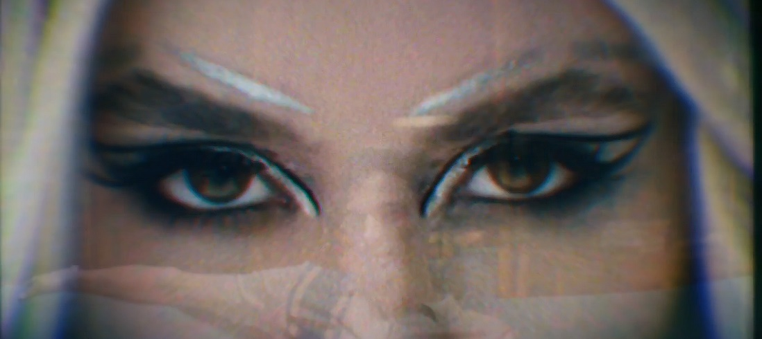

“Best New Music” – COMPLEX

“Dance-Pop Excellence” – MTV NEWS

“Ava Max’s ‘Torn’ Will Make You Want To Hit The Dance Floor” – ELITE DAILY

Global pop sensation Ava Max has unveiled the official video for her latest single “Torn” – listen to the disco-tinged track HERE and watch the video, which premiered on MTV, HERE. Created in collaboration with Fiat and directed by the acclaimed Joseph Kahn (Britney Spears’ “Toxic,” Taylor Swift’s “Bad Blood”), the instantly iconic video was shot earlier this summer across four days on location in Milan, IT and features stunning landmarks throughout the city including the Duomo di Milano.

“Shooting the torn music video was a dream come true,” says Ava. “I got to travel all over Milan as a superhero confronting my cheating husband. I want women to know all around the world that they have the power!”

Released last week, “Torn” has already earned critical praise from COMPLEX, Billboard, MTV News, Idolator and more. The official video for her newest single arrives after a week of high-profile performances and appearances. Yesterday, Ava attended her first-ever MTV Video Music Awards where she was nominated “Best New Artist” alongside Lizzo, Billie Eilish, Lil Nas X, Rosalía and H.E.R. Watch her perform an electric medley of “Torn” and “Sweet but Psycho” LIVE the Red Carpet Pre-Show HERE. Last week, Max joined the Jonas Brothers in NYC to perform during an exclusive concert at Pandora LIVE and this past Sunday, the singer/songwriter performed at Arthur Ashe Kids’ Day which aired on ABC.

The release of “Torn” follows Ava’s summer streak of bops including “Freaking Me Out,” “Blood, Sweat & Tears” and her feature on AJ Mitchell’s new single “Slow Dance.” Upon release, “Freaking Me Out” and “Blood, Sweat & Tears” were praised by publications including TIME Magazine, Rolling Stone, Billboard, MTV News and more.

Ava has cemented her pop status with the success of her RIAA 2x-platinum certified hit “Sweet but Psycho” which spent three weeks in the top 10 of Billboard’s Hot 100 and peaked at #3 at USA Pop Radio. With over 650 million global streams and counting, “Sweet but Psycho,” which earned Max her first-ever Teen Choice Awards nomination for “Choice Pop Song” – where she was also nominated for “Choice Summer Female Artist” – is joined by an official video which has garnered over 415 million views HERE. Produced by GRAMMY® Award-nominated super-producer Cirkut (Maroon 5, Miley Cyrus, The Weeknd) and co-written with Madison Love (Camila Cabello), “Psycho” hit #1 on both Spotify’s “United States Viral 50” and Billboard’s “Dance Club Songs.” The stateside success of “Sweet But Psycho,” including top 5 airplay at Hot AC radio outlets nationwide, follows the track’s remarkable popularity abroad, including four consecutive weeks atop the UK Singles Chart and #1 rankings on charts in nearly 20 countries.

In March, Max unveiled her follow-up single “So Am I,” which proved a phenomenon for its universal message of acceptance and inclusivity, earning top 5 airplay across Europe along with over 33 million streams in the US alone. The official video for the irresistibly catchy empowerment anthem now boasts over 77 million YouTube views HERE. Upon release, MTV News praised the song as a “big, melodic pop anthem that celebrates individuality and embracing one’s unique flaws and quirks.” Watch her performance of “So Am I” on Jimmy Kimmel Live! HERE.

Dubbed the “Princess of Pop” by V Magazine and “Artist You Need to Know” by Rolling Stone, Ava has been feted with a wide range of media attention, including features in Vanity Fair, Billboard, FORBES, PAPER, and more. Earlier this year, the rising pop artist made her national TV debut with performances of “Sweet but Psycho” on The Late Late Show with James Corden, The TODAY Show, and The Ellen DeGeneres Show. Max spent much of her summer on the road, lighting up the stage at radio-sponsored summer concerts and making her much-anticipated World Pride debut by headlining PrideFestival Tea Dance at New York City’s Pier 17.

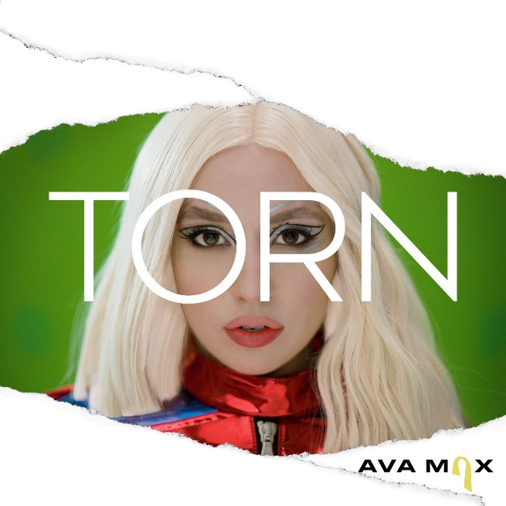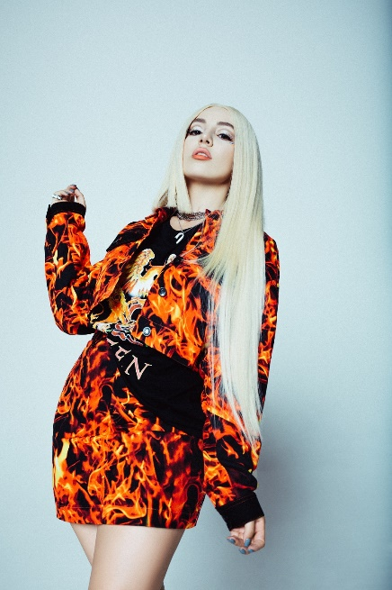
Download High-Res Art + Press Photo (Credit: Lauren Dunn)

CONNECT WITH AVA MAX:
OFFICIAL I INSTAGRAM I TWITTER I FACEBOOK | PRESS ASSETS

CONTACT:
Andrew George | andrew.george@atlanticrecords.com

