AVA MAX STUNS WITH PERFORMANCES OF GLOBAL HIT “SWEET BUT PSYCHO” ON
THE LATE LATE SHOW WITH JAMES CORDEN AND THE TODAY SHOW

RISING POP SENSATION SOARS TO #1 ON BILLBOARD’S EMERGING ARTIST CHART

INTERNATIONAL SMASH HIT #1 IN THE UK 4 WEEKS IN A ROW

WATCH AVA’S TODAY SHOW PERFORMANCE HERE:
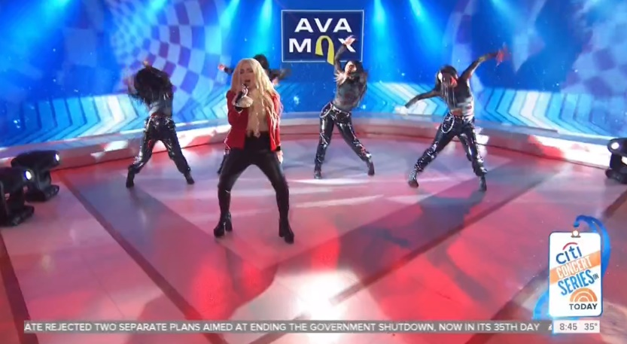

WATCH AVA’S LATE LATE SHOW PERFORMANCE HERE:

“By re-appropriating language used to gaslight women, Ava Max creates an unlikely feminist anthem, written by and for someone who has nothing to hide, who, furthermore, has fought for herself to be seen completely.”
– V MAGAZINE

2019’s newest pop sensation Ava Max is taking the new year by storm. This week, the rising songstress made her U.S. TV debut with stunning performances of her global hit “Sweet but Psycho” on both CBS’ The Late Late Show with James Corden and NBC’s The TODAY Show. Amidst the incredible week of firsts, Ava also soared to #1 on Billboard’s Emerging Artists Chart.

Since release, the international hit single “Sweet but Psycho” has amassed over 250M+ streams worldwide. The track has topped Spotify’s Global, US and UK Viral Charts while being added to the esteemed Today’s Top Hits playlist, Pop Rising, Young Wild & Free and more. With love for the single across the globe, “Sweet but Psycho” hit the #1 spot in the UK 4 weeks in a row and is currently the global #1 single on Shazam for the third week in a row. Climbing Top 20 at USA Pop Radio, the earworm is also Top 10 on U.S. iTunes. The official companion visual has gone on to amass over 91M+ views on YouTube.

Produced by GRAMMY® Award-nominated super-producer Cirkut (Maroon 5, Miley Cyrus, The Weeknd) and co-written with Madison Love (Bazzi), “Psycho” was recently included on FADER’s list of “20 best new pop songs right now” with Idolator writing “Ava Max caught lightning in a bottle with ‘Sweet But Psycho,’ a ruthlessly catchy, deeply relatable bop about embracing all facets of your personality.” Publications including FLAUNT have also praised Ava as an artist “on her way to becoming music's next ‘It’ girl’” while Billboard included the pop newcomer on their list of “Ones to Watch” advising readers to “Get familiar with Ava Max, because her name is about to be everywhere.”

Max also co-wrote and is featured on David Guetta’s “Let It Be Me” off his album “7.” She recently collaborated with Vice and global multi-platinum recording artist Jason Derulo on “Make Up” – watch the video HERE – which PAPER called a “bop” describing the song and video as a “mix of sultry and upbeat pop funk.” Her beaming voice was first introduced to listeners through her stellar featured performance on LA-based Nü Disco Le Youth’s summer 2017 smash, “Clap Your Hands,” and has since generated attention for her first original single “My Way” as well as viral hit “Not Your Barbie Girl” which went on to amass over 10 million views across YouTube and Musical.ly.

LISTEN TO “SWEET BUT PSYCHO” HERE
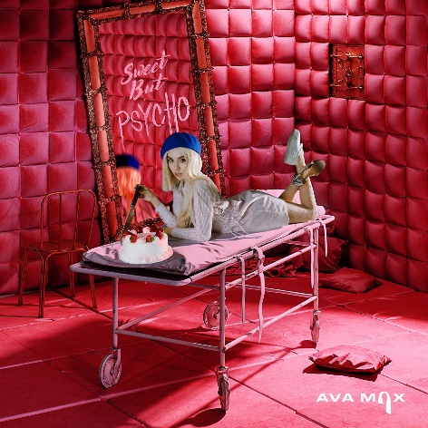

CONNECT WITH AVA MAX:
OFFICIAL I INSTAGRAM I TWITTER I FACEBOOK I SOUNDCLOUD I PRESS TOOLS

CONTACT:
Andrew George | andrew.george@atlanticrecords.com

