AVONLEA UNVEILS NEW SINGLE “STRANGER”

DOWNLOAD/STREAM:
http://avonlea.lnk.to/StrangerPR
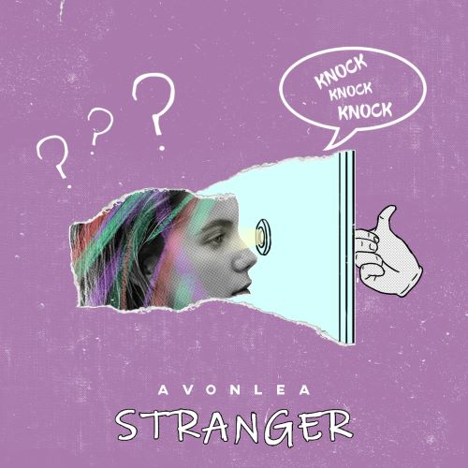
*Download Art HERE*

Today, rising singer-songwriter Avonlea releases her newest single “Stranger,” available now at all DSPs and streaming services. The song’s unforgettable melody and emotional lyrics highlight Avonlea’s talent as a new artist to watch.

“I wrote this song on bass after a breakup,” says Avonlea. “This guy was my partner and best friend for two really pivotal years of my life. It was the strangest, loneliest culture shock cutting him out of it. Stranger is about putting yourself back out there. Even though it’s unsettling after years of comfort.”

The release of “Stranger” follows Avonlea’s previously released track, “Again,” which quickly received rave reviews with Billboard praising the song’s official video as a “stunning visual… bringing viewers an emotional and heartbreaking depiction of Avonlea's intense message.” Upon release, L’Officiel USA wrote, “Avonlea’s lo-fi beats, easy pop hooks, and haunting voice are the definition of mellow millennial pop.” “Again” represents Avonlea’s experience at the age of 15 and follows her debut track “It Sucks” and second single “Cars and Boys” – representing ages 14 and 16 respectively. The official music video for “It Sucks” has garnered well over one million views since its release. “Cars and Boys” was instantly applauded by NYLON who described the track to be “filled with poignant lines that are beautifully morose in their simplicity.”
At only 19 years old, Avonlea is a multi-instrumentalist who began producing and songwriting at a very young age. This past year, she collaborated with producer Oshi on their track “Whispers” and opened for Jhené Aiko on the singer’s 2018 European “Trip Tour.” With a firm grasp on what she believes in, Avonlea’s musical talents mirror her abilities to be incredibly self-aware, raw and vulnerable all at the same time. Avonlea’s fierce feminist spirit and independent nature are reflective in her music and push her to accomplish one goal - for her fans to find solace in her songs.

(Photo Credit: Haley Bowman – Download High Res Imagery)

CONNECT:
Website| Instagram | Facebook | Twitter | YouTube

CONTACT:
Chelsey Northern | chelsey.northern@atlanticrecords.com

