FOR IMMEDIATE RELEASE
APRIL 8, 2020

CHRISTIAN LALAMA DROPS NEW SINGLE “KNOCKED ME OFF MY FEET”

ATLANTIC RECORDS SINGER AND MULTI-INSTRUMENTALIST LEVELS UP ON SMOOTH NEW RELEASE

LISTEN TO “KNOCKED ME OFF MY FEET” HERE
WATCH THE ANIMATED VISUALIZER HERE

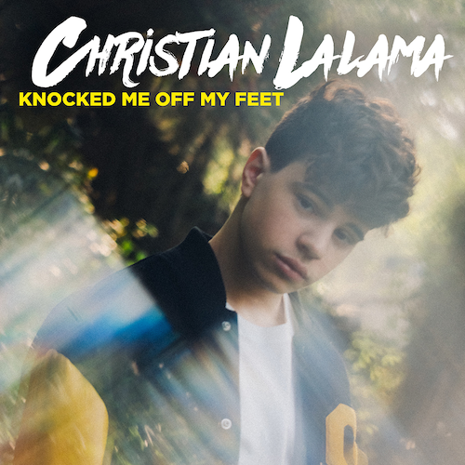
*Download Press Assets HERE*

Canadian R&B/pop artist Christian Lalama, has unveiled his new single “Knocked Me Off My Feet” (Atlantic Records) available today at all digital music retailers and streaming services. The rising recording artist’s sound continues to evolve with this smooth new release. Watch the accompanying animated visualizer, streaming now via Christian’s increasingly popular YouTube channel HERE and keep an eye out for the official music video arriving soon.

“‘Knocked Me Off My Feet’ is a song about ‘that someone’ who gives out mixed signals,” says Christian. “They don’t let you get too close and somehow always leave you wanting more. Having the opportunity to work with Wallis Lane, Rice N’ Peas, Ivory Scott and Johnny Yukon was an inspiring experience. They’re amazing people and a dream team of incredible songwriters and producers!”

“Knocked Me Off My Feet” follows Lalama’s recently released single, “Miss Me.” Produced by Roark Bailey (Lil Uzi Vert, Summer Walker, Playboi Carti), the irresistibly catchy track has quickly proven a breakthrough with over 400K worldwide streams. The official video, which premiered on Billboard, continues to light up YouTube with over 400K views HERE.

Over the past year, Lalama has worked tirelessly, crafting his mature new sound both inside and outside the studio. Both “Miss Me” and “Knocked Me Off My Feet” mark a leap forward for Christian, affirming the Ontario-based artist’s gift for blending his own signature mix of R&B and pop. He’s also continued sharing his adored covers with fans, uploading a new performance video each week and garnering over 14 million views in less than a year. At only 16, the talented singer and multi-instrumentalist has already earned more than 600K followers on YouTube and over 42 million individual YouTube views. Critical praise has also continued to roll in with support from TigerBeat, Entertainment Tonight Canada, Just Jared Jr., Hollywire, Sweety High, and more. Listeners can expect more new music from Christian to arrive in the coming months.

Lalama has had an innate calling to perform since he can remember. The quickest scroll through YouTube will turn up footage of a young Christian rocking behind a piano at just four-years-old. In 2018, he made his official Atlantic Records debut with his first original single, “Tic Toc.” Co-produced by ISM Beats (Chris Brown, Chief Keef) and S1 (Kanye West, Drake) and written by Nija (Cardi B, The Carters), the showcase track is accompanied by an official music video now boasting over 2.1 million views on YouTube. Straight out of the gate, TigerBeat, praised the 16-year-old star for his “oh-so smooth lyrics,” writing they “are giving us serious old-school Justin Bieber vibes!” “Tic Toc” was followed by the release of “FrFr” – which stands for “For Real For Real” – and the sweetly captivating companion visual, streaming HERE. Upon release, Idolator quickly called the track “a ruthlessly catchy bop.”

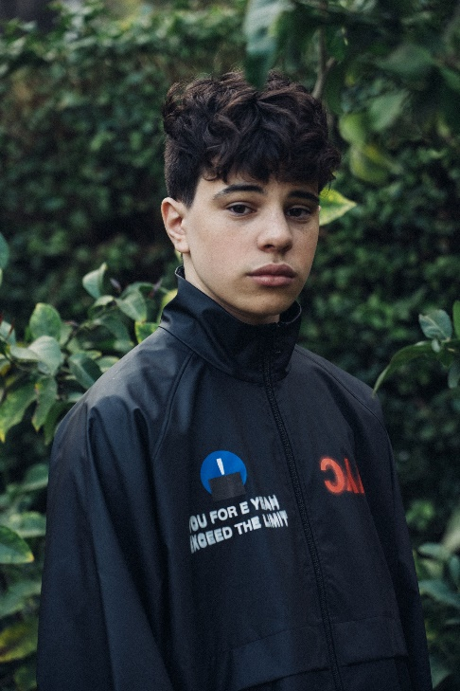
(Photo credit: Trent Barboza – download high res)

CONNECT:
INSTAGRAM | YOUTUBE | TWITTER | FACEBOOK | TIKTOK

CONTACT:
Andrew George | andrew.george@atlanticrecords.com

