FOR IMMEDIATE RELEASE
FEBRUARY 18, 2022

CHRISTIAN LALAMA RETURNS WITH NEW SINGLE “GIRLFRIEND”

ATLANTIC RECORDS POP/R&B ARTIST SHARES BELATED VALENTINE’S DAY GIFT WITH FANS

LISTEN HERE | WATCH HERE

DOWNLOAD HI-RES ARTWORK

“Lalama is proving his worth among the ranks of pop icons like Justin Bieber and Shawn Mendes. A perfect blend of smooth R&B beats and addictive pop melodies.” – YOUNG HOLLYWOOD

Atlantic Records pop/R&B artist Christian Lalama is back with his first new single in almost two years. A belated Valentine’s Day gift to his fans, “Girlfriend” is available now at all DSPs and streaming services. Interpolating Fabolous, P. Diddy & Jagged Edge’s “Trade It All (Part 2),” originally found on the blockbuster 2002 soundtrack to Barbershop, the feel-good track is joined by an official music video, premiering HERE.

“I’m so excited for my fans to hear my new song Girlfriend,” says Christian. It’s my first release in a while and it showcases how my sound has grown over the past few years. I hope you love it!”

“Girlfriend” marks a major leap forward for Christian, affirming his signature gift for blending his own mix of pop and R&B. Newly signed to LA-based music management company, The Shalizi Group (Marshmello, Alesso), the Ontario-based artist has worked tirelessly over the past year crafting his mature new sound, with additional releases on the horizon.

Lalama has had an innate calling to perform for as long as he can remember. The quickest scroll through YouTube will turn up footage of a young Christian rocking behind a piano at just four-years-old. In 2018, he made his official Atlantic Records debut with his first original single, “Tic Toc,” accompanied by an official music video now boasting almost 2.5M views via YouTube. A string of increasingly acclaimed singles followed, including “Gotta Be You,” “Knocked Me Off My Feet,” “FrFr” and “Miss Me,” for which the video premiered exclusively via Billboard, now approaching 1.5M views at YouTube.

Now, at only 18, the talented singer and multi-instrumentalist has earned more than 1.5M followers on TikTok and close to 75M individual views on his hugely popular YouTube channel, all as critical praise rolled in from high-profile media outlets including Billboard, E! News, Idolator, E! News, and more.

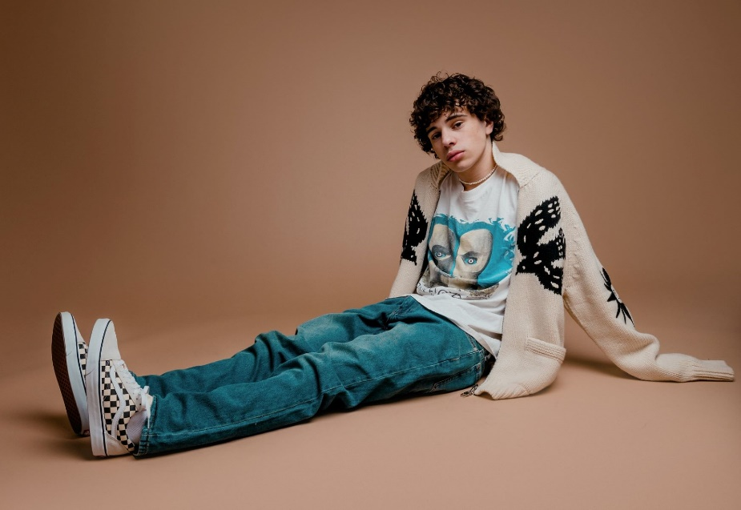
DOWNLOAD HI-RES PRESS PHOTOS (CREDIT: BRANDON PHILLIPS)

CONNECT:
WEBSITE | INSTAGRAM | YOUTUBE | TWITTER | FACEBOOK | TIKTOK | PRESS ASSETS

CONTACT:
Andrew George | andrew.george@atlanticrecords.com

