FOR IMMEDIATE RELEASE
MAY 27, 2020

CHRISTIAN LALAMA RELEASES NEW SONG “GOTTA BE YOU”

R&B/POP ARTIST DROPS NEW SONG AND OFFICIAL COMPANION VIDEO

WATCH HERE | LISTEN HERE

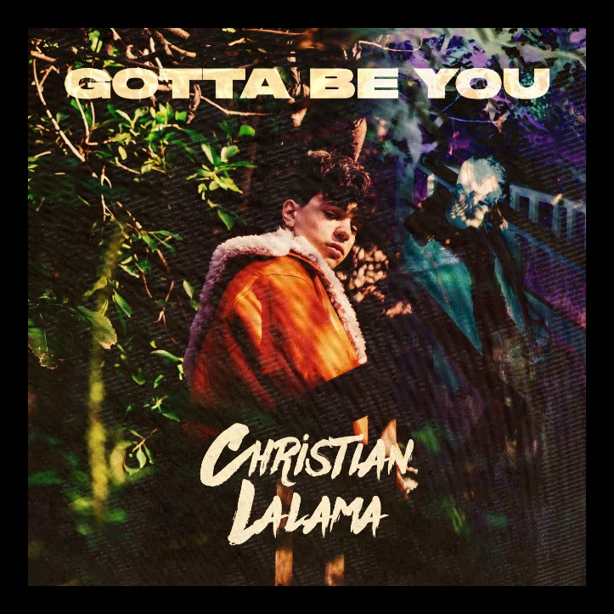
*Download Press Assets HERE*

Rising R&B/pop artist Christian Lalama, has unveiled his new song “Gotta Be You” (Atlantic Records) available today at all digital music retailers and streaming services. Co-written by Christian himself alongside Jozzy (Lil Nas X/Billy Ray Cyrus) and Johnny Yukon (Lil Wayne/PnB Rock), “Gotta Be You” was produced by Bizness Boi (Party Next Door/Rihanna) and Xeryus (DaBaby). Listen HERE and watch the inventive video shot in quarantine at Christian’s official YouTube channel HERE.

Today’s release follows Christian’s latest single, “Knocked Me Off My Feet.” Check out the video, which fuses quarantine visuals with mesmerizing animation, HERE. Produced and co-written alongside Wallis Lane (Travis Scott, Drake), Rice N’ Peas (Bazzi, G-Eazy), Ivory Scott (Lil Baby, A Boogie Wit Da Hoodie), and Johnny Yukon (Jeremih, Lil Yachty, Wiz Khalifa), “Knocked Me Off My Feet” has been mey by critical applause, with Idolator hailing it as “another genre-bending banger” from “the breakout star.” “The Canadian pop up-and-comer is a bit lovesick on this slick new track,” raved E! News, “which may be bad news for him, but is great news for us.” “Christian Lalama has a voice that is sentimental to anyone who grew up listening to 90s R&B, wrote LADYGUNN. “The brave, Gen – Z icon bears a rhythm like no other.” Perhaps Young Hollywood said it best: “Lalama is proving his worth among the ranks of pop icons like Justin Bieber and Shawn Mendes. A perfect blend of smooth R&B beats and addictive pop melodies, ‘Knocked Me Off My Feet’ is a must for your summer playlist!”

“Knocked Me Off My Feet” arrived mere weeks after Christian’s first new release of 2020, the breakthrough hit single, “Miss Me.” Produced by Roark Bailey (Lil Uzi Vert, Summer Walker, Playboi Carti), the irresistibly catchy track quickly proved a sensation with over 400,000 worldwide streams thus far. The official video – which premiered exclusively via Billboard – continues to light up YouTube, with individual views now approaching 650,000 HERE.

Lalama has worked tirelessly over the past year, crafting his mature new sound both inside and outside the studio. The recent series of singles mark a major leap forward for Christian, affirming the Ontario-based artist’s gift for blending his own signature mix of R&B and pop. He’s also continued sharing his adored covers with fans, uploading a new performance video each week and garnering over 20 million views in the past year. At only 16, the talented singer and multi-instrumentalist has already earned close to 650,000 subscribers and over 46 million individual views at his popular YouTube channel.

Lalama has had an innate calling to perform since he can remember. The quickest scroll through YouTube will turn up footage of a young Christian rocking behind a piano at just four-years-old. In 2018, he made his official Atlantic Records debut with his first original single, “Tic Toc.” Co-produced by ISM Beats (Chris Brown, Chief Keef) and S1 (Kanye West, Drake) and written by Nija (Cardi B, The Carters), the showcase track is accompanied by an official music video now boasting 2.2 million views on YouTube. Straight out of the gate, TigerBeat, praised the 16-year-old star for his “oh-so smooth lyrics,” writing they “are giving us serious old-school Justin Bieber vibes!” “Tic Toc” was followed by the release of “FrFr” – which stands for “For Real For Real” – and the sweetly captivating companion visual, streaming HERE. Upon release, Idolator quickly called the track “a ruthlessly catchy bop.”

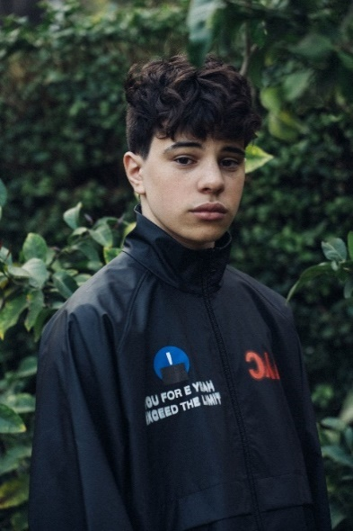
(Photo credit: Trent Barboza – download high res)

CONNECT:
INSTAGRAM | YOUTUBE | TWITTER | FACEBOOK | TIKTOK | PRESS ASSETS

CONTACT:
Andrew George | andrew.george@atlanticrecords.com

