FOR IMMEDIATE RELEASE
MAY 1, 2020

CHRISTIAN LALAMA SHARES AT-HOME VIDEO FOR “KNOCKED ME OFF MY FEET”

RISING R&B/POP SENSATION UNVEILS OFFICIAL COMPANION VISUAL FOR LATEST SINGLE

WATCH HERE | LISTEN HERE

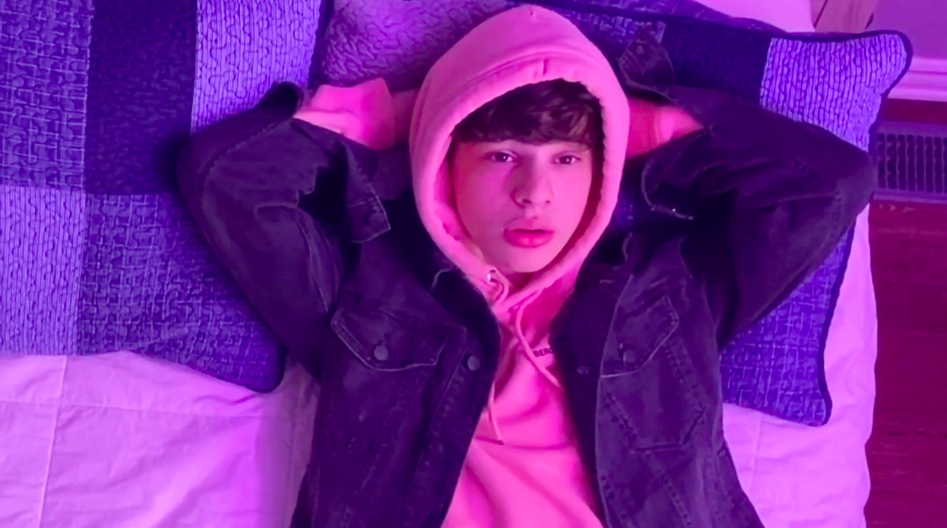

Rising R&B/pop artist Christian Lalama, has unveiled the official video for his acclaimed new single, “Knocked Me Off My Feet” (Atlantic Records). The visual, which fuses content shot in quarantine with mesmerizing animation, can be viewed now at Christian’s official YouTube channel HERE.

Produced and co-written alongside Wallis Lane (Travis Scott, Drake), Rice N’ Peas (Bazzi, G-Eazy), Ivory Scott (Lil Baby, A Boogie Wit Da Hoodie), and Johnny Yukon (Jeremih, Lil Yachty, Wiz Khalifa), “Knocked Me Off My Feet” has been met by critical applause, with Idolator hailing it as “another genre-bending banger” from “the breakout star.” “The Canadian pop up-and-comer is a bit lovesick on this slick new track,” raved E! News, “which may be bad news for him, but is great news for us.” “Christian Lalama has a voice that is sentimental to anyone who grew up listening to 90s R&B, wrote LADYGUNN. “The brave, Gen – Z icon bears a rhythm like no other.” Perhaps Young Hollywood said it best: “Lalama is proving his worth among the ranks of pop icons like Justin Bieber and Shawn Mendes. A perfect blend of smooth R&B beats and addictive pop melodies, ‘Knocked Me Off My Feet’ is a must for your summer playlist!”

“Knocked Me Off My Feet” follows “Miss Me,” Christian’s first new release of 2020. Produced by Roark Bailey (Lil Uzi Vert, Summer Walker, Playboi Carti), the irresistibly catchy track has quickly proven a breakthrough with over 400K worldwide streams. The official video – which premiered exclusively via Billboard – continues to light up YouTube, now with more than 550,000 individual views HERE.

Over the past year, Lalama has worked tirelessly, crafting his mature new sound both inside and outside the studio. Both “Miss Me” and “Knocked Me Off My Feet” mark a leap forward for Christian, affirming the Ontario-based artist’s gift for blending his own signature mix of R&B and pop. He’s also continued sharing his adored covers with fans, uploading a new performance video each week and garnering over 20 million views in the past year. At only 16, the talented singer and multi-instrumentalist has already earned more than 600K followers on YouTube and over 44 million individual YouTube views. Critical praise has also continued to roll in with support from TigerBeat, Entertainment Tonight Canada, Just Jared Jr., Hollywire, Sweety High, and more. Listeners can expect more new music from Christian to arrive in the coming months.

Lalama has had an innate calling to perform since he can remember. The quickest scroll through YouTube will turn up footage of a young Christian rocking behind a piano at just four-years-old. In 2018, he made his official Atlantic Records debut with his first original single, “Tic Toc.” Co-produced by ISM Beats (Chris Brown, Chief Keef) and S1 (Kanye West, Drake) and written by Nija (Cardi B, The Carters), the showcase track is accompanied by an official music video now boasting nearly 2.2 million views on YouTube. Straight out of the gate, TigerBeat, praised the 16-year-old star for his “oh-so smooth lyrics,” writing they “are giving us serious old-school Justin Bieber vibes!” “Tic Toc” was followed by the release of “FrFr” – which stands for “For Real For Real” – and the sweetly captivating companion visual, streaming HERE. Upon release, Idolator quickly called the track “a ruthlessly catchy bop.”

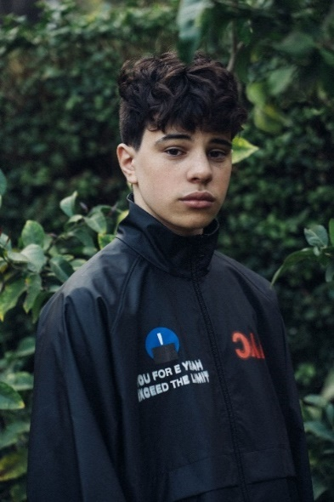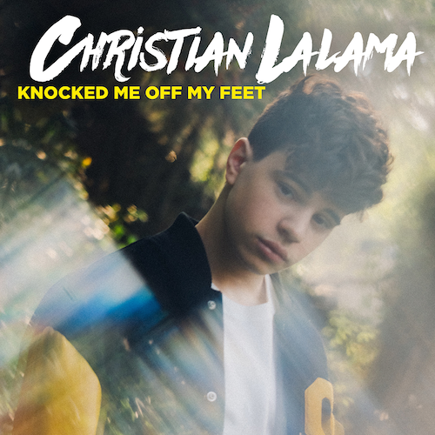
(Photo credit: Trent Barboza – download high res)

CONNECT:
INSTAGRAM | YOUTUBE | TWITTER | FACEBOOK | TIKTOK | PRESS ASSETS

CONTACT:
Andrew George | andrew.george@atlanticrecords.com

