FOR IMMEDIATE RELEASE
FEBRUARY 5, 2020

RISING ARTIST CHRISTIAN LALAMA RETURNS WITH “MISS ME”

ATLANTIC RECORDS SINGER/MULTI-INSTRUMENTALIST EMBRACES NEW SOUND
ON IRRESISITIBLY CATCHY NEW SINGLE AND VIDEO

WATCH HERE | LISTEN HERE

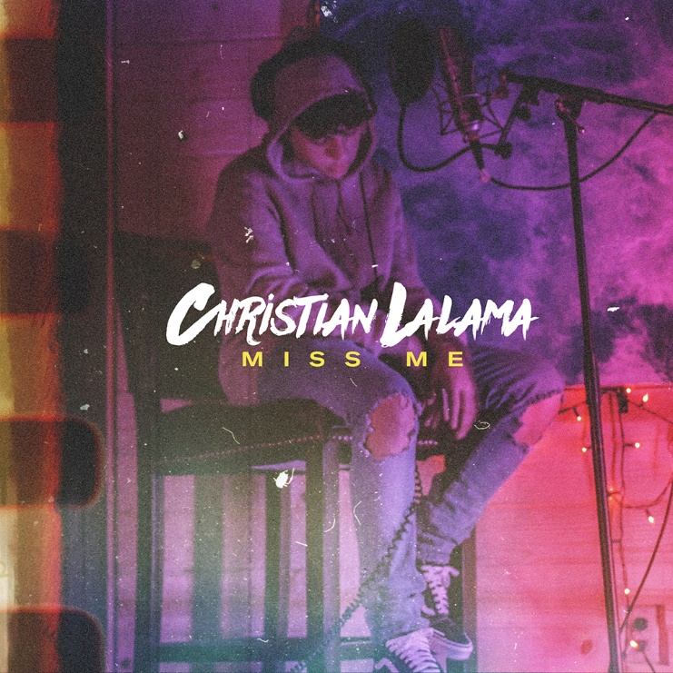
*Download Press Assets HERE*

Rising singer and multi-instrumentalist Christian Lalama is back with his latest single “Miss Me” (Atlantic Records) available today at all digital music retailers and streaming services. The young recording artist embraces a more evolved sound on his newest catchy release which arrives alongside a companion video, streaming now via his official YouTube channel HERE.

“‘Miss Me’ means a lot to me,” Christian shared with Billboard. “When I started this journey, I had to leave a lot behind back home. The lyrics are my thoughts and where my mind sometimes wanders. I often ask myself ‘how have the changes in my life affected the people closest to me?’”

Produced by Roark Bailey (Lil Uzi Vert, Summer Walker, Playboi Carti), “Miss Me” is just the first offering of new music Christian is excited to share with listeners in 2020. Over the past year, Lalama has worked tirelessly, crafting his sound both inside and outside the studio, merging R&B and pop with his own fire, fervor and flavor. At the same time, he’s managed to continue sharing his adored covers with fans, uploading a new performance video each week and garnering over 14 million views in less than a year.

Christian has felt an innate calling to perform since the age of three, making music since before he could even talk. The Ontario-native was born into a musically inclined family and learned to play piano at the impressive young age of four. He won a contest at ten-years-old to perform as part of The Kid Mitchell Band, founded by renowned Canadian artist Kim Mitchell. One short year later he found himself performing in front of 10,000 screaming fans opening for Mitchell in between belting out classics by Elton John and Billy Joel at solo gigs and honing his piano chops. Lalama soon began to ignite YouTube generating millions of views on a steady stream of covers that have earned him more than 37 million views at his official YouTube channel alone. Along the way, he’s earned critical acclaim from TigerBeat, Entertainment Tonight Canada, Just Jared Jr., Hollywire, Sweety High, and more.

In 2018, Lalama made his official Atlantic Records debut with his first original single, “Tic Toc.” Co-produced by ISM Beats (Chris Brown, Chief Keef) and S1 (Kanye West, Drake) and written by Nija (Cardi B, The Carters), the showcase track is accompanied by an official music video now boasting over 2.1 million views on YouTube. Straight out of the gate, TigerBeat, praised the 16-year-old star for his “oh-so smooth lyrics,” writing they “are giving us serious old-school Justin Bieber vibes!” “Tic Toc” was followed by the release of “FrFr” – which stands for “For Real For Real” – and the sweetly captivating companion visual, streaming HERE. Upon release, Idolator quickly called the track “a ruthlessly catchy bop.”

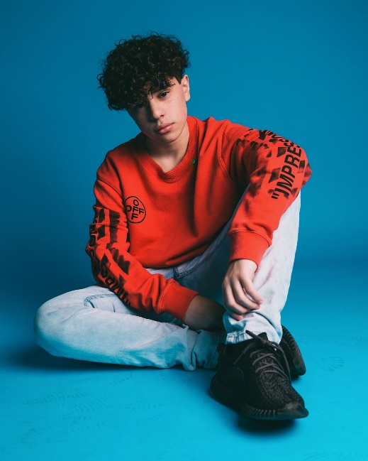
(Photo credit: Dawn Kingston – download high res)

CONNECT:
INSTAGRAM | YOUTUBE | TWITTER | FACEBOOK

CONTACT:
Andrew George | andrew.george@atlanticrecords.com

