FOR IMMEDIATE RELEASE
JUNE 1, 2021

HAYLEY KIYOKO KICKS OFF PRIDE MONTH WITH NEW SINGLE “CHANCE”

GROUNDBREAKING POP STAR SHARES ROMANTIC SELF-DIRECTED VIDEO
CO-STARRING ALEXANDRA SHIPP (LOVE, SIMON, X-MEN APOCALYPSE)

CELEBRATORY LIVE PERFORMANCES BEGIN THIS WEEKEND WITH
IHEARTRADIO’S “CAN’T CANCEL PRIDE” VIRTUAL BENEFIT ON FRIDAY, JUNE 4TH
AND HEADLINE SHOW AT LA’S OUTLOUD: RAISING VOICES ON SATURDAY, JUNE 5TH

LISTEN HERE | WATCH HERE

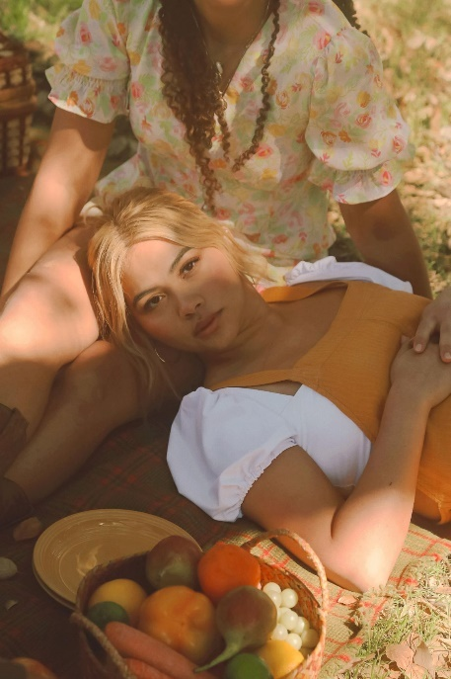
(Download High Res Artwork + Press Photo // Credit: Trevor Flores)

Trailblazing pop star Hayley Kiyoko is officially kicking off Pride Month with today’s release of her dreamy new synth-pop anthem. “Chance” is available now via Atlantic Records at all DSPs and streaming services. Produced by GRAMMY® Award-winner Danja (Justin Timberlake, Britney Spears) and co-written by Kiyoko, Pat Morrissey & Kill Dave, and Nate Cyphert, the single arrives alongside a cinematic, narrative music video that matches the song’s spirit of romantic risk and reward. Directed by Kiyoko and shot on 16mm film, the sun-drenched visual, which co-stars acclaimed actress Alexandra Shipp (Love, Simon, X-Men: Apocalypse) made its broadcast premiere on MTV and is streaming now at Hayley’s official YouTube channel HERE.

“‘Chance’ is a song based on those moments when I denied my true feelings for someone out of fear of rejection, and therefore didn't allow someone to take a chance on me,” says Hayley. “I hope this song empowers people to push past their own self-doubt and realize how worthy they are of love.”

“I'm always starved for hopeful queer stories onscreen, and I really wanted to direct a narrative that focused on the happier 'honeymoon' phase of a relationship, to show what can happen if we take a chance on ourselves and have that love reciprocated. The video is meant to portray those first few weeks, months, or even years when you are utterly head over heels in love with each other. I directed the video on 16mm film, alongside an incredible team of badass women - from the director of photography to the editor, and the producers. I am so grateful for the entire crew who helped bring this vision to life as well as to our incredible lead actress, Alexandra Shipp. I hope ‘Chance’ sparks the hope that anyone can and will find the love they deserve.”

“Chance” follows the recent release of “Found My Friends,” which marked the beginning of a new era for Kiyoko as her first single of 2021. Co-produced by Hayley, Danja and Pat Morrissey & Kill Dave, the song emphasizes the importance of finding friendship within yourself. An official music video – directed by Kiyoko and shot on 16mm film at LA’s historic Millennium Biltmore Hotel – is streaming now HERE. Upon release, “Found My Friends” was met with ecstatic critical applause from a wide range of publications including PAPER, NYLON, V MAGAZINE, Teen Vogue, People and more. E! News declared “Lesbian Jesus is back” while Billboard praised the “groovy anthem to self-love” writing, “The song’s entrancing, woozy production provides a dopamine-boosting backdrop that will have you reaching for the repeat button.”

Hayley will usher in Pride festivities with a pair of eagerly anticipated live performances beginning this Friday, June 4th at “Can’t Cancel Pride,” a virtual relief benefit for the LGBTQ+ community produced by Procter & Gamble® and iHeartMedia and available to stream at 9:00 PM (ET). Continuing the celebrations, Hayley is gearing up for an in-person headline performance at OUTLOUD: RAISING VOICES, an all-star benefit concert set for Saturday, June 5th at the LA Memorial Coliseum. Hosted and curated by Adam Lambert, and available to stream on Twitch, tickets for the in-person event are on sale now HERE.

Kiyoko has become one of the most celebrated pop artists since releasing 2018’s landmark debut album EXPECTATIONS, which according to Rolling Stone, placed her “at the forefront of an unapologetically queer pop movement.” In #20GAYTEEN, Kiyoko was nominated for two VMAs where she performed “Curious” and won “Push Artist Of The Year.” Since her 2015 debut, Hayley has amassed over 816M global streams, over 2.14M YouTube subscribers, and has accrued over 728M lifetime YouTube views, in addition to selling out numerous venues across the country and abroad on her previous headline tour. Lauded as one of “The 21st Century’s Most Influential Women Musicians” by NPR among other milestones, Hayley continues to impact and inspire her community. Through her honest storytelling and lyricism, she encourages hope as her resounding message, showcased on her collection of songs, I’M TOO SENSITIVE FOR THIS SHIT, which arrived in early 2020.

Earlier this year, Hayley launched her gender-inclusive fragrance, “HUE,” available to order now at huebyhayley.com. An audacious scent designed as an expression of liberation, freedom, and self-empowerment, “HUE” has received coverage from a variety of high-profile publications including Vogue, Allure, NYLON, Teen Vogue, Glamour, Cosmopolitan, PAPER and more. As an artist determined to create a safe space for the LGBTQ+ community throughout her body of work, it was imperative that Kiyoko’s first fragrance embody that same spirit of acceptance and inclusivity.

CONNECT WITH HAYLEY KIYOKO:
WEBSITE | FACEBOOK | TWITTER | INSTAGRAM | TIKTOK | YOUTUBE | PRESS ASSETS

PRESS CONTACT:
Andrew George / Atlantic Records
andrew.george@atlanticrecords.com

