FOR IMMEDIATE RELEASE
MARCH 30, #20GAYTEEN

HAYLEY KIYOKO’S “EXPECTATIONS” ARRIVES TODAY

BREAKTHROUGH POP ARTIST TO CELEBRATE RELEASE OF DEBUT ALBUM
WITH FIRST-EVER LATE-NIGHT TV PERFORMANCE OF HIT SINGLE “CURIOUS”
SET FOR APRIL 3RD ON JIMMY KIMMEL LIVE!

“EXPECTATIONS” FEATURES SEXY COLLABORATION WITH R&B POWERHOUSE KEHLANI

NATIONWIDE HEADLINE TREK KICKS OFF APRIL 11TH AND INCLUDES
TWO SOLD-OUT IRVING PLAZA SHOWS PLUS EAGERLY AWAITED PERFORMANCES AT COACHELLA

LIVE SCHEDULE CONTINUES WITH PANIC! AT THE DISCO’S “PRAY FOR THE WICKED”
ARENA TOUR STARTING JULY 11TH

LISTEN TO “WHAT I NEED” FEAT. KEHLANI HERE: https://youtu.be/gElfzPo7IfI
LISTEN TO EXPECTATIONS HERE: https://atlantic.lnk.to/Expectations

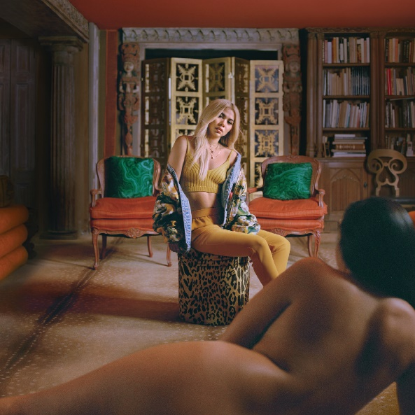
*Download Hi-Res Images HERE*

Atlantic recording artist Hayley Kiyoko has officially released her hugely anticipated debut album today. EXPECTATIONS, which includes the smash single, “Curious,” is available now at all music retailers and streaming services (Download/Stream HERE). In addition to “Curious,” the 13-track collection includes Kiyoko’s eagerly awaited collaboration, “What I Need” feat. Kehlani (Listen HERE).

“‘EXPECTATIONS’ has a level of maturity that I’ve never had before. There’s a sense of grounded confidence within the lyrics, the melodies, and the production. It’s very unwavering. This is what it is. Take it or leave it. It’s not that I wasn’t confident before, but that energy really exudes through the music now. It represents everything in my life from health to girls to loss.” – Hayley Kiyoko

Hayley is hitting both NYC and LA to celebrate the release of EXPECTATIONS. Last night, the singer/songwriter/actor/director packed the Samsung 837 space in New York City with fans and tastemakers, performing songs from the album for the first time live. Tonight, she’ll take over the YouTube Space in LA for “Expectations: A Hayley Kiyoko Music Video Retrospective,” sharing her journey with fans from her first video “Girls Like Girls” to the release of her debut album.

Just named as both MTV’s Global PUSH “Artist To Watch” and Fuse’s “Fuse First” for April 2018, Kiyoko will continue EXPECTATIONS album release week with her late-night TV debut, performing her smash single “Curious” for the first time ever on ABC’s Jimmy Kimmel Live!, set for Tuesday, April 3rd (check local listings).

Hayley will make her Coachella debut shortly after embarking on her nationwide EXPECTATIONS TOUR, which has already sold out two shows at New York City’s Irving Plaza, plus dates in Portland, Seattle, San Francisco, Chicago, Boston, Toronto, Philadelphia and more. For complete details and availability, please see attached itinerary and visit www.hayleykiyokoofficial.com. What’s more, Kiyoko was recently announced as special guest on Panic! At The Disco’s upcoming “Pray For The Wicked Tour,” getting underway July 11th at Minneapolis, MN’s Target Center and continuing through mid-August. Tickets for all “Pray For The Wicked Tour” dates go on sale to the general public today at 12 pm (local).

Kiyoko kicked off #20GAYTEEN (coined by Hayley and her fans) with current smash single, “Curious,” which heralded the official launch of EXPECTATIONS. Watch the video for “Curious,” which has amassed nearly 8 million views in under two months HERE. The relentlessly catchy single went on to receive the official remix treatments from Platinum-certified Philadelphia duo Marian Hill, producer/musician Sweater Beats, and Chicago dance duo Win and Woo.

Hayley has garnered critical acclaim for all album tracks unveiled leading up today’s official release including “Curious,” the recently released “Let It Be,” and fan favorites “Feelings” and “Sleepover.” Early on, Billboard cited “high expectations” for Kiyoko writing, “At this point, Hayley Kiyoko’s ascension to Billboard Hot 100 domination seems inevitable.” “Curious” was immediately placed upon The New York Times’ “The Playlist” and TIME Magazine’s “5 Songs You Need to Listen to this Week,” with Idolator declaring it “One Of The First Great Pop Songs Of 2018,”and The FADER praising the companion visual as “a beautifully shot commentary on the dynamics of queer love and the complicated laws of same-sex attraction.” Over the past several weeks, the outpour of support has not slowed down with publications continuing to rally passionately behind Hayley. Billboard recently placed EXPECTATIONS on their “Spring Album Preview” and Newsday published a glowing review writing, “(Expectations) doesn’t feel like a debut as much as it feels like the start of something big, comparable to Lady Gaga’s debut ‘The Fame,’ in the more carefree days before she became Mother Monster.”

CONNECT:
WEBSITE | FACEBOOK | TWITTER | INSTAGRAM | YOUTUBE | PRESS TOOLS

PRESS CONTACTS:
Chelsey Northern/Atlantic Records (NATIONAL)
chelsey.northern@atlanticrecords.com

Andrew George/Atlantic Records (TOUR/ONLINE)
andrew.george@atlanticrecords.com

HAYLEY KIYOKO
EXPECTATIONS NORTH AMERICAN TOUR 2018
* JULY 11-AUGUST 18 w/PANIC! AT THE DISCO “PRAY FOR THE WICKED” ARENA TOUR

APRIL
11 San Diego, CA Observatory North Park – SOLD OUT!
12 San Luis Obispo, CA The Fremont Theater
13 Santa Cruz, CA Rio Theatre – SOLD OUT!
15 Indio, CA Coachella Valley Music & Arts Festival
17 Portland, OR Wonder Ballroom – SOLD OUT!
18 Vancouver, BC Vogue Theatre
19 Seattle, WA The Showbox – SOLD OUT!
22 Indio, CA Coachella Valley Music & Arts Festival
24 San Francisco, CA The Fillmore – SOLD OUT!
25 Santa Ana, CA The Observatory – SOLD OUT!
27 Salt Lake City, UT The Depot
28 Denver, CO Summit Music Hall
30 Omaha, NE Waiting Room

MAY
1 Minneapolis, MN Varsity Theater – SOLD OUT!
3 Chicago, IL House of Blues – SOLD OUT!
4 St. Louis, MO Delmar Hall – SOLD OUT!
5 Lawrence, KS Granada Theater
7 Austin, TX Emo's
8 Houston, TX House of Blues
9 Dallas, TX Granada Theater
11 Atlanta, GA Buckhead Theatre
12 Orlando, FL The Beacham Theatre
13 St. Petersburg, FL Jannus Live

JUNE
1 Silver Spring, MD The Fillmore Silver Spring
2 Pittsburgh, PA Mr. Smalls Theatre
3 Toronto, ON Danforth Music Hall – SOLD OUT!
5 Cleveland, OH House of Blues
6 Detroit, MI St. Andrews Hall
8 Indianapolis, IN Deluxe – SOLD OUT!
9 Columbus, OH Newport Music Hall
11 Charlotte, NC The Underground – SOLD OUT!
12 Norfolk, VA The Norva
14 Philadelphia, PA Theatre of Living Arts – SOLD OUT!
15 Boston, MA Paradise Rock Club – SOLD OUT!
16 New York, NY Irving Plaza – SOLD OUT!
18 New York, NY Irving Plaza – SOLD OUT!

JULY
11 Minneapolis, MN Target Center
13 Indianapolis, IN Bankers Life Fieldhouse
14 Detroit, MI Little Caesars Arena
15 Columbus, OH Nationwide Arena
17 Chicago, IL United Center
18 Pittsburgh, PA PPG Paints Arena
20 Uniondale, NY NYCB Live: Nassau Coliseum
21 Baltimore, MD Royal Farms Arena
22 Toronto, ON Air Canada Centre
24 New York, NY Madison Square Garden
25 Boston, MA TD Garden
27 Philadelphia, PA Wells Fargo Center
28 Raleigh, NC PNC Arena
29 Duluth, GA Infinite Energy Center
31 Sunrise, FL BB&T Center

AUGUST
1 Tampa, FL Amalie Arena
3 Houston, TX Toyota Center
4 Dallas, TX American Airlines Center
5 Tulsa, OK BOK Center
7 Denver, CO Pepsi Center
8 Salt Lake City, UT Vivint Smart Home Arena
10 Seattle, WA KeyArena
11 Vancouver, BC Rogers Arena
12 Portland, OR Moda Center
14 San Jose, CA SAP Center
15 Los Angeles, CA STAPLES Center
17 Glendale, AZ Gila River Arena
18 Las Vegas, NV T-Mobile Arena

# # #

