FOR IMMEDIATE RELEASE

OCTOBER 19, 2017

**GET HOOKED ON HAYLEY KIYOKO’S BRAND NEW SONG “FEELINGS”**

*TRACK & VIDEO AVAILABLE NOW AT ALL DSPS*

**BREAKTHROUGH POP ARTIST PREMIERES FIRST SONG AND**

**SELF-DIRECTED VIDEO FROM HIGHLY ANTICIPATED DEBUT LP**

**ON MTV’S** [***TOTAL REQUEST LIVE***](https://youtu.be/G8R7jcEktTE)

**SET TO PERFORM AT NEW ORLEANS’ VOODOO MUSIC + ARTS EXPERIENCE**

**ON OCTOBER 28TH AND HEADLINE THE ICONIC EL REY THEATRE**

**IN LOS ANGELES ON NOVEMEBER 4TH**

**LISTEN** [**HERE**](https://Atlantic.lnk.to/feelings) **| WATCH** [**HERE**](https://atlanti.cr/watchfeelings)

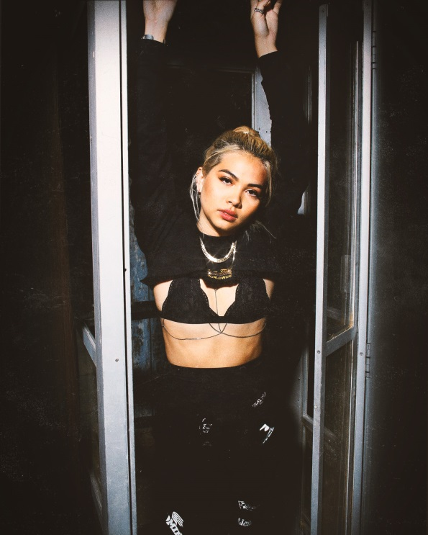

***\*****Download Hi-Res Images* [***HERE***](https://warnermusicgroup.box.com/s/8tymcgrq7ws2d7ed5vjod6d0h5nittbr)***\****

Atlantic recording artist **Hayley Kiyoko** has unveiled her catchy new song “[Feelings](https://Atlantic.lnk.to/feelings)” – the first track from her highly anticipated debut album is available now via all digital music retailers and streaming services. Earlier today, Hayley premiered her brand new song along with the self-directed music video on MTV’s [*Total Request Live*](https://youtu.be/G8R7jcEktTE). [*BuzzFeed*](https://www.buzzfeed.com/skarlan/hayley-kiyokos-new-video-is-for-all-the-girls-out-there?utm_term=.igqaLzY0LY#.yfV1ZJr6Zr) has already applauded the video for its “unapologetic, real, and honest representation.” Watch the companion video, which captures all of the “feelings” associated with a budding romance, on Hayley’s official [YouTube](youtube.com/user/TheHayleyKiyokoVEVO) channel [HERE](https://atlanti.cr/watchfeelings).

Hayley is set to celebrate the release of “Feelings” with a performance at Voodoo Music + Arts Experience in New Orleans, LA on Saturday, October 28th. Shortly thereafter, Hayley will return to Los Angeles to headline El Rey Theatre on Saturday, November 4th. For complete details, ticket information, and additional announcements, please visit [www.hayleykiyokoofficial.com](http://www.hayleykiyokoofficial.com/).

The release of “Feelings” follows an already massive year for the rising singer/songwriter/director who was recently featured as one of *Rolling Stone’s* [“10 New Artists You Need To Know.”](https://protect-us.mimecast.com/s/EJ4lBOSo5nVdtr) At the end of 2016, Hayley celebrated the release of her label debut EP [***CITRINE***](https://protect-us.mimecast.com/s/nKAlB9FlDwVNf6)***,*** which reached the top 5 on Billboard’s “Heatseekers” chart and features the acclaimed singles and self-directed companion visuals, “[One Bad Night](https://www.youtube.com/watch?v=L_wXWFnTjxU)” and “[Gravel To Tempo](https://www.youtube.com/watch?v=XOm2rGwmhWg), by launching the first leg of her nationwide “One Bad Night Tour.” The completely sold out headline tour saw Hayley performing her new music for her passionate and devoted fans in multiple cities throughout the US. According to [Baeble](https://www.baeblemusic.com/musicblog/3-29-2017/hayley-kiyoko-creates-a-safe-space-at-the-bowery-ballroom.html), “Hayley Kiyoko’s music acts as a safe space for the LGBTQ community.”

This past spring, just before embarking upon the second leg of her “One Bad Night Tour,” which included a stop at NYC’s famed Bowery Ballroom in addition to performances down in Austin at SXSW, Hayley unleashed the again self-directed video for her song “[Sleepover](https://www.youtube.com/watch?v=W6jxPFtIAnw&feature=youtu.be),” which arrived amidst widespread media attention from outlets such as [Pop Crush](http://popcrush.com/hayley-kiyoko-sleepover-video-lgbtq-review-watch/), which highly praised the single as “a poignant piece of pro-LGBTQ art… set against a hazy, humid electronic soundscape of drowsy mid-tempo beats and flickering guitar twinkles.” To date, Hayley’s self-directed music videos have collectively amassed over 125 million views on YouTube.

**\*STAY TUNED FOR MORE INFO ON HAYLEY KIYOKO\***

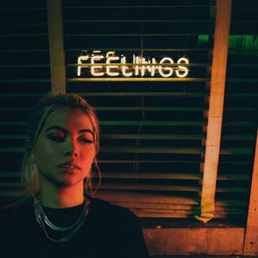

[WEBSITE](http://www.hayleykiyokoofficial.com/) | [FACEBOOK](facebook.com/HayleyKiyoko) | [TWITTER](twitter.com/hayleykiyoko) | [INSTAGRAM](instagram.com/kiyoko11) | [YOUTUBE](youtube.com/user/TheHayleyKiyokoVEVO)

**PRESS ASSETS:**

press.atlanticrecords.com/hayley-kiyoko/

**PRESS CONTACTS:**

Chelsey Northern/Atlantic Records (NATIONAL)

[chelsey.northern@atlanticrecords.com](mailto:chelsey.northern@atlanticrecords.com)

Andrew George/Atlantic Records (TOUR/ONLINE)

[andrew.george@atlanticrecords.com](mailto:andrew.george@atlanticrecords.com)