FOR IMMEDIATE RELEASE
MARCH 3, 2021

HAYLEY KIYOKO LAUNCHES NEW FRAGRANCE “HUE”
IN PARTNERSHIP WITH SLATE BRANDS

“HUE” BY HAYLEY KIYOKO IS AVAILABLE NOW HERE

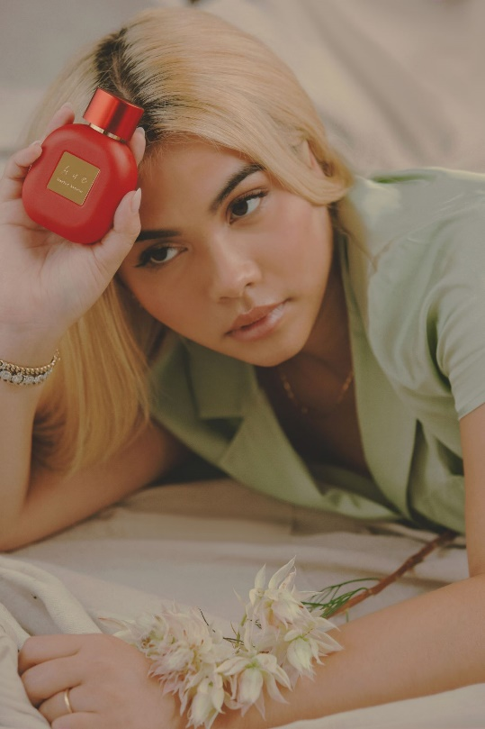
(CREDIT: TREVOR FLORES – DOWNLOAD HIGH RES IMAGES)

“…designed to be a gender-neutral scent of ‘armor’…the end goal is to strike a balance that welcomes anyone that wants to be a part of it.”
– VOGUE

“Kiyoko's gender-inclusive fragrance ‘HUE’ mirrors her commitment to self-empowerment, expression, and creating a safe space for all to find and celebrate themselves – specifically those in the LGBTQ+ community – in all other areas of her art.”
– NYLON

“A fragrance that brings confidence and empowerment with every spritz.”
– TEEN VOGUE

Trailblazing pop star Hayley Kiyoko’s new gender-inclusive fragrance, “HUE,” has officially arrived. Powered by Warner Music Artist Services, Atlantic Records and Brands With Purpose in collaboration with Slate Brands, “HUE” is available to order now at huebyhayley.com. HUE-branded merchandise items are also available today at hayleykiyokoofficial.com/store. All merchandise purchases include a limited-edition HUE-scented bracelet.

“Perfume has been a massive part of my queer experience,” Hayley told Vogue during last month’s exclusive announcement interview. “I remember feeling famous in middle school because girls said that I smelled good. They wouldn’t date me. They didn’t have crushes on me. But they said I smelled good, and that was like a huge thing for me, and I’ve carried that throughout my life. I want to give that power and that armor to my fans, even if they’re sitting at home!”

An audacious scent designed as an expression of liberation, freedom, and self-empowerment, “HUE” is packaged with a vibrant portrait of Hayley designed by illustrator Liz Hirsch, exemplifying the variety of hues within every individual. As an artist determined to create a safe space for the LGBTQ+ community throughout her body of work, it was imperative that Kiyoko’s first fragrance embody that same spirit of acceptance and inclusivity.

Since the initial pre-order announcement, “HUE” has received coverage from a variety of high-profile publications including Allure, NYLON, Teen Vogue, Glamour, Cosmopolitan, PAPER, Page Six Style and more. With its irresistible, floral, and fruity aroma, “HUE” embodies Hayley’s very essence from start to finish. Bold, energetic, and just a little disruptive, sparkling top notes of blood orange, watermelon and freesia unfold into an expressive, feminine heart of blooming peony petals, lychee, rose and pink magnolia. Warm and cocooning, the background develops into a simple aphrodisiac, as milky undertones of creamy cacao blanc merge with a soft, sensual trail of skin musk.

“HUE” was created by Kiyoko in collaboration with perfumer Constance Georges-Picot of Cosmo Fragrances and developmental support by Bart Schmidt. Atlantic Records worked with Warner Music Artist Services and Brands With Purpose to facilitate Hayley’s partnership with Slate Brands. A concentrated eau de parfum designed for longer wear and enhanced ambrosial notes, “HUE” includes many of Slate Brands’ exclusive ingredients, including Rose and Cacao Blanc Craftivity®, and is also vegan, cruelty-free, phthalate-free, and paraben-free.

“Like Hayley, we wanted the fragrance to be an expression of liberation, freedom, and self-empowerment,” says Constance. “‘Not easily defined, complicated, powerful and worthy’ were things Hayley reiterated numerous times.”

“Hayley is the perfect partner since she knows exactly what she wants and takes control of the creative process,” says Slate Brands’ Judah Abraham. “To create ‘HUE,’ she met numerous times with the creative team and the perfumers. The pandemic made it all a bit more challenging to connect and meet, but we had plenty of virtual get-togethers and smelling sessions.”

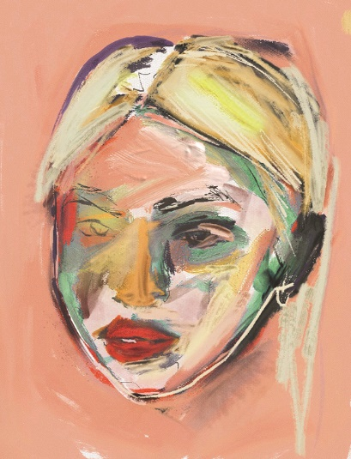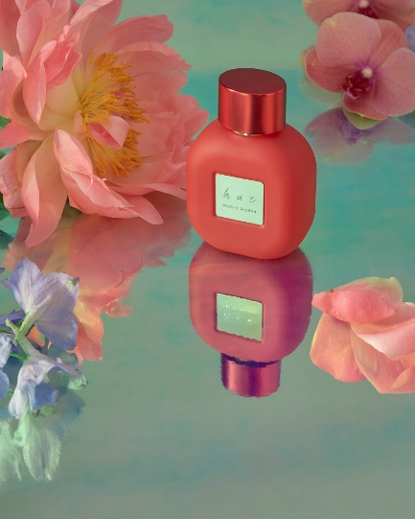
(ILLUSTRATION CREDIT: LIZ HIRSCH – BOTTLE IMAGE CREDIT: DOAN LY)

ABOUT HAYLEY KIYOKO
Hayley Kiyoko has become one of the most celebrated pop artists since releasing 2018’s landmark debut album EXPECTATIONS, which according to Rolling Stone, placed her “at the forefront of an unapologetically queer pop movement.” In #20GAYTEEN, Kiyoko was nominated for two VMAs where she performed “Curious” and won Push Artist Of The Year. Since her 2015 debut, Hayley has amassed over 780 million global streams, over 2.1 million YouTube subscribers and has accrued over 730 million lifetime YouTube views, in addition to selling out numerous venues across the country and abroad on her previous headline tour. Lauded as one of “The 21st Century's Most Influential Women Musicians” by NPR among other milestones, Hayley continues to impact and inspire her community. Through her honest storytelling and lyricism, she encourages hope as her resounding message. Last year, the pop star unveiled her newest collection of songs, I’M TOO SENSITIVE FOR THIS SHIT.

CONNECT WITH HAYLEY KIYOKO:
WEBSITE | FACEBOOK | TWITTER | INSTAGRAM | YOUTUBE | PRESS ASSETS

CONNECT WITH HUE:
WEBSITE | INSTAGRAM

ABOUT SLATE BRANDS, INC.
Slate Brands is a full-service beauty marketing and branding agency that gives celebrities, brands, influencers and entrepreneurs looking to enter the beauty space the freedom to take the creative lead with their own beauty brands. The company’s expertise extends across several beauty categories including fragrance, skin, color cosmetics, hair, nails, beauty tools, and supplements. Slate’s brand development services include private label, brand incubation for new-to-market beauty lines, exclusive celebrity and influencer products, as well as in-house brands developed exclusively by the company.

CONTACTS:

For Hayley Kiyoko Press Inquiries, Please Contact:
Andrew George
Atlantic Records
andrew.george@atlanticrecords.com

Slate Brands, Inc.
Rachael Guida
Head of Marketing and PR
rachael@slatebrands.com

