FOR IMMEDIATE RELEASE

MAY 31, **#20GAYTEEN**

**HAYLEY KIYOKO PREMIERES SELF-DIRECTED COMPANION VISUAL FOR**

**NEWEST SINGLE “WHAT I NEED” (FEAT. KEHLANI)**

**EPIC VIDEO STARRING BOTH ARTISTS LAUNCHES ON THE EVE OF PRIDE MONTH**

**NATIONWIDE HEADLINE TOUR CONTINUES THROUGH JUNE, ENDING WITH**

**TWO SOLD-OUT IRVING PLAZA SHOWS JUNE 16TH &18TH**

**KIYOKO TO PERFORM ON *LATE NIGHT WITH SETH MEYERS* ON JUNE 19TH**

**WATCH THE VIDEO FOR “WHAT I NEED” HERE:** <https://atlanti.cr/whatineed>

***EXPECTATIONS* IS AVAILABLE NOW; LISTEN HERE:** <https://atlantic.lnk.to/Expectations>

[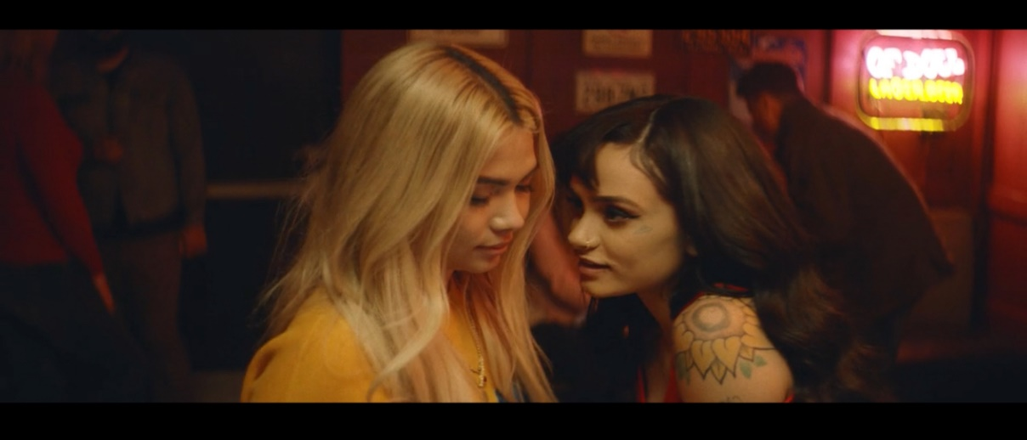](https://atlanti.cr/whatineed)

*Download Hi-Res Image [HERE](https://warnermusicgroup.box.com/s/mccp1nfbd7t3lmrn5dg5obhdnr8bm5om)*

This spring, Atlantic recording artist **Hayley Kiyoko** tapped R&B powerhouse Kehlani for “What I Need,” the only collaboration on her critically-acclaimed debut album *Expectations.* Today, on the eve of Pride Month, the rising pop star debuts the epic, self-directed companion video starring both artists. Watch “What I Need” here: <https://atlanti.cr/whatineed>

Back in December, Hayley and Kehlani drove up to beautiful Ojai, CA to film what would become the song’s gorgeous visual. In typical Hayley fashion, the video is yet another beautifully shot narrative, complete with her signature color palette, and like many of her previously self-directed music videos, takes form in the shape of a short film. It centers around two young women, one of whom, portrayed by Kehlani, is clearly struggling to connect with her aunt and finds an escape through her relationship with her childhood best friend, played by Hayley. In the end, it’s a love story that illuminates the importance of having someone close to you, who cares for you in times of need without judgment and supports you no matter what.

Tomorrow, Kiyoko will kick off the second leg of her nationwide EXPECTATIONS TOUR, which has been selling out every date and racking up rave live reviews. After her headline tour concludes, Kiyoko will embark on her first-ever arena tour as a special guest on Panic! At The Disco’s upcoming “Pray For The Wicked Tour,” getting underway July 11th at Minneapolis, MN’s Target Center and continuing through mid-August. Tickets for all “Pray For The Wicked Tour” dates go on sale to the general public today at 12 pm (local). For complete details and availability, see attached itinerary and visit [www.hayleykiyokoofficial.com](https://protect-us.mimecast.com/s/vFlUCKr5Q0IPE2jRS5PhI9).

On June 19th, Hayley will return to late night TV for a special performance on NBC’s *The Late Show with Seth Meyers*, airing at 12:35/11:35c on NBC. This follows her applauded late-night debut in April on ABC’s *Jimmy Kimmel Live!*, where she won over the audience performing her single “[Curious](https://youtu.be/o6V2ikO_CDY)” and fan-favorite “[Let It Be](https://youtu.be/p6za96Pi9wc).”

Hayley has been taking #20GAYTEEN by storm with her debut album *EXPECTATIONS*, which has propelled her into one of the most celebrated new artists in the pop landscape. According to *Rolling Stone*, “her latest singles – ‘Curious’ and ‘What I Need’ (featuring Kehlani) – have placed her at the forefront of an apologetically queer pop movement, and she turned 2018 into "#20GayTeen" with the release of her long-awaited debut LP.” *Billboard* goes on to say, “the record solidifies Kiyoko as one of the few modern artists who is able to unapologetically capture the queer female experience through pop music,” while *GQ* writes “Not only is Kiyoko one of the only openly queer pop stars signed to a major label, she’s a major pop force to be reckoned with all labels aside.” Perhaps *Teen Vogue* sums it up best, declaring *EXPECTATIONS* “an unapologetically queer pop masterpiece for 20gay-teen.”

“What I Need” is Kiyoko’s newest single following “[Curious](https://atlantic.lnk.to/curiousID),” which heralded the official launch of *EXPECTATIONS* in January. Watch the video for “Curious,” which has  gone on to amass nearly 11 million views [HERE](https://www.youtube.com/watch?v=YXTzMOmmEfE). Upon release, “Curious” was immediately placed upon *The New York Times*’ “[The Playlist](https://www.nytimes.com/2018/01/12/arts/music/playlist-black-eyed-peas-lil-peep-carrie-underwood.html)” and *TIME Magazine*’s “[5 Songs You Need to Listen to this Week](http://time.com/5101034/5-songs-you-need-to-listen-to-this-week-37/),” with [Idolator](http://www.idolator.com/7673809/hayley-kiyoko-curious-video-review) declaring it “One Of The First Great Pop Songs Of 2018,” and [*The FADER*](http://www.thefader.com/2018/01/13/hayley-kiyoko-curious-video) praising the companion visual as “a beautifully shot commentary on the dynamics of queer love and the complicated laws of same-sex attraction.”

**CONNECT WITH HAYLEY KIYOKO:**

[WEBSITE](http://www.hayleykiyokoofficial.com/) | [FACEBOOK](https://www.facebook.com/HayleyKiyoko/) | [TWITTER](https://twitter.com/HayleyKiyoko) | [INSTAGRAM](https://www.instagram.com/hayleykiyoko/) | [YOUTUBE](https://www.youtube.com/channel/UC00X4AUEmat8Pk772tDu8OA) | [PRESS TOOLS](http://press.atlanticrecords.com/hayley-kiyoko/)

**PRESS CONTACTS:**

Chelsey Northern/Atlantic Records (NATIONAL)

chelsey.northern@atlanticrecords.com

Andrew George/Atlantic Records (TOUR/ONLINE)

[andrew.george@atlanticrecords.com](mailto:andrew.george@atlanticrecords.com)

**HAYLEY KIYOKO**

**EXPECTATIONS NORTH AMERICAN TOUR 2018**

***\* JULY 11-AUGUST 18 w/PANIC! AT THE DISCO “PRAY FOR THE WICKED” ARENA TOUR***

**JUNE**

1              Silver Spring, MD                        The Fillmore Silver Spring – SOLD OUT!

2              Pittsburgh, PA                              Mr. Smalls Theatre – SOLD OUT!

3              Toronto, ON                           Danforth Music Hall – SOLD OUT!

5              Cleveland, OH                             House of Blues

6              Detroit, MI                                St. Andrews Hall – SOLD OUT!

8              Indianapolis, IN                            The Egyptian Room – SOLD OUT!

9              Columbus, OH                           Newport Music Hall – SOLD OUT!

11           Charlotte, NC                               The Underground – SOLD OUT!

12           Norfolk, VA                                The Norva

14           Philadelphia, PA                         Theatre of Living Arts – SOLD OUT!

15           Boston, MA                               Paradise Rock Club – SOLD OUT!

16           New York, NY                                Irving Plaza – SOLD OUT!

18           New York, NY                             Irving Plaza – SOLD OUT!

**JULY**

11           Minneapolis, MN                        Target Center

13           Indianapolis, IN                           Bankers Life Fieldhouse

14           Detroit, MI                                 Little Caesars Arena

15           Columbus, OH                            Nationwide Arena

17           Chicago, IL                                  United Center

18           Pittsburgh, PA                             PPG Paints Arena

20           Uniondale, NY                              NYCB Live: Nassau Coliseum

21           Baltimore, MD                             Royal Farms Arena

22           Toronto, ON                              Air Canada Centre

24           New York, NY                              Madison Square Garden

25           Boston, MA                               TD Garden

27           Philadelphia, PA                          Wells Fargo Center

28           Raleigh, NC                                PNC Arena

29           Duluth, GA                                Infinite Energy Center

31           Sunrise, FL                                 BB&T Center

**AUGUST**

1             Tampa, FL                                Amalie Arena

3             Houston, TX                              Toyota Center

4             Dallas, TX                                  American Airlines Center

5             Tulsa, OK                                   BOK Center

7             Denver, CO                                 Pepsi Center

8             Salt Lake City, UT                        Vivint Smart Home Arena

10           Seattle, WA                                  KeyArena

11           Vancouver, BC                               Rogers Arena

12           Portland, OR                                 Moda Center

14           San Jose, CA                                  SAP Center

15           Los Angeles, CA                             STAPLES Center

17           Glendale, AZ                                 Gila River Arena

18           Las Vegas, NV                                T-Mobile Arena

25 Asbury Park, NJ Shadow Of The City Festival

# # #