FOR IMMEDIATE RELEASE
SEPTEMBER 28, 2018

KEVIN GATES IS BACK WITH LUCA BRASI 3

MULTI-PLATINUM ARTIST DROPS FIRST MIXTAPE SINCE PRISON RELEASE EARLIER THIS YEAR

DEFINITIVE INTERVIEW WITH SWAY – COVERING COLIN KAEPERNICK, LIL WAYNE, POLICE BRUTALITY, BEING PUT IN LOCKDOWN + MORE – COMING SOON

THE LUCA BRASI 3 TOUR GETS UNDERWAY OCTOBER 2ND

LISTEN TO LUCA BRASI 3 HERE
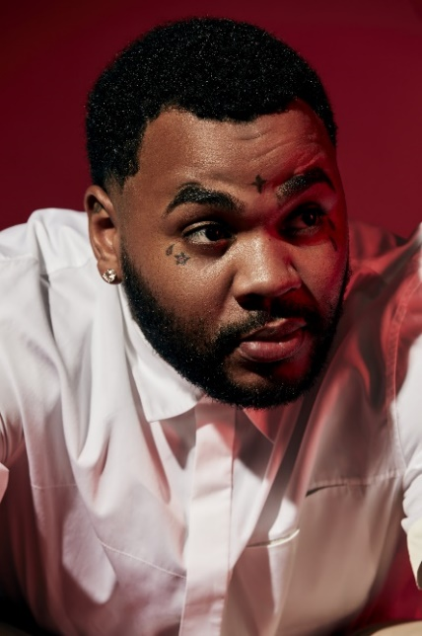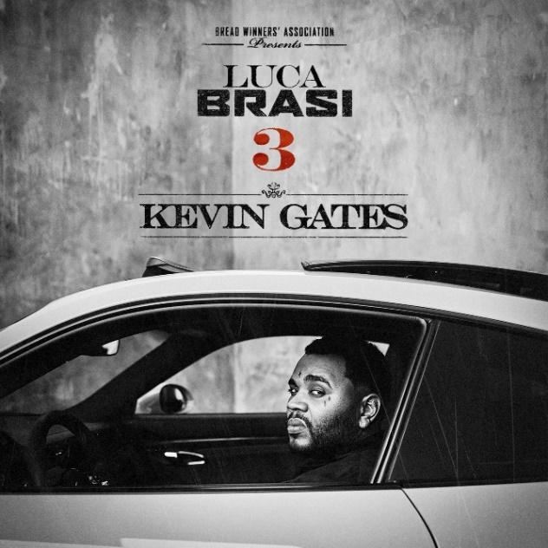
*Download Artwork*

Multi-Platinum artist Kevin Gates is back. Today, the hugely successful, yet controversial rapper drops his highly-anticipated new mixtape Luca Brasi 3, the first project since his release from prison earlier this year. Luca Brasi 3 - the third installment of Gates’ breakout mixtape The Luca Brasi Story - is now streaming at all DSPs. Listen HERE.

Gates has been rolling out Luca Brasi 3 over the past few weeks, giving fans a taste of the mixtape with an array of tracks including “Adding Up,” “Me Too,” “Money Long” and “Great Man.” Each new song released shows a different side of Kevin, alluding to the variety of themes the multi-faceted rapper explores on Luca Brasi 3, an 18-track collection with no features. Gates’ debut album ISLAH also did not include any featured artists and went Platinum the same year it was released, cementing Kevin as one of the best-selling hip-hop artists of 2016, second only to Drake.

So far the tracks released from Luca Brasi 3 have received praise from fans and media alike, with XXL declaring, “if they serve as any indication, we have a lot to be excited for.” “Sounds like Gates is in top form,” they continued with SPIN claiming, “Both (songs) are quintessential Gates: melancholic trap songs punctuated by his partially crooned, highly emotive raps.”

On the cusp of the arrival of Luca Brasi 3, Gates sat down with longtime friend and brother Sway for an unprecedented interview addressing many topics he’s never discussed. In the interview that will be released soon, Gates discusses everything from his time working with Young Money, Birdman and Lil Wayne, to the incident in Florida; from being put in lockdown while in prison to his pilgrimage to Mecca; from taking his kids to school for the first time to his thoughts on Colin Kaepernick and police brutality; and more. Gates unveiled the first excerpt this week, speaking about “the scariest moment of his life” sitting at a table across from Lil Wayne. Watch HERE.

To celebrate the upcoming release of Luca Brasi 3, the Bread Winners’ Association MC will hit the road on the “LUCA BRASI 3 TOUR,” with dates kicking off October 2nd in Austin, TX and continuing through November 3rd in Wichita, KS (see full itinerary below). For more information, visit www.kvngates.com. Gates recently took the stage at Rolling Loud festival in Oakland and charmed the audience with his deep catalogue of hits. Check out a recap on Gates’ Instagram here.

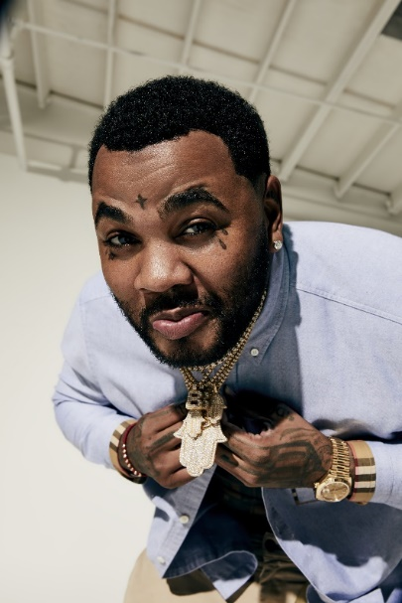
ABOUT KEVIN GATES
Gates made history with this debut album ISLAH, which was released in January 2016 and cemented Kevin as one of the best-selling hip-hop artists of 2016, second only to Drake. The critically acclaimed debut album was certified platinum by the RIAA for sales in excess of 1 million – 2016’s only debut album to receive platinum certification within one year. One of the rare major hip-hop releases to contain no featured artists, ISLAH made an incredible chart debut, entering Billboard’s “Top Rap Albums” chart at #1 while also coming in at #2 on the Billboard 200. “ISLAH” received critical acclaim cementing its place as a milestone hip-hop release, named among 2016’s top 50 releases by both Billboard and Complex. “‘ISLAH’ is a sustained and triumphant outpouring,” declared Pitchfork in a “Best New Music” 8.5-out-of-10 rave review, “and Gates gives every good, bad, and ugly thing he has. It’s by far the best single release of his career.” The album earned Gates a nomination for Best Rap Album at the 2017 Billboard Music Awards.

While incarcerated by the Illinois Board of Corrections, Gates surprised fans around the world with the September 2017 release of BY ANY MEANS 2, which debuted at No. 4 on the Billboard 200. Gates launched the BY ANY MEANS 2 mixtape with an emotional visual for his acclaimed single “What If” and a deeply personal handwritten message posted on his official Instagram – Gates’ first public statement since his October 2016 imprisonment. Following “What If” came two more emotional and personal visuals for both “Imagine That,” and “Had To.”

MORE ON KEVIN GATES
PRESS PHOTOS // ARTWORK // INSTAGRAM
WEBSITE // TWITTER // YOUTUBE // OFFICIAL BWA // ATLANTIC RECORDS
KEVIN GATES
LUCA BRASI 3 TRACKLIST

1. Discussion
2. Shakin Back
3. Ridiculous
4. Money Long
5. I Got U
6. Great Man
7. Find You Again
8. Adding Up
9. In God I Trust
10. Me Too
11. Servin H
12. Wrong Love
13. Luca Brasi Freestyle
14. Shoulda
15. Kung Fu
16. Don’t Know
17. Tryna Yea
18. M.A.T.A.
KEVIN GATES
LUCA BRASI 3 TOUR 2018
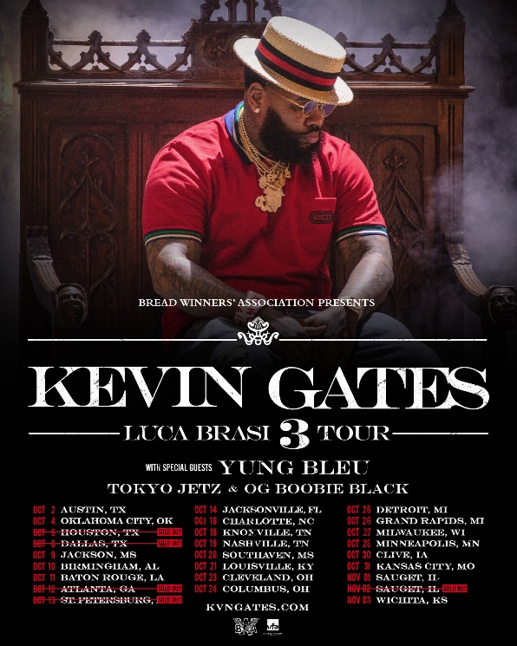

DATE CITY VENUE
2-Oct Austin, TX ACL The Moody Theater
4-Oct Oklahoma City, OK The Criterion
5-Oct Houston, TX Revention Music Center [SOLD OUT]
6-Oct Dallas, TX The Bomb Factory [SOLD OUT]
9-Oct Jackson, MS Thalia Mara Hall
10-Oct Birmingham, AL BJCC Concert Hall
11-Oct Baton Rouge, LA Raising Cain's River Center
12-Oct Atlanta, GA Tabernacle [SOLD OUT]
13-Oct St. Petersburg, FL Jannus Live [SOLD OUT]
14-Oct Jacksonville, FL Moran Theater
16-Oct Charlotte, NC Ovens Auditorium
18-Oct Knoxville, TN Knoxville Civic Coliseum
19-Oct Nashville, TN Nashville Municipal Auditorium
20-Oct Southaven, MS Landers Center
21-Oct Louisville, KY The Bourbon Hall
23-Oct Cleveland, OH Agora Ballroom
24-Oct Columbus, OH Express Live!
25-Oct Detroit, MI Royal Oak Music Theatre
26-Oct Grand Rapids, MI 20 Monroe Live
27-Oct Milwaukee, WI The Eagles Ballroom
28-Oct Minneapolis, MN Myth Live
30-Oct Clive, IA Seven Flags Event Center
31-Oct Kansas City, MO Uptown Theater
1-Nov Sauget, IL Pop's
2-Nov Sauget, IL Pop's [SOLD OUT]
3-Nov Wichita, KS The Cotillion Ballroom

