FOR IMMEDIATE RELEASE
SEPTEMBER 20, 2018

KEVIN GATES REVEALS ANOTHER NEW TRACK FROM LUCA BRASI 3
LISTEN TO THE PLAYFUL “ME TOO” HERE
GATES’ FIRST MIXTAPE SINCE PRISON RELEASE WILL ARRIVE SEPTEMBER 27TH

THE LUCA BRASI 3 TOUR GETS UNDERWAY OCTOBER 2ND

“ME TOO” FOLLOWS NEW TRACKS “MONEY LONG” AND “GREAT MAN” FROM LUCA BRASI 3
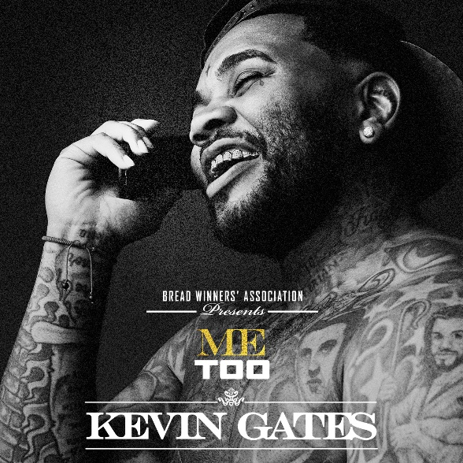
*Download Artwork*

The rollout of Kevin Gates’ highly-anticipated new mixtape Luca Brasi 3 continues today with another brand-new track called “Me Too,” which is available now at all DSPs. Listen HERE. Luca Brasi 3 – Gates’ first mixtape since his release from prison earlier this year, and the third installment of Gates’ breakout mixtape The Luca Brasi Story – will arrive everywhere September 27th.

In “Me Too,” we hear Gates turn back to his romantic, sexual side with lyrics like, “She says, ‘bae I’m nasty,’ I say, ‘me too.’ Girl you addicted, and I need you.” In classic Gates style, the rapper sings about themes he’s never shied away from, like sucking his woman’s toes and having sex in public.

Last week, Gates launched Luca Brasi 3 with two new tracks, “Money Long” and “Great Man,” to praise from fans and critics alike, with the latter garnering attention from celebrities from New York Giants wide receiver Odell Beckham Jr. to rapper Plies and singer Monica Brown.

Both songs have received media applause with XXL declaring, “if they serve as any indication, we have a lot to be excited for.” “Sounds like Gates is in top form,” they continued with SPIN claiming, “Both (songs) are quintessential Gates: melancholic trap songs punctuated by his partially crooned, highly emotive raps.” Listen to “Money Long” and “Great Man” HERE. Watch the official video for “Money Long” HERE.
The launch of Luca Brasi 3 came on the heels of two massive milestones for the controversial, multi-platinum rapper, an RIAA Platinum certification for Luca Brasi 2 and an RIAA Gold certification for By Any Means. Both mixtapes were released in 2014 and received widespread critical acclaim further cementing Gates presence in hip-hop as a undeniable star. The mixtape came prior to Gates’ debut album ISLAH, which received RIAA Platinum certification the same year it was released, 2016.

This past weekend, Gates took the stage at Rolling Loud festival in Oakland and charmed the audience with his deep catalogue of hits. Check out a recap on Gates’ Instagram here. To celebrate the upcoming release of Luca Brasi 3, the Bread Winners’ Association MC will hit the road on the “LUCA BRASI 3 TOUR,” with dates kicking off October 2nd in Austin, TX and continuing through November 3rd in Wichita, KS (see full itinerary below). For more information, visit www.kvngates.com.

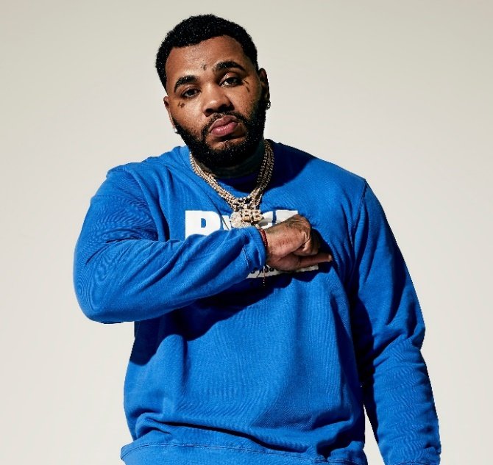

ABOUT KEVIN GATES
Gates made history with this debut album ISLAH, which was released in January 2016 and cemented Kevin as one of the best-selling hip-hop artists of 2016, second only to Drake. The critically acclaimed debut album was certified platinum by the RIAA for sales in excess of 1 million – 2016’s only debut album to receive platinum certification within one year. One of the rare major hip-hop releases to contain no featured artists, ISLAH made an incredible chart debut, entering Billboard’s “Top Rap Albums” chart at #1 while also coming in at #2 on the Billboard 200. “ISLAH” received critical acclaim cementing its place as a milestone hip-hop release, named among 2016’s top 50 releases by both Billboard and Complex. “‘ISLAH’ is a sustained and triumphant outpouring,” declared Pitchfork in a “Best New Music” 8.5-out-of-10 rave review, “and Gates gives every good, bad, and ugly thing he has. It’s by far the best single release of his career.” The album earned Gates a nomination for Best Rap Album at the 2017 Billboard Music Awards.

While incarcerated by the Illinois Board of Corrections, Gates surprised fans around the world with the September 2017 release of BY ANY MEANS 2, which debuted at No. 4 on the Billboard 200. Gates launched the BY ANY MEANS 2 mixtape with an emotional visual for his acclaimed single “What If” and a deeply personal handwritten message posted on his official Instagram – Gates’ first public statement since his October 2016 imprisonment. Following “What If” came two more emotional and personal visuals for both “Imagine That,” and “Had To.”

MORE ON KEVIN GATES
PRESS PHOTO // ARTWORK // INSTAGRAM
WEBSITE // TWITTER // YOUTUBE // OFFICIAL BWA // ATLANTIC RECORDS
KEVIN GATES
LUCA BRASI 3 TOUR 2018
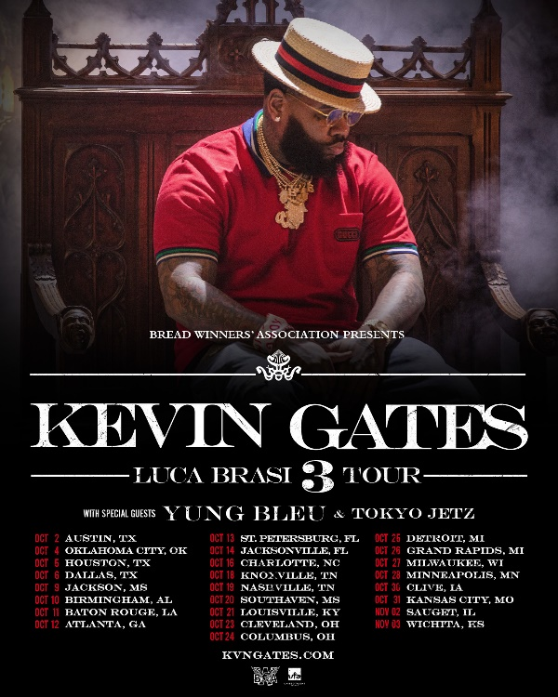

DATE CITY VENUE
2-Oct Austin, TX ACL The Moody Theater
4-Oct Oklahoma City, OK The Criterion
5-Oct Houston, TX Revention Music Center
6-Oct Dallas, TX The Bomb Factory
9-Oct Jackson, MS Thalia Mara Hall
10-Oct Birmingham, AL BJCC Concert Hall
11-Oct Baton Rouge, LA Raising Cain's River Center
12-Oct Atlanta, GA Tabernacle
13-Oct St. Petersburg, FL Jannus Live
14-Oct Jacksonville, FL Moran Theater
16-Oct Charlotte, NC Ovens Auditorium
18-Oct Knoxville, TN Knoxville Civic Coliseum
19-Oct Nashville, TN Nashville Municipal Auditorium
20-Oct Southaven, MS Landers Center
21-Oct Louisville, KY The Bourbon Hall
23-Oct Cleveland, OH Agora Ballroom
24-Oct Columbus, OH Express Live!
25-Oct Detroit, MI Royal Oak Music Theatre
26-Oct Grand Rapids, MI 20 Monroe Live
27-Oct Milwaukee, WI The Eagles Ballroom
28-Oct Minneapolis, MN Myth Live
30-Oct Clive, IA Seven Flags Event Center
31-Oct Kansas City, MO Uptown Theater
2-Nov Sauget, IL Pop's
3-Nov Wichita, KS The Cotillion Ballroom

