FOR IMMEDIATE RELEASE
SEPTEMBER 13, 2018

MULTI-PLATINUM RAPPER KEVIN GATES UNVEILS FIRST TWO SONGS FROM
HIGHLY-ANTICIPATED NEW MIXTAPE LUCA BRASI 3

GATES’ FIRST MIXTAPE SINCE PRISON RELEASE WILL OFFICIALLY ARRIVE SEPTEMBER 27TH

PREVIOUS MIXTAPES LUCA BRASI 2 AND BY ANY MEANS RECEIVE PLATINUM AND GOLD RIAA CERTIFICATIONS, RESPECTIVELY

GATES TO PERFORM AT OAKLAND’S ROLLING LOUD FESTIVAL THIS SATURDAY 9/15, FOLLOWED BY THE LAUNCH OF THE LUCA BRASI 3 TOUR KICKING OFF OCTOBER 2ND

WATCH THE OFFICIAL VIDEO FOR “MONEY LONG” HERE

*LISTEN TO “MONEY LONG” + “GREAT MAN”*
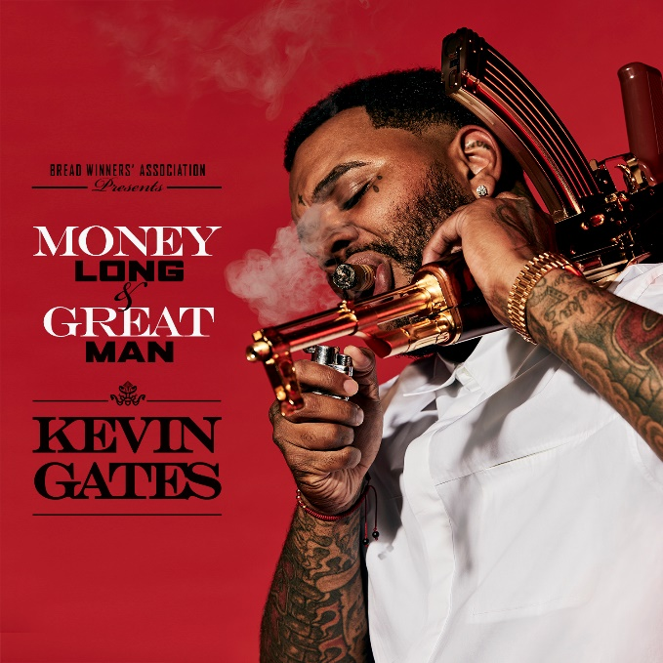
*Download Artwork*

The rollout of Kevin Gates’ highly-anticipated first mixtape since his release from prison earlier this year has officially begun. The controversial, multi-platinum rapper unveils two brand new tracks today – “Money Long” and “Great Man” – and announces the release date of Luca Brasi 3, arriving everywhere September 27th. Luca Brasi 3 is the third installment of Gates’ breakout mixtape The Luca Brasi Story, which first put the artist on the map in 2013. Listen to “Money Long” and “Great Man” HERE. Watch the official video for “Money Long” HERE.

The announcement comes on the heels of two massive milestones for Gates, an RIAA Platinum certification for Luca Brasi 2 and an RIAA Gold certification for By Any Means. Both mixtapes were released in 2014 and received widespread critical acclaim further cementing Gates presence in hip-hop as a undeniable star. The mixtape came prior to Gates’ debut album ISLAH, which received RIAA Platinum certification the same year it was released, 2016.

Gates has a number of live music appearances slated to celebrate the upcoming release of Luca Brasi 3. This Saturday, the Bread Winners’ Association MC will take the stage at Rolling Loud Festival, before hitting the road on the “LUCA BRASI 3 TOUR,” with dates kicking off October 2nd in Austin, TX and continuing through November 3rd in Wichita, KS (see full itinerary below). For more information, visit www.kvngates.com.

The Bread Winners Association MC returned to music earlier this summer with CHAINED TO THE CITY, Gates first release after 15 months of incarceration. On the first week of release, two of the three tracks from “Chained To The City” made remarkable debuts on the Billboard Hot 100 chart. With “Change Lanes” and “Let It Sing” debuting at No. 68 and No. 82, respectively, Gates redeclared he is a major force to be reckoned with. Gates launched “Chained To The City” with a video by Chicago native Cole Bennett for “Change Lanes,” which garnered over 1 million views in the first day and has now climbed to nearly 34 million views since its release. Watch “Change Lanes” HERE.

Most recently, Gates unveiled a new video for “Vouch,” where he took to the streets of Watts, Los Angeles, proving Gates is welcomed and shown love in any neighborhood. Directed by Julien Soulier, the video features Kevin in his most natural element, connecting with a community of characters including Compton native Demar Derozan, pro NBA player for the San Antonio Spurs. Watch “Vouch” HERE.

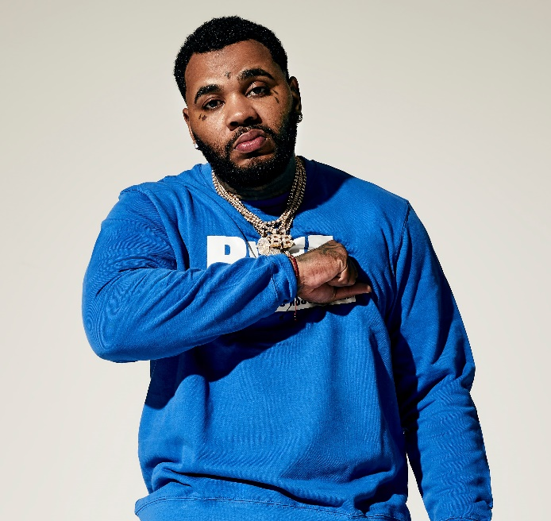

ABOUT KEVIN GATES
Gates made history with this debut album ISLAH, which was released in January 2016 and cemented Kevin as one of the best-selling hip-hop artists of 2016, second only to Drake. The critically acclaimed debut album was certified platinum by the RIAA for sales in excess of 1 million – 2016’s only debut album to receive platinum certification within one year. One of the rare major hip-hop releases to contain no featured artists, ISLAH made an incredible chart debut, entering Billboard’s “Top Rap Albums” chart at #1 while also coming in at #2 on the Billboard 200. “ISLAH” received critical acclaim cementing its place as a milestone hip-hop release, named among 2016’s top 50 releases by both Billboard and Complex. “‘ISLAH’ is a sustained and triumphant outpouring,” declared Pitchfork in a “Best New Music” 8.5-out-of-10 rave review, “and Gates gives every good, bad, and ugly thing he has. It’s by far the best single release of his career.” The album earned Gates a nomination for Best Rap Album at the 2017 Billboard Music Awards.

While incarcerated by the Illinois Board of Corrections, Gates surprised fans around the world with the September 2017 release of BY ANY MEANS 2, which debuted at No. 4 on the Billboard 200. Gates launched the BY ANY MEANS 2 mixtape with an emotional visual for his acclaimed single “What If” and a deeply personal handwritten message posted on his official Instagram – Gates’ first public statement since his October 2016 imprisonment. Following “What If” came two more emotional and personal visuals for both “Imagine That,” and “Had To.”

MORE ON KEVIN GATES
PRESS PHOTO // ARTWORK // INSTAGRAM
WEBSITE // TWITTER // YOUTUBE // OFFICIAL BWA // ATLANTIC RECORDS

KEVIN GATES
LUCA BRASI 3 TOUR 2018
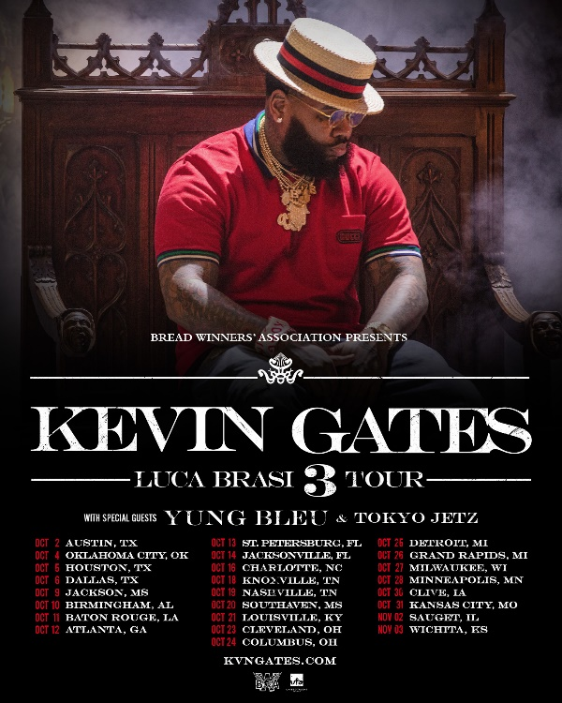

DATE CITY VENUE
2-Oct Austin, TX ACL The Moody Theater
4-Oct Oklahoma City, OK The Criterion
5-Oct Houston, TX Revention Music Center
6-Oct Dallas, TX The Bomb Factory
9-Oct Jackson, MS Thalia Mara Hall
10-Oct Birmingham, AL BJCC Concert Hall
11-Oct Baton Rouge, LA Raising Cain's River Center
12-Oct Atlanta, GA Tabernacle
13-Oct St. Petersburg, FL Jannus Live
14-Oct Jacksonville, FL Moran Theater
16-Oct Charlotte, NC Ovens Auditorium
18-Oct Knoxville, TN Knoxville Civic Coliseum
19-Oct Nashville, TN Nashville Municipal Auditorium
20-Oct Southaven, MS Landers Center
21-Oct Louisville, KY The Bourbon Hall
23-Oct Cleveland, OH Agora Ballroom
24-Oct Columbus, OH Express Live!
25-Oct Detroit, MI Royal Oak Music Theatre
26-Oct Grand Rapids, MI 20 Monroe Live
27-Oct Milwaukee, WI The Eagles Ballroom
28-Oct Minneapolis, MN Myth Live
30-Oct Clive, IA Seven Flags Event Center
31-Oct Kansas City, MO Uptown Theater
2-Nov Sauget, IL Pop's
3-Nov Wichita, KS The Cotillion Ballroom

