FOR IMMEDIATE RELEASE
MARCH 20, 2019

LIL SKIES DROPS NEW VIDEO FOR “BREATHE”

RISING RAPPER UNVEILS ANOTHER NEW VISUAL FROM DEBUT ALBUM SHELBY

OFFICIAL VIDEO FOLLOWS SKIES’ FIRST LIVE PERFORMANCE OF “BREATHE” IN HOUSTON LAST WEEK

CURRENT HEADLINE TOUR WITH LIL PUMP WRAPS MAY 22ND IN LA
WITH NEW LIVE DATES AND FESTIVAL PERFORMANCES KICKING OFF NEXT MONTH

WATCH “BREATHE” HERE
LISTEN TO SHELBY HERE

*Download Hi-Res*

Today, critically-acclaimed rapper Lil Skies drops another new visual from his instant hit debut album Shelby. Following the first live performance of “Breathe” in Houston last week, the official video is now available to stream at Skies official YouTube channel HERE.

Earlier this year, Skies stunned fans around the world as he dropped his highly-anticipated debut album Shelby. Named after his mom, the album debuted top 5 on the Billboard 200 with 54,000 in album equivalents marking Skies’ second top 10 effort following his Life of a Dark Rose mixtape, which has impressively remained on the Billboard 200 since its release over 17 months ago. Shelby is available now at all DSPs and streaming services HERE. Watch the intimate mini-documentary featuring rare behind-the-scenes moments with Skies and one-on-one conversation with his mom HERE.

The magnetic album opener and first single “i” has officially been certified gold with over 6.4 million streams worldwide. Watch the Cole Bennett directed visual which peaked at #8 on YouTube’s “Trending” HERE. Shelby boasts a total of fourteen tracks representing a moment of transformation for Lil Skies. Like a proverbial caterpillar to butterfly, the rapper realizes the full scope of his sound, sharpening the flows, magnifying the melodies, and delivering a truthful statement behind each hook.

Lil Skies, who made waves as he walked in Philipp Plein’s show during New York Fashion Week, joined forces with Lil Pump for their 2019 Spring co-headline tour. This highly successful trek, which saw Skies and Pump each headlining their biggest venues yet, will wraps on May 22nd at The Shrine Expo Hall in Los Angeles, California. This summer, Skies will continue to wow audiences on tour with more live dates and festival performances including Lollapalooza on August 3rd. Check out the full confirmed itinerary below.

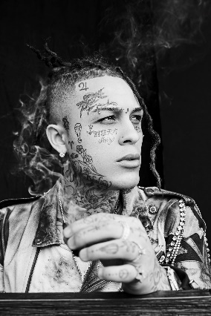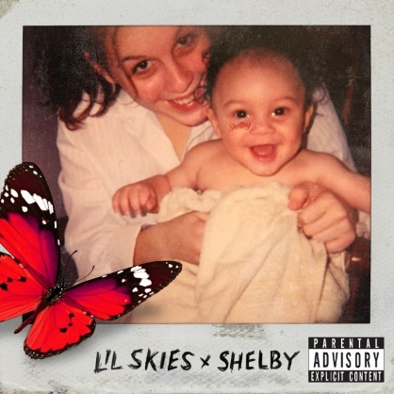
*Download Hi-Res Art HERE*
*Download High Res Photo HERE – Credit: Jimmy Fontaine*

ABOUT LIL SKIES
With over 2 billion streams under his belt, 20-year-old rapper on the rise Lil Skies, who is managed by The Stokey Project which entered into a partnership with Roc Nation this year for management, has been building a massive storm of fans and followers with his angsty brand of high-energy hip hop. Released last January, his critically-acclaimed major label debut mixtape Life Of A Dark Rose [All We Got Ent/Atlantic Records] was certified Gold by the RIAA and quickly spawned three RIAA Platinum certified singles including “Red Roses,” “Nowadays” and “Lust.” Get it HERE. Skies has continued to release a nonstop stream of new music and visuals, most recently holding over his ravenous fans with “Real Ties” and “Name in the Sand,” both of which collectively amassed an extremely impressive 30 million streams within the first few weeks of release. 2018 saw Skies heading out on his first-ever nationwide headline tour which sold out venues across North America before going on to play Made in America Festival and joining Wiz Khalifa and Rae Sremmurd on their Dazed & Blazed amphitheater tour. Skies hasn’t slowed down in 2019, continuing to release new music including “I Know You” (feat. Young Pinch), “Opps Want Me Dead,” “No Rest” and “World Rage,” which have collectively been streamed over 200 million times worldwide. Hailed by Rolling Stone, Billboard, Complex, Pandora and more as an artist to watch, Lil Skies has an extremely promising year ahead.

CONNECT WITH LIL SKIES
SOUNDCLOUD | FACEBOOK | TWITTER |INSTAGRAM | YOUTUBE | PRESS TOOLS

CONTACT:
Chelsey Northern | chelsey.northern@atlanticrecords.com

LIL SKIES ON TOUR
MAY
20 El Paso, TX El Paso County Coliseum
22 Los Angeles, CA The Shrine Expo Hall

JUNE
9 Clio, MI High Times Cannabis Cup
15 Vancouver, BC Breakout Festival
29 Lommel, Belgium Vestiville

JULY
4 London, UK Brixton Electric
5 London, UK Wireless Festival
6 Turku, Finland Ruisrock Festival

AUGUST
3 Chicago, IL Lollapalooza
24 Moscow, Russia Booking Machine Festival
31 Sydney, Australia Parramatta Park
7 Melbourne, Australia Flemington Racecourse
8 East Perth, Australia Gloucester Park
27 Chandler, AZ Gold Rush AZ

# # #

