FOR IMMEDIATE RELEASE
MARCH 13TH, 2019

LIL SKIES RELEASES SHELBY DOCUMENTARY
AFTER ALBUM DEBUTS TOP 5 ON BILLBOARD 200

WATCH THE RISING RAPPER’S MINI-DOCUMENTARY HERE

THE COLE BENNETT-DIRECTED VIDEO FOR “i” SURPASSES 9 MILLION VIEWS – WATCH HERE

LIL SKIES TO HEADLINE SPRING TOUR WITH LIL PUMP; TICKETS ON SALE HERE

“SHELBY” AVAILABLE NOW AT ALL DSPS AND STREAMING SERVICES HERE

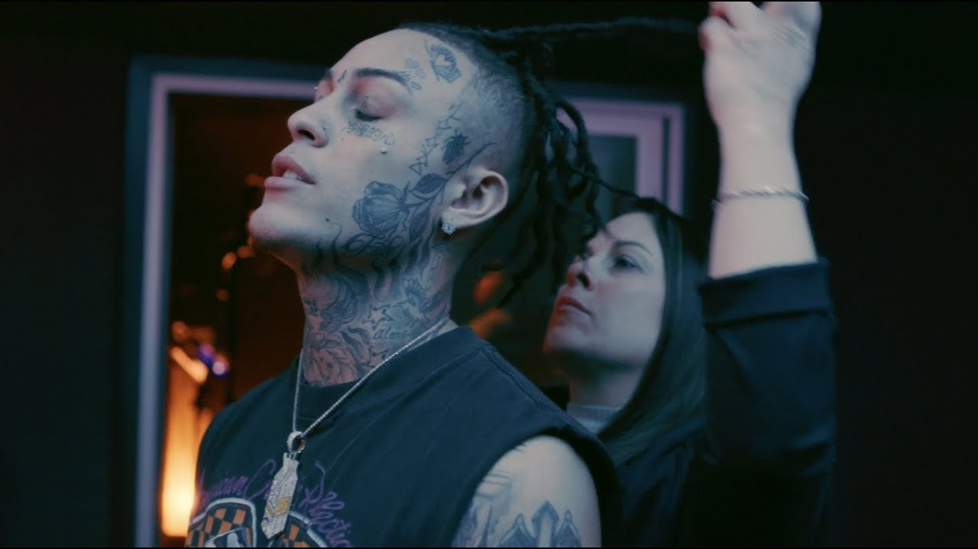

Today, critically-acclaimed rapper Lil Skies unveils an intimate mini-documentary companion piece for his recently released debut album Shelby. Watch the mini-doc which premiered earlier on YouTube HERE. Named after his mom, Shelby debuted top 5 on the Billboard 200 with 54,000 in album equivalents marking Skies’ second top 10 effort following his Life of a Dark Rose mixtape. Shelby is available now at all DSPs and streaming services HERE.

On March 1st, Skies stunned fans around the world as he dropped his highly-anticipated debut album as a surprise, celebrating with an intimate release party in the Hollywood Hills surrounded by his family, closest friends and supporters. Skies also unveiled the official video for the magnetic album opener and first single “i,” which entered the Billboard Hot 100 at No. 39 this week. Watch the Cole Bennett directed visual which peaked at #8 on YouTube’s “Trending” HERE. With the first single “i” kicking off the album, Shelby boasts a total of fourteen tracks representing a moment of transformation for Lil Skies. Like a proverbial caterpillar to butterfly, the rapper realizes the full scope of his sound, sharpening the flows, magnifying the melodies, and delivering a truthful statement behind each hook. “It’s my first real project,” says Skies. “It’s like a new beginning. This is really like me being born again. “

Lil Skies, who made waves as he walked in Philipp Plein’s show during New York Fashion Week, recently joined forces with Lil Pump to announce the dates for their 2019 Spring co-headline tour – tickets available HERE. This trek sees Skies and Pump each headlining their biggest venues yet. Kicking off on Friday, April 19 at WaMu Theater in Seattle, Washington, the tour will roll through major markets nationwide, concluding Friday, May 22 at The Shrine Expo Hall in Los Angeles, California. Check out the full confirmed itinerary below.
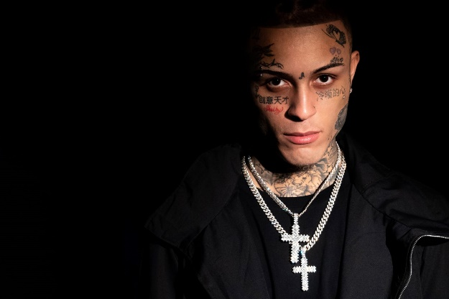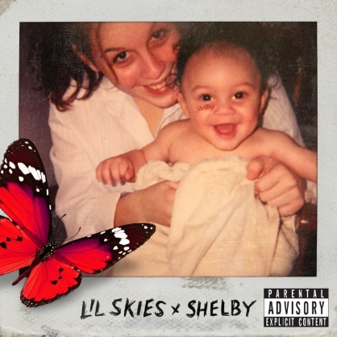
*Download Hi-Res Art HERE*
*Download High Res Photo HERE*

ABOUT LIL SKIES
With over 2 billion streams under his belt, 20-year-old rapper on the rise Lil Skies, who is managed by The Stokey Project which entered into a partnership with Roc Nation this year for management, has been building a massive storm of fans and followers with his angsty brand of high-energy hip hop. Released last January, his critically-acclaimed major label debut mixtape Life Of A Dark Rose [All We Got Ent/Atlantic Records] was certified Gold by the RIAA and quickly spawned three RIAA Platinum certified singles including “Red Roses,” “Nowadays” and “Lust.” Get it HERE. Skies has continued to release a nonstop stream of new music and visuals, most recently holding over his ravenous fans with “Real Ties” and “Name in the Sand,” both of which have collectively amassed an extremely impressive 30 million streams in just the past few weeks. 2018 saw Skies heading out on his first-ever nationwide headline tour which sold out venues across North America before going on to play Made in America Festival and joining Wiz Khalifa and Rae Sremmurd on their Dazed & Blazed amphitheater tour. Skies hasn’t slowed down in 2019, continuing to release new music including “I Know You” (feat. Young Pinch), “Opps Want Me Dead,” “No Rest” and “World Rage,” which have collectively been streamed over 200 million times worldwide. Hailed by Rolling Stone, Billboard, Complex, Pandora and more as an artist to watch, Lil Skies has an extremely promising year ahead.

CONNECT WITH LIL SKIES
SOUNDCLOUD | FACEBOOK | TWITTER |INSTAGRAM | YOUTUBE | PRESS TOOLS

CONTACT:
Chelsey Northern | chelsey.northern@atlanticrecords.com

LIL SKIES + LIL PUMP SPRING TOUR 2019

APRIL
19 Seattle, WA Wamu Theater
24 Anaheim, CA House of Blues
26 San Francisco, CA The Warfield
29 Salt Lake City, UT The Complex

MAY
1 Denver, CO The Fillmore
3 Minneapolis, MN The Myth
5 Detroit, MI The Fillmore
7 Philadelphia, PA The MET
8 Washington, DC The Anthem
9 Boston, MA House of Blues
10 New York, NY Terminal 5
14 Atlanta, GA Coca-Cola Roxy
16 Dallas, TX South Side Ballroom
17 Houston, TX Revention Music Center
18 Austin, TX Stubb’s Waller Creek Amphitheater
20 El Paso, TX El Paso County Coliseum
22 Los Angeles, CA The Shrine Expo Hall

# # #

