FOR IMMEDIATE RELEASE
JANUARY 28, 2018

MASON RAMSEY KICKS OFF THE NEW YEAR WITH
HOW’S YOUR GIRL & HOW’S YOUR FAMILY SPRING TOUR 2019

ARRIVES AFTER NATIONWIDE TOUR WITH CHRIS LANE AND
LAS VEGAS RESIDENCY WITH FLORIDA GEORGIA LINE

PRESALE TICKETS AVAILABLE JANUARY 29th;
GENERAL ONSALE BEGINS FEBRUARY 1st

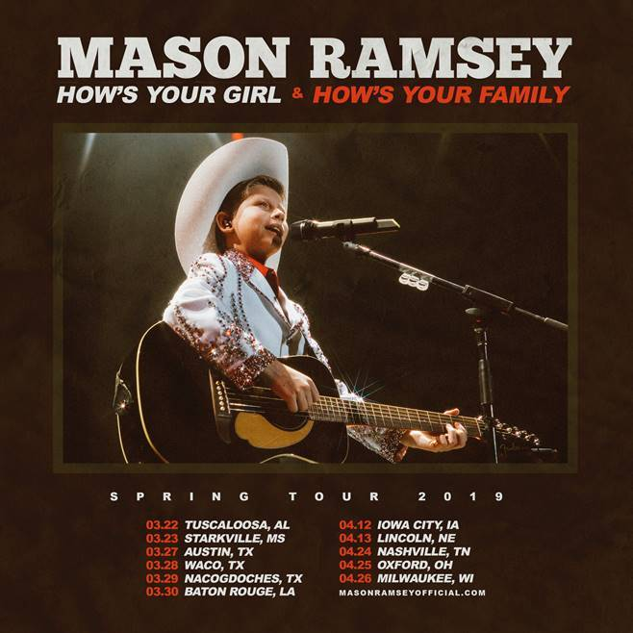

After an amazing 2018, 12-year-old rising star MASON RAMSEY has announced his HOW’S YOUR GIRL & HOW’S YOUR FAMILY SPRING TOUR 2019 which is set to begin later this spring in Tuscaloosa, AL at the Druid City Music Hall on March 22nd. Before the tour’s final date in Milwaukee, WI at The Rave II on April 26th, the country sensation is set to also visit other markets including Austin, TX, Baton Rouge, LA and Nashville, TN. Presale tickets are available for purchase on January 29th (10am local time) while general ticket sales begin February 1st (10am local time). Please visit www.masonramseyofficial.com for more information/ticket sales.

Artist Presale: Tues 1/29 @ 10am Local
Local Presale: Wed 1/30 @ 10am Local
General Onsale: Fri 2/1 @ 10am Local

The 2019 tour announcement arrives after Ramsey wrapped his special guest appearance during Florida Georgia Line’s FLORIDA GEORGIA LINE LIVE FROM LAS VEGAS residency, becoming the youngest artist ever billed to a Las Vegas residency. He also recently wrapped his first nationwide tour as the opener on Chris Lane’s LAPS AROUND THE SUN TOUR.

Since bursting onto the scene, Ramsey quickly made 2018 one to remember. He was named as one of Billboard’s “21 Under 21” for the class of 2018 and applauded by the New York Times for offering “a stylistically diverse country and roots music EP” with his FAMOUS EP, which went on to earn over 45 million streams . PAPER Magazine also went on to praise him as he “continues to steal the spotlight thanks to his loveable spirit – and his musical genuine musical chops.” Most recently Ramsey has been nominated for the Social Star Award at the 2019 iHeartRadio Awards taking place March 14th.

2018 also saw his debut at Grand Ole Opry along with major music festival appearances including the CMA Fest, iHeartCountry Festival, Stagecoach and Coachella. On top of that, he also opened for the 52nd Annual CMA Awards alongside Brad Paisley and Carrie Underwood while also appearing at the 2018 CCMA Awards alongside Shania Twain. Additional TV appearances included the 2018 Teen Choice Awards, 2018 Radio Disney Music Awards, Good Morning America, The Ellen DeGeneres Show, TODAY and TRL.

For more information about Mason Ramsey and upcoming appearances, please visitwww.masonramseyofficial.com and follow him on Facebook, Twitter, and Instagram.

MASON RAMSEY
HOW’S YOUR GIRL & HOW’S YOUR FAMILY SPRING TOUR 2019

3/22 – Tuscaloosa, AL – Druid City Music Hall
3/23 – Starkville, MS – Rick’s Café
3/27 – Austin, TX – Scoot Inn
3/28 – Waco, TX – Baylor University (Waco Hall)
3/29 – Nacogdoches, TX – Banita Creek Hall
3/30 – Baton Rouge, LA – Texas Club
4/12 – Iowa City, IA – Blue Moose Tap House
4/13 – Lincoln, NE – The Bourbon Theatre
4/24 – Nashville, TN – Exit/In
4/25 – Oxford, OH – Brick Street Bar
4/26 – Milwaukee, WI – The Rave II

# # #

ABOUT MASON RAMSEY
As the youngest major label Country artist signed in the genre in nearly two decades, 12-year-old Mason Ramsey continues his fast-track to stardom after being discovered singing in an aisle at his local Walmart. Praised by The New York Times as delivering "a stylistically diverse country and roots music EP,” the Big Loud Records and Atlantic Records artist’s breakout hit, “Famous,” is the lead track off his FAMOUS EP. In addition to making his debut at the famed Grand Ole Opry, the Golconda, IL-bred phenom has also performed at several high-profile festivals including CMA Fest, iHeartCountry Festival, Stagecoach, and Coachella, plus is currently nominated for the Social Star Award at the 2019 iHeartRadio Awards. Named among Billboard’s “21 Under 21” class of 2018, Ramsey has supported multi-platinum duo Florida Georgia Line during their FLORIDA GEORGIA LINE LIVE FROM LAS VEGAS residency and labelmate Chris Lane.

MEDIA CONTACTS:
Jason Davis, Atlantic Records (National)
Jason.Davis@atlanticrecords.com

Andrew George, Atlantic Records (Tour/Online)
andrew.george@atlanticrecords.com

Jensen Sussman, Sweet Talk Publicity
jensen@sweettalkpr.com

Julianne Cassidy, Sweet Talk Publicity
jcassidy@sweettalkpr.com

