FOR IMMEDIATE RELEASE

OCTOBER 15, 2020

MILCK CALLS FOR RACIAL JUSTICE WITH POWERFUL NEW SONG

“SOMEBODY’S BELOVED” (FT. BIPOLAR SUNSHINE)

SINGER-SONGWRITER-ACTIVIST PARTNERS WITH ONE FAMILY MEMPHIS FOUNDATION TO CREATE A DEEPLY MOVING VIDEO HIGHLIGHTING SYSTEMIC RACISM IN AMERICA

LAUNCHES THE SOMEBODY’S BELOVED FUND TO
DIRECTLY BENEFIT RACIAL JUSTICE ORGANIZATIONS

LISTEN HERE | WATCH HERE

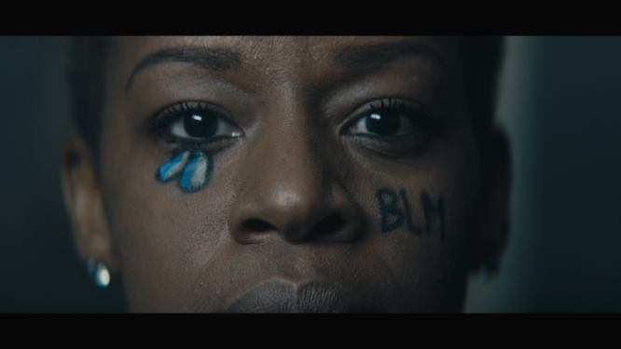
DOWNLOAD HIGH RES VIDEO STILLS HERE

“When Breonna Taylor, Ahmaud Arbery, Nina Pop, and George Floyd’s murders sparked a global uprising, I faced the harsh reality that as an Asian American woman, I am both a beneficiary of white privilege, and victim of systemic racism. To understand how I could be a more active part of the country’s healing from racial injustices, I started to do more research. As listened to Tamika Palmer talk about the memory of her daughter, “Somebody’s Beloved” came to me. “Somebody’s Beloved” is a delicate yet powerful song that we hope can soften the vitriol prevalent in today’s polarized culture.” – MILCK

Acclaimed singer-songwriter-activist MILCK, who first made waves with her global fight song “Quiet,” continues to use music as a means to work towards social justice with her timely and powerful new song, “Somebody’s Beloved” Ft. British singer-songwriter, Bipolar Sunshine. Written, produced, and recorded by MILCK amidst protests for Black Lives Matter, “Somebody’s Beloved” chronicles the life-shattering effects of systemic racism in America.

In partnership with writer/director, Tom Shadyac and his Tennessee-based non-profit, One Family Memphis, which mentors Black creators through nature, recreation, filmmaking, and afterschool programs, MILCK created a heart wrenching narrative video that further amplifies the song’s compelling message, honoring the lives lost to police brutality. The video’s production team includes One Family Memphis mentees, Chris Dean, Elisha Jewell, Joshua Cannon, and Malik Martin. Watch the video, streaming now HERE.

“Somebody’s Beloved” will be complimented by a “soul-cial action” and fundraising campaign along with charitable merchandise. somebodysbeloved.com has been created to help people find their place in the anti-racism movement through self-reflection, education, creativity, social action.

MILCK has launched the Somebody’s Beloved Fund to directly benefit seven organizations. The primarily Southern-based organizations include BEAM: Black Emotional And Mental Health Collective, Black Mamas Matter Alliance, One Family Memphis, Dignity for Incarcerated Women, Freedom, Inc., SONG: Southerners on New Ground, and City Kicks—a partnership between City in the Community & Families Against Violence. Mostly founded by Black women-identified individuals, these organizations are based in principles of community and healing, and are building power around areas of racial justice, feminism, LGBTQ+ rights, criminal justice reform, and mental health.

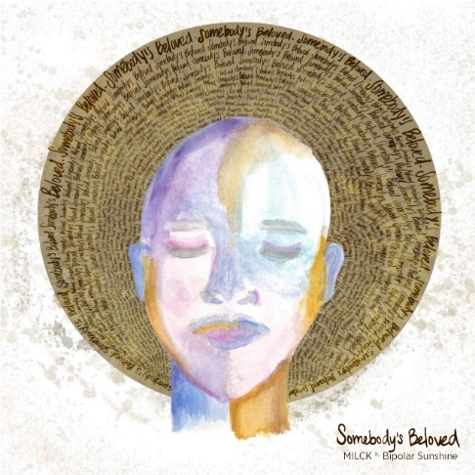
DOWNLOAD PRESS PHOTOS + ARTWORK

ABOUT MILCK
“Somebody’s Beloved” follows MILCK’s acclaimed Into Gold EP which arrived earlier this year and follows her journey as a woman leaving a safe relationship in search of her authentic place in the world. Produced by GRAMMY® Award-winner Malay (Frank Ocean, Sam Smith, Lorde), Into Gold is highlighted by the empowering lead single, “If I Ruled The World.” TIME named “If I Ruled The World” one of the best songs of the week. It was also praised by supporters such as Reese Witherspoon and Sophia Bush. MILCK went on to perform “If I Ruled The World” on Full Frontal with Samantha Bee and during her NPR Tiny Desk (Home) Concert.

Into Gold marked MILCK’s sophomore EP release, following her debut 2018 EP, THIS IS NOT THE END, highlighted by her breakthrough hit single, “Quiet.” The unofficial anthem of the inaugural Women’s March On Washington, “Quiet” caused a worldwide sensation after MILCK teamed with two dozen female singers to perform acapella flash mobs of the song on the streets in Washington, DC. A video captured by award-winning director Alma Har’el quickly went viral, drawing over 14 million plays in just two days. In November 2017, MILCK released a new studio recording of “Quiet” as her “musical #METOO” in light of the massive movement of women and survivors speaking out against sexual assault. Billboard later named “Quiet” as the year’s “Best Protest Song” and NPR included “Quiet” as part of its landmark “American Anthem” series on songs that rouse, unite, celebrate and call to action. MILCK ushered in the release of THIS IS NOT THE END with a remarkably powerful solo piano version of “Quiet” on NBC’s TODAY. Other milestone performances include a headline appearance at 2018’s Women’s March in NYC, performing alongside such iconic names as Yoko Ono, Halsey, and Whoopi Goldberg.

ABOUT BIPOLAR SUNSHINE
Based in Los Angeles, but raised in Manchester by Jamaican parents, Adio Marchant creates poetic tales of life under the moniker Bipolar Sunshine. His sound defies genres -- uniting the euphoric highs of pop, the emotional resonance of hip hop, and the uplifting spirit of a gospel choir.

His understated interplay of the human experience & powerful metaphor has proven to capture the ears and souls of people around the world. Two of his collaborations landed in the top 20 on Billboard’s Hot 100, including “Middle” with DJ Snake and “Whole Heart” with Gryffin. He made history at 2019 Cannes Festival as he joined The Avener atop the Palais de Festival to perform their joint track called “Beautiful”. As a writer, Marchant contributed to “Brown Skin Girl” from Beyonce’s The Lion King: The Gift, which Harper’s Bazaar called an “uplifting message of self-love and empowerment for Black Girls.”

As we all search for our purpose in this world, Marchant sees his role as an artist to convert life experiences into songs that people can relate to and find happiness within. He writes about the darker, grey-tinged moments in life but with a colorful radiance that suggests there’s always something brighter sitting just beyond the horizon.

FOR MORE, PLEASE VISIT:
SOMEBODYSBELOVED.COM
MILCKMUSIC.COM
FACEBOOK
INSTAGRAM
TWITTER
YOUTUBE
PRESS ASSETS

FOR MORE INFO ON MILCK CONTACT:
Andrew George // Andrew.George@atlanticrecords.com
Allison Elbl // aelbl@id-pr.com

# # #

