WATCH MILCK PERFORM “IF I RULED THE WORLD” AND DEBUT AN UNRELEASED SONG DURING HER “NPR TINY DESK (HOME) CONCERT”

WATCH HERE

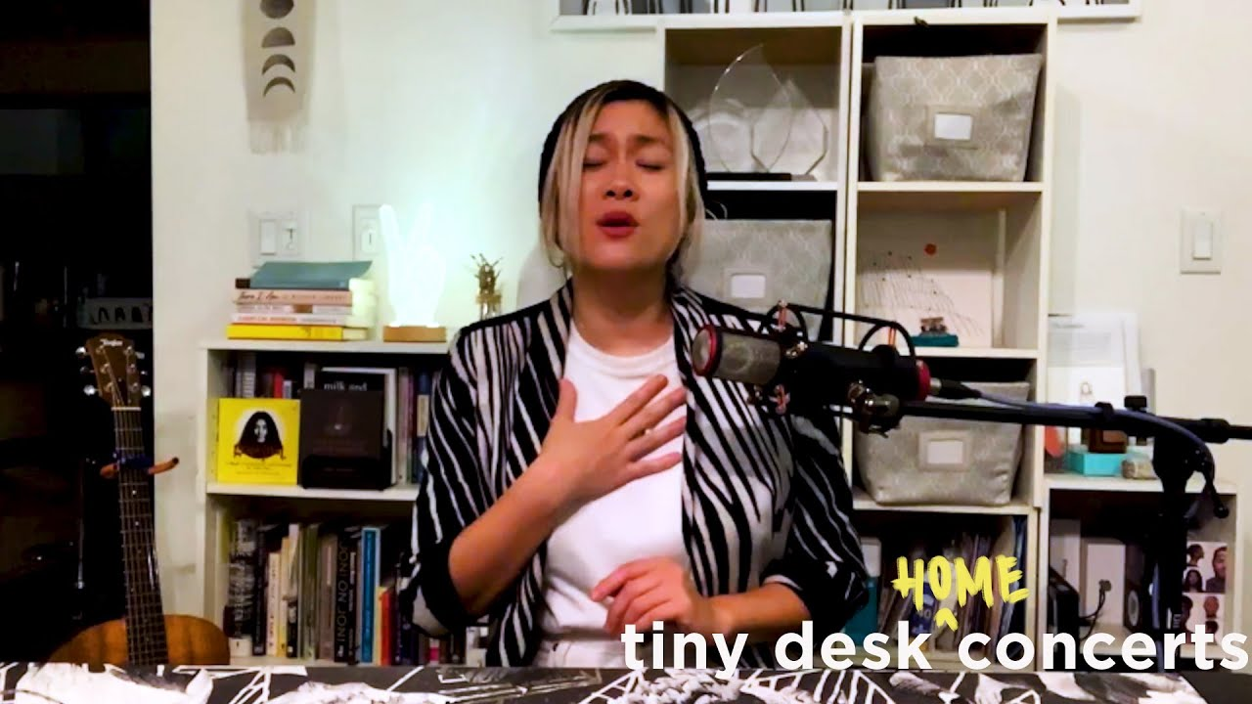

“MILCK's songs of empowerment, unity and understanding have never resonated more.”
– NPR

While in quarantine, Atlantic Records singer-songwriter-activist, MILCK delivered an incredibly moving NPR Tiny Desk (Home) Concert – WATCH HERE. Highlighted by a performance of “If I Ruled The World” from her new Into Gold EP, the incomparable powerhouse also performed fellow EP track, “Gold” as well as “Double Sided,” one of her unreleased and most personal songs.

“I struggle with depression and anxiety,” MILCK shared after performing “Double Sided.” “I’ve had it all my life ever since I was a kid and that song helps me reconcile with my shadows especially during this time of quarantine and really facing ourselves. If you’re finding that this time is challenging and that you’re learning new things about yourself, know that you’re not alone and I am here with you.”

Released earlier this year, MILCK’s inspirational anthem “If I Ruled The World,” was instantly named by TIME one of the “best songs of the week” and celebrities Reese Witherspoon and Sophia Bush quickly shared across socials. The lyric video and official video have also racked up over 400k views. Check out her recent performance of “If I Ruled The World” on Full Frontal with Samantha Bee.

Into Gold was produced by GRAMMY® Award-winner Malay (Frank Ocean, Lorde) and chronicles the journey of a woman leaving a safe relationship in search of her authentic place in the world. While deeply personal, Into Gold is also a universal lesson in how to show up for ourselves in order to be a positive force for others. To accompany each song, MILCK shared a quintet of avant-garde movement videos to illustrate the transformative journey of the EP. All five expressive visuals are streaming now via MILCK’s official YouTube channel HERE.

MILCK first made waves with her global anthem “Quiet” which went viral at the inaugural Women’s March, eventually becoming the sonic parallel to the #MeToo movement and being named Billboard’s #1 protest song of the year. Over the past several weeks, the artist and activist hosted a special weekly livestream concert and conversation to fundraise for Feeding America's Covid-19 Response Fund. She set a goal of $2500 by the end of March and surpassed it after only 2 weeks.

LISTEN TO MILCK’S INTO GOLD EP HERE
WATCH THE INTO GOLD VIDEO QUINTET HERE

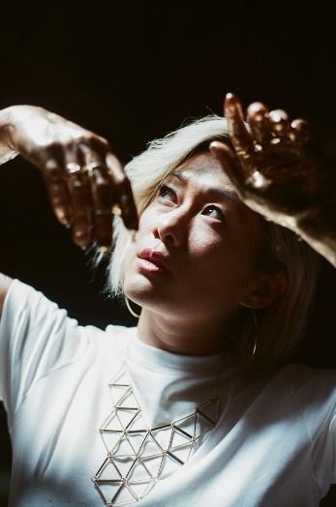

FOR MORE, PLEASE VISIT:
MILCKMUSIC.COM
FACEBOOK
INSTAGRAM
TWITTER
YOUTUBE
PRESS ASSETS

FOR MORE INFO ON MILCK CONTACT:
Andrew George // Andrew.George@atlanticrecords.com

