FOR IMMEDIATE RELEASE
FEBRUARY 3, 2022

OLIVER TREE DROPS AN ANTHEM FOR “FREAKS & GEEKS”

WATCH VIDEO FOR NEW SINGLE HERE

NEW ALBUM COWBOY TEARS – OUT FEBRUARY 18 ON ATLANTIC RECORDS

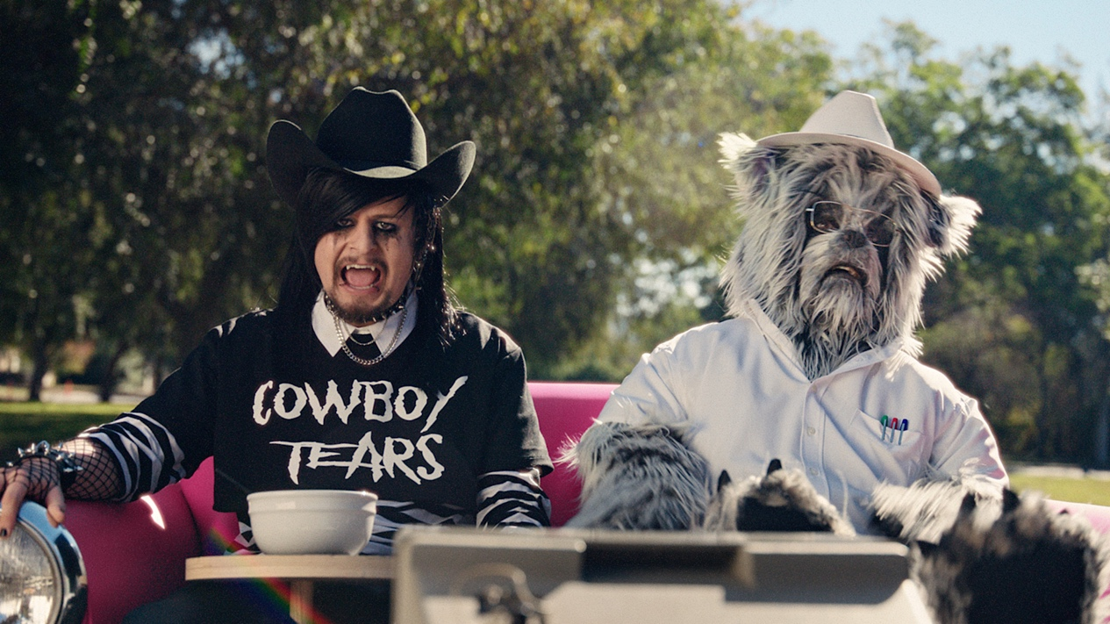
(“Freaks & Geeks” video still)

(February 3, 2022) – Today, chart-topping, genre-bending artist Oliver Tree unveils a new song entitled “Freaks & Geeks.” Listen to “Freaks & Geeks” HERE and watch the music video HERE.

The track hinges on sparse acoustic guitar punctuated by warm lo-fi production from Oliver Tree, Whethan, and Casey Mattson. Right out of the gate, he declares, “I’m a weirdo, I’m a freak, no matter who I try to be…I change my life. I change my ways. I always wanted better days.” His vulnerable vocals resound on the chantable refrain as he ultimately serves up an empowering anthem for outcasts everywhere.

As Oliver traverses through neighborhoods adorned in an emo cowboy outfit and accompanied by a furry friend, he gives new meaning to being an outlaw in his “Freaks and Geeks” music video – a western ode to misfit-ism.

“Freaks & Geeks” arrives on the heels of his latest single “Cowboys Don’t Cry.” He delivered the track’s debut performance on Jimmy Kimmel LIVE! Watch it HERE. So far, the music video has racked up over 12 million YouTube views, while song has garnered 10 million streams and counting. He also appeared on Apple Music 1’s ALT CTRL radio where he discussed the single and what’s in store for 2022.

The singles pave the way for the arrival of his recently announced new album, Cowboy Tears (Atlantic Records), out on February 18th (Atlantic Records). It’s available for pre-order and pre-save HERE.

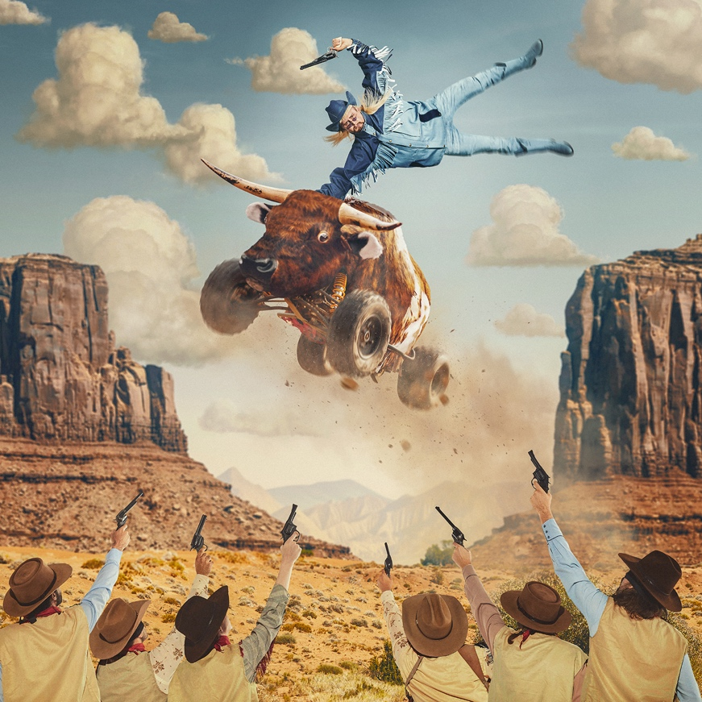
(Cowboy Tears album artwork)

Listen to “Cowboys Don’t Cry” HERE and watch the music video HERE.

The Cowboy Tears tour kicks off February 19, 2022, at Los Angeles, CA’s legendary venue, The Shrine Expo Hall, and continues through late March with support from RIAA certified singer/producer and viral phenomenon Sueco as well as 18-year-old Canadian DIY artist 347aidan. Oliver will also light up the stage at Ultra Music Festival, Hangout Fest, Boston Calling, and more in 2022. For all touring details, please visit www.olivertreemusic.com.

(Oliver Tree Press Photo – credit: Jimmy Fontaine)

ABOUT OLIVER TREE
An internet-based vocalist, producer, writer, director and performance artist, Oliver Tree explores the intersection where pop and alternative meet sonically and has arrived where art and entertainment collide visually. From comedy to action sports, mock reality TV drama to WWF wrestling in his live shows, the world of Oliver Tree is unlike any artist who has come before him.

A Santa Cruz, California native, Tree has emerged as a polymath from many different projects and iterations over the last 10 years. As unpredictable as one artist can be, no one can seem to put their finger on what Oliver Tree will do next. Unafraid to make you laugh, cry, think profoundly or feel completely uncomfortable for the length of a 4 minute music video, he is on the road to developing his own blueprint for packaging and marketing pop culture in the internet era. Versatile in every sense of the word, Tree not only explores every type of entertainment but also every type of genre in his music alike. The box he puts himself in is limitless. It has no boundaries. Oliver Tree has built a multimedia project designed to challenge people’s perspective of what art is, and he’s not the slightest bit concerned with what anyone has to say about it!

OLIVER TREE
COWBOY TEARS TOUR
Featuring special guests Sueco and 347aidan

FEBRUARY 2022
19 – Los Angeles, CA – Shrine Expo Hall
22 – San Francisco, CA – The Warfield Theatre
25 – Seattle, WA – Showbox SoDo
26 – Garden City, ID – Revolution Concert House & Event Center

MARCH 2022
1 – Salt Lake City, UT – The Complex
2 – Denver, CO – The Mission Ballroom
4 – Chicago, IL – Radius
5 – Detroit, MI – The Fillmore Detroit
6 – Cleveland, OH – Agora Theatre & Ballroom
9 – Columbus, OH – Kemba Live!
11 – Boston, MA – House of Blues
12 – New York, NY – Hulu Theatre at Madison Square Garden
14 – Pittsburgh, PA – Stage AE
16 – Philadelphia, PA – The Fillmore Philadelphia
17 – Silver Spring, MD – The Fillmore Silver Spring
18 – Charlotte, NC – The Fillmore Charlotte
19 – Atlanta, GA – The Tabernacle
22 – Nashville, TN – Marathon Music Works
24 – Dallas, TX – The Factory
25 – Houston, TX – 713 Music Hall
25-27 – Miami, FL – Ultra Music Festival
26 – Austin, TX – Stubb's Waller Creek Amphitheater

MAY 2022
20-22 – Gulf Shores, AL – Hangout Music Festival
27 – Boston, MA – Boston Calling Music Festival
29 – Louisville, KY – Forecastle Festival

# # #

CONNECT WITH OLIVER TREE
WEBSITE | FACEBOOK | TWITTER | INSTAGRAM | YOUTUBE | SPOTIFY | TIK TOK

