FOR IMMEDIATE RELEASE
MARCH 9, 2018

ATLANTIC RECORDS TEAM UP WITH THE PRODUCERS OF “HAMILTON,”
“FRIDAY NIGHT LIGHTS” AND “PARENTHOOD”
TO RELEASE WEEKLY ORIGINAL CAST RECORDINGS
FROM NBC’S GROUNDBREAKING NEW DRAMA SERIES “RISE”

WEEKLY RELEASES BEGIN FRIDAY, MARCH 9 HIGHLIGHTING MUSIC
FROM THE MARCH 13 PREMIERE

INITIAL MUSICAL OFFERING ALSO INCLUDES AN UPLIFTING RENDITION OF
MACKLEMORE’S “GLORIOUS” PERFORMED BY THE “RISE” CAST

“GLORIOUS” COMPANION MUSIC VIDEO FEATURING “RISE” CAST MEMBERS
AULI’I CRAVALHO (DISNEY’S “MOANA”), DAMON J. GILLESPIE AND MORE,
STREAMING NOW

WEEKLY RELEASES CULMINATE WITH FULL-LENGTH ALBUM FEATURING PREVIOUSLY
UNRELEASED MATERIAL, NEW VERSIONS OF TRACKS REVEALED THROUGHOUT THE
SEASON AND EXCLUSIVE NEW COVERS

“RISE SEASON 1: THE ALBUM” ARRIVES MAY 11

WATCH “GLORIOUS” HERE
LISTEN TO THE “RISE” WEEK 1 PLAYLIST HERE
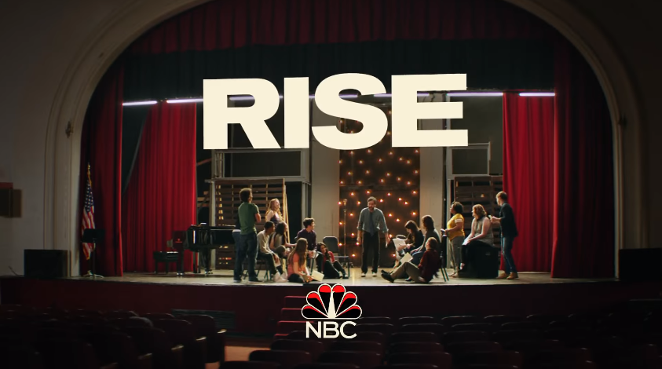

Atlantic Records has announced plans for a prolific slate of musical releases tied to “Rise,” NBC’s much anticipated new drama series from the producers of “Hamilton,” “Friday Night Lights” and “Parenthood.”

Each Friday, beginning, March 9, original cast recordings of the tracks featured in the following Tuesday’s episode of “Rise” will be released at all DSPs and streaming services. The first musical offering highlights cast recordings included in the “Rise” series premiere, airing on Tuesday, March 13 at 10 p.m. ET/PT on NBC, immediately following the season finale of “This Is Us.” The weekly musical releases will culminate with a full album, entitled “RISE SEASON 1: THE ALBUM,” due Friday, May 11. The collection will highlight selected tracks released over the course of the season, alongside additional unreleased songs from the cast.

Among the first tracks being released today is an uplifting rendition of Macklemore’s hit song “Glorious,” performed by the “Rise” cast, featuring Auli’i Cravalho, the voice of Moana, and Damon J. Gillespie. The inspirational recording was first heard in a “Rise” promo spot that aired during NBC’s telecast of Super Bowl LII and was subsequently featured in the show’s promotional campaign throughout the network’s presentation of the 2018 Winter Olympic Games. The “Glorious” companion visual – featuring Cravalho, Gillespie and the cast – is currently available to watch HERE and listen to HERE.

Also released today are a number of songs featured in the series premiere episode, including a rendition of Pearl Jam’s “Just Breathe” by the “Rise” cast and Ellie Desautels, a rousing version of “I Believe” from the Tony Award-winning musical “Spring Awakening,” and a special original “Spring Awakening Montage.” The “Rise” cast & Damon J. Gillespie also deliver a performance of “Football Freestyle,” an original piece written exclusively for the show by “Hamilton’s” Tony-winning creator Lin-Manuel Miranda (see full list of tracks being released this week below).

The RISE musical releases are produced by five-time GRAMMY nominee and Atlantic Records President, West Coast Kevin Weaver (THE GREATEST SHOWMAN, FURIOUS 7, SUICIDE SQUAD, THE FAULT IN OUR STARS) and Atlantic Records President, A&R Pete Ganbarg (HAMILTON ORIGINAL BROADWAY CAST RECORDING, DEAR EVAN HANSEN ORIGINAL BROADWAY CAST RECORDING, TWENTY ONE PILOTS), alongside Tony Award and Pulitzer Prize winner Tom Kitt (Next To Normal, If/Then), and RISE music producer Scott Riesett; Executive Album Producers are Jason Katims and Jeffrey Seller. GRAMMY nominee Liza Richardson is the series’ Music Supervisor (The Leftovers, Narcos, Friday Night Lights).

ABOUT “RISE”
From Jason Katims, executive producer and showrunner of “Friday Night Lights” and “Parenthood,” and “Hamilton producer” Jeffrey Seller comes a heartening new drama about finding inspiration in unexpected places. When dedicated teacher Lou Mazzuchelli (Josh Radnor) sheds his own self-doubt, and takes over the lackluster theater department and its ambitious plans for a school production of “Spring Awakening,” he galvanizes not only the faculty and students but also the entire working-class town.

The cast includes Josh Radnor, Rosie Perez, Auli’i Cravalho, Damon J. Gillespie, Marley Shelton, Rarmian Newton, Ted Sutherland, Amy Forsyth, Casey W. Johnson, Taylor Richardson, Joe Tippett, and Shirley Rumierk.

“Rise” is created by Jason Katims, who serves as showrunner and executive producer. Jeffrey Seller, Flody Suarez and Michelle Lee also executive produce. Mike Cahill directs and executive produces the pilot.

“Rise” is produced by Universal Television, True Jack Productions and Seller Suarez Productions.

Please visit the official show site at http://www.nbc.com/rise.

Facebook: Facebook.com/NBCRise/
Twitter: @RiseNBC
Hashtag: #Rise

For more, please visit www.atlanticrecords.com.

RISE – ORIGINAL CAST RECORDINGS
(Atlantic)
Release date: March 9, 2018

- “Glorious (Rise Cast Version)” - Rise Cast, Auli'i Cravalho & Damon J. Gillespie
- “Football Freestyle (Rise Cast Version)” - Rise Cast & Damon J. Gillespie
- “Just Breathe (Rise Cast Version)” - Rise Cast & Ellie Desautels
- “Spring Awakening Montage (Rise Cast Version)” - Rise Cast
- “I Believe (Rise Cast Version)” - Rise Cast

ATLANTIC RECORDS PRESS CONTACT:
Glenn Fukushima – glenn.fukushima@atlanticrecords.com

NBC PRESS CONTACTS:
Lauren Manasevit – lauren.manasevit@nbcuni.com – 212-664-2193
Yong Kim – yong.kim@nbcuni.com – 818-777-0631

