“RISE SEASON 1: THE ALBUM” AVAILABLE NOW

COMPLETE COLLECTION OF ORIGINAL CAST RECORDINGS FROM
NBC’S GROUNDBREAKING NEW DRAMA SERIES ARRIVES TODAY

ALBUM FEATURES “ALL YOU DESIRE,” A NEW SPRING AWAKENING SONG WRITTEN
BY THE BROADWAY SHOW’S VERY OWN DUNCAN SHEIK AND STEVEN SATER
AND CREATED EXCLUSIVELY FOR NBC’S RISE

BUY/STREAM HERE + LISTEN HERE

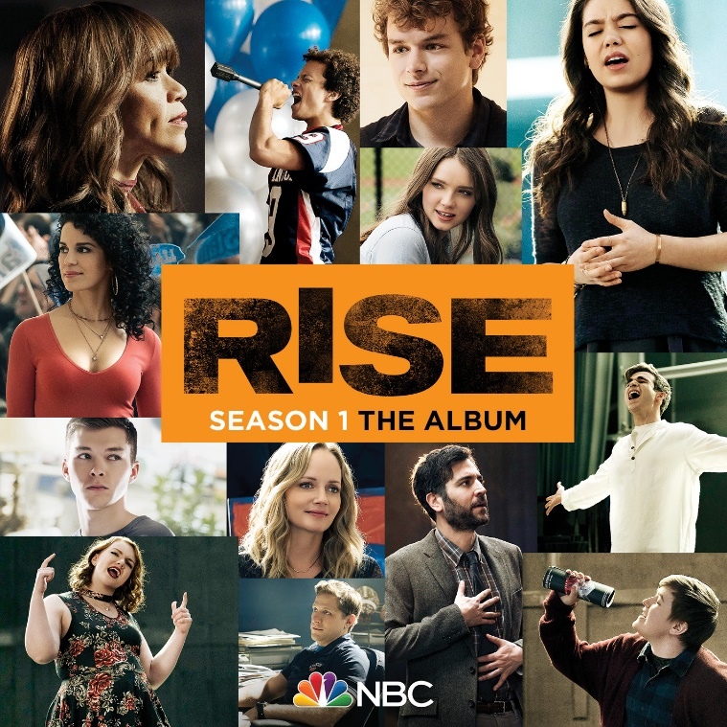
*Download Press Assets HERE*

Atlantic Records has officially unveiled “RISE SEASON 1: THE ALBUM,” available now at all DSPs and streaming services HERE.

Today’s release marks the culmination of Atlantic Records’ prolific slate of weekly musical releases tied to “Rise,” NBC’s new drama series from the producers of “Hamilton,” “Friday Night Lights” and “Parenthood.” Over the past several weeks, Atlantic has released original cast recordings of the tracks featured in the following Tuesday’s episode of “Rise.” The complete collection, available today, features selected tracks released over the course of the season, alongside additional unreleased songs from the cast (see attached tracklisting).

Recently, the “Rise” cast feat. Auli’i Cravalho performed a breathtaking cover of Alessia Cara’s “Scars To Your Beautiful” – included on “RISE SEASON 1: THE ALBUM” – on NBC’s The Voice. Watch the performance in full HERE. Also included on the album, as unveiled this week by Entertainment Weekly, is “All You Desire,” a new “Spring Awakening” song written by the Broadway show’s composer, Duncan Sheik and lyricist, Steven Sater exclusively for “Rise.” “All You Desire” will be performed during next week’s “Rise” season 1 finale and feature vocals by cast members including Auli’i Cravalho, Damon J. Gillespie, Amy Forsyth, and Ted Sutherland. Previously released tracks include several gorgeous “Rise” cast covers of songs originally featured in the Tony Award-winning musical, “Spring Awakening” as well as an uplifting rendition of Macklemore’s hit song “Glorious,” performed by the “Rise” cast, featuring Auli’i Cravalho and Damon J. Gillespie. The “Glorious” companion visual – featuring Cravalho, Gillespie and the cast – is currently available to watch HERE and listen to HERE.

The RISE musical releases are produced by five-time GRAMMY nominee and Atlantic Records President, West Coast Kevin Weaver (THE GREATEST SHOWMAN, FURIOUS 7, SUICIDE SQUAD, THE FAULT IN OUR STARS) and Atlantic Records President, A&R Pete Ganbarg (HAMILTON ORIGINAL BROADWAY CAST RECORDING, DEAR EVAN HANSEN ORIGINAL BROADWAY CAST RECORDING, TWENTY ONE PILOTS), alongside Tony Award and Pulitzer Prize winner Tom Kitt (Next To Normal, If/Then), and RISE music producer Scott Riesett; Executive Album Producers are Jason Katims and Jeffrey Seller. GRAMMY nominee Liza Richardson is the series’ Music Supervisor (The Leftovers, Narcos, Friday Night Lights).

“RISE SEASON 1: THE ALBUM” TRACKLISTING

- Glorious [feat. Auli'i Cravalho & Damon J. Gillespie] (Rise Cast Version)
- Football Freestyle [feat. Damon J. Gillespie] (Rise Cast Version)
- I Believe (Rise Cast Version)
- The Word of Your Body [feat. Auli'i Cravalho & Damon J. Gillespie] (Rise Cast Version)
- The Song of Purple Summer [feat. Amy Forsyth] (Rise Cast Version)
- Left Behind [feat. Ted Sutherland] (Rise Cast Version)
- My Junk (Rise Cast Version) (Rise Cast Version)
- The Guilty Ones [feat. Auli'i Cravalho & Damon J. Gillespie] (Rise Cast Version)
- Mama Who Bore Me [feat. Auli'i Cravalho] (Rise Cast Version)
- The Bitch of Living (Rise Cast Version)
- Touch Me (Rise Cast Version)
- Whispering [feat. Auli'i Cravalho] (Rise Cast Version)
- The Dark I Know Well [feat. Amy Forsyth & Erin Kommor] (Rise Cast Version)
- Mama Who Bore Me (Reprise) (Rise Cast Version)
- Totally Fucked (Rise Cast Version)
- The Word of Your Body (Reprise) [feat. Ted Sutherland & Sean Grandillo] (Rise Cast Version)
- Blue Wind/Don’t Do Sadness [feat. Amy Forsyth & Ellie Desautels] (Rise Cast Version)
- Those You’ve Known [feat. Auli'i Cravalho, Damon J Gillespie & Ellie Desautels] (Rise Cast Version)
- All You Desire (Rise Cast Version)
- Perfect [feat. Auli'i Cravalho] (Rise Cast Version)
- Scars To Your Beautiful [feat. Auli'i Cravalho] (Rise Cast Version)
- Carry On [feat. Shannon Purser] (Rise Cast Version)
- Just Breathe [feat. Ellie Desautels] (Rise Cast Version)
- Carry You (Rise Cast Version)

ABOUT “RISE”
From Jason Katims, executive producer and showrunner of “Friday Night Lights” and “Parenthood,” and “Hamilton producer” Jeffrey Seller comes a heartening new drama about finding inspiration in unexpected places. When dedicated teacher Lou Mazzuchelli (Josh Radnor) sheds his own self-doubt, and takes over the lackluster theater department and its ambitious plans for a school production of “Spring Awakening,” he galvanizes not only the faculty and students but also the entire working-class town.

The cast includes Josh Radnor, Rosie Perez, Auli’i Cravalho, Damon J. Gillespie, Marley Shelton, Rarmian Newton, Ted Sutherland, Amy Forsyth, Casey W. Johnson, Taylor Richardson, Joe Tippett, and Shirley Rumierk.

“Rise” is created by Jason Katims, who serves as showrunner and executive producer. Jeffrey Seller, Flody Suarez and Michelle Lee also executive produce. Mike Cahill directs and executive produces the pilot.

“Rise” is produced by Universal Television, True Jack Productions and Seller Suarez Productions.

Please visit the official show site at http://www.nbc.com/rise.

Facebook: Facebook.com/NBCRise/
Twitter: @RiseNBC
Hashtag: #Rise

For more, please visit www.atlanticrecords.com

ATLANTIC RECORDS PRESS CONTACTS:
Glenn Fukushima – glenn.fukushima@atlanticrecords.com
Andrew George – andrew.george@atlanticrecords.com

NBC PRESS CONTACTS:
Lauren Manasevit – lauren.manasevit@nbcuni.com – 212-664-2193
Yong Kim – yong.kim@nbcuni.com – 818-777-0631

