FOR IMMEDIATE RELEASE
NOVEMBER 29, 2018

RISING ARTIST CHRISTIAN LALAMA DEBUTS NEW SONG “FRFR”

ATLANTIC RECORDS SINGER/MULTI-INSTRUMENTALIST FOLLOWS DEBUT SINGLE “TIC TOC”
WITH CATCHY NEW SONG AND OFFICIAL COMPANION VISUAL

“FRFR” (FOR REAL FOR REAL) AVAILBLE NOW VIA ALL STREAMING SERVICES

WATCH: https://Atlantic.lnk.to/FrFrPR/youtube | BUY/STREAM: https://Atlantic.lnk.to/FrFrPR

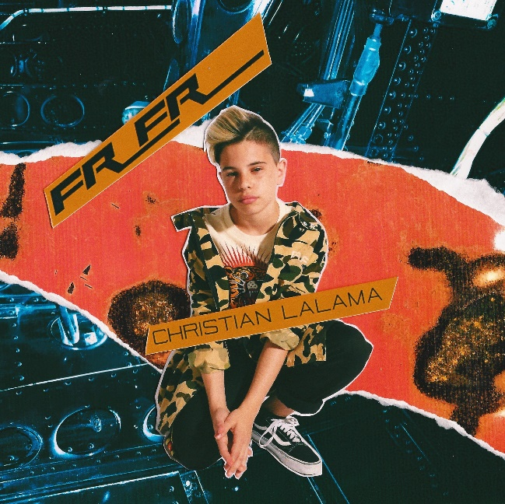
*Download Press Assets HERE*

Rising singer and multi-instrumentalist Christian Lalama has unveiled his new song “FrFr” (Atlantic Records) – available today via all digital music retailers and streaming services. Along with the new release which stands for “For Real For Real,” comes an official companion visual which sweetly captures a blossoming young love. Watch HERE.

This past summer, Christian made his official debut with his first original single “Tic Toc” – available via all DSPs HERE. Co-produced by ISM Beats (Chris Brown, Chief Keef) and S1 (Kanye West, Drake) and written by Nija (Cardi B, The Carters), “Tic Toc” showcases Christian’s flawless ability to merge R&B and pop with his own fire, fervor and flavor. The debut song is accompanied by an official music video that has gone on to amass over 1.6 million views on YouTube. Upon release, TigerBeat instantly praised Christian for his “oh-so smooth lyrics” writing they “are giving us serious old-school Justin Bieber vibes!”

Christian has felt an innate calling to perform since the age of three, making music since before he could even talk. The Ontario-native was born into a musically inclined family and learned to play piano at the impressive young age of four. He won a contest at ten-years-old to perform as part of The Kid Mitchell Band—founded by renowned Canadian artist Kim Mitchell. One short year later he found himself performing in front of 10,000 screaming fans opening for Kim in between belting out classics by Elton John and Billy Joel at solo gigs and honing his piano chops. Simultaneously, Christian began to ignite YouTube generating millions of views on a steady stream of covers that have earned him nearly 17.5 million views at his official YouTube channel alone. Along the way, press attention included from TigerBeat, Entertainment Tonight Canada, Just Jared Jr., Hollywire, Sweety High and more.

This past year saw Lalama emerge victorious in Atlantic Records and Artist Partner Group’s EMERGE, a groundbreaking nationwide, social media-driven search for exceptional teen Pop/R&B talent. Presented in partnership with AEG Presents, Deckstar, Spotify and Deutsch, EMERGE received close to 7,000 extraordinary submissions from young artists across the United States and Canada but in the end, it was Lalama’s remarkable talents that proved undeniable, earning him a label deal with Atlantic Records.

(Photo credit: Trevor Flores – download high res)

CONNECT:
INSTAGRAM | YOUTUBE | TWITTER | FACEBOOK

CONTACT:
Andrew George | andrew.george@atlanticrecords.com

