FOR IMMEDIATE RELEASE
APRIL 28, 2021

SABRINA CLAUDIO ANNOUNCES GLOBAL STREAMING EVENT ON MAY 20TH

ACCLAIMED SONGSTRESS TO PERFORM 2017 BREAKTHROUGH PROJECT DURING
“SABRINA CLAUDIO PRESENTS ABOUT TIME” LIVESTREAM
CELEBRATING INSTANTLY SOLD-OUT VINYL RE-ISSUE

ABOUT TIME EXTENDED VINYL EDITION ARRIVES AT ALL STREAMING SERVICES ON MAY 14TH
FEAT. NEW INTERLUDE PLUS BREATHTAKING VERSIONS OF “BELONG TO YOU” AND “STAND STILL”

TICKETS ON SALE NOW HERE
WATCH THE TRAILER HERE

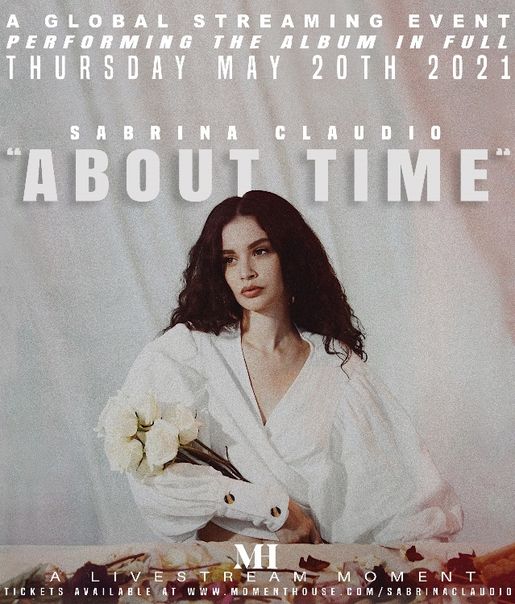
DOWNLOAD HIGH RES IMAGES (PHOTO CREDIT: CASSANDRA BORGES)

“Sabrina Claudio muses on lust, longing and love over songs that fuse minimal R&B, dark jazz and Bossa Nova rhythms informed by her half-Cuban, half-Puerto Rican heritage.”
– THE LOS ANGELES TIMES

Critically acclaimed Puerto Rican/Cuban songstress Sabrina Claudio is teaming up with premium digital live platform Moment House for an eagerly awaited global streaming event on Thursday, May 20th. The exclusive livestream concert will see Sabrina performing her breakthrough 2017 project, About Time, in its entirety. Tickets for “SABRINA CLAUDIO PRESENTS ABOUT TIME” are available now exclusively via Moment House HERE. Check out the stunning trailer HERE.

“I’m doing the show in celebration of the album that’s changed my life,” says Sabrina. “It’s my way of thanking my supporters for receiving me in an extremely vulnerable way in hopes that this body of work has positively affected them even if in the smallest amount.”
Last week, Sabrina announced the pre-order for her first-ever vinyl. The limited-edition baby pink vinyl re-issue of About Time immediately sold out and a second pressing will be available soon. Featuring a new interlude along with breathtaking versions of fan-favorite songs, “Belong To You” and “Stand Still,” the About Time extended vinyl edition is set to arrive at all DSPs and streaming services on Friday, May 14th – see full tracklisting below.

Sabrina also shared: “Vinyls for me signify a tangible moment in time and something that we as listeners can have as some sort of treasure so I’m honored to know that my supporters will be able to physically hold an album that symbolizes so much for both them and myself.”

ABOUT SABRINA CLAUDIO:
Sabrina Claudio has been garnering much attention from fans and critics alike since she independently unveiled her debut EP CONFIDENTLY LOST in 2016 on Soundcloud. In under six months, she quietly amassed over 3 million cumulative plays. The EP was eventually released commercially and shot to No. 3 on the iTunes R&B chart sitting only behind Khalid and The Weeknd. This was only the beginning for the Puerto Rican/Cuban singer-songwriter whose breathy vocals immediately hypnotize and captivate. Sabrina would follow with a 12-song collection ABOUT TIME that shot to the top of R & B charts and continued to cement Claudio as one to watch. On the heels of the new music, Sabrina was announced as Apple’s “Up Next” Artist and made her national TV debut with an alluring performance on The Late Late Show with James Corden. Audiences were treated to seeing Claudio’s sultry, beautiful live performances on her first ever-national tour as main support for 6LACK. Sabrina was featured on the Fifty Shades Freed Original Motion Picture Soundtrack, with an original song called “Cross Your Mind.” Not to mention, she collaborated with everyone from Khalid and BURNS to A$AP Rocky and Wale.

In 2018, the ultra-talented artist released an eight-song collection No Rain, No Flowers which featured sonic highlights “Numb” and “Messages from Her.” Upon release, Rolling Stone praised the project as “consistently suave, admirably steady” and “a soothing balm for whatever ails you.” Following the release, Sabrina traveled the country on her SOLD-OUT U.S. headline ‘No Rain, No Flowers Tour.’ She has played shows around the world and conquered the festival circuit, performing for massive crowds at Coachella, Lollapalooza, Outside Lands, Life Is Beautiful and more. Last year, Sabrina released her most recent full length LP Truth Is. Truth Is marks the culmination of a three-year journey for Sabrina, from D.I.Y. bedroom singer and songwriter to prolific international headliner and, most importantly, a confident, conscious, and charismatic femme fatale. Having welcomed a myriad of co-writers and producers for the first time, the album sees Sabrina more vulnerable and collaborative than ever before.

Recently named as the newest Savage X Fenty brand ambassador, Sabrina celebrated the 2020 holiday season with Christmas Blues, an eight-song collection highlighted by Sabrina’s Christmas favorites and A-list features from superstars, The Weeknd and Alicia Keys. Watch her beautiful performance of the sultry lead single “Warm December” on Jimmy Kimmel Live! HERE.

ABOUT TIME
EXTENDED VINYL TRACKLIST

SIDE A
ABOUT TIME (INTRO)
NATURAL
EVERLASTING LOVE
BELONG TO YOU
UNRAVEL ME
FOR THE TIME BEING (INTERLUDE)
STAND STILL

SIDE B
WANNA KNOW
FROZEN
WE HAVE TIME
USED TO
WAIT
BELONG TO YOU (FEAT. 6LACK) (REMIX)
BELONG TO YOU (ACOUSTIC)
STAND STILL (LIVE)

CONNECT:
OFFICIAL | YOUTUBE | INSTAGRAM | TWITTER | FACEBOOK

CONTACT:
Andrew George // Andrew.George@atlanticrecords.com
Megan Rasmussen // Megan.Rasmussen@atlanticrecords.com

