FOR IMMEDIATE RELEASE
JANUARY 21, 2022

SABRINA CLAUDIO RETURNS WITH SULTRY NEW SINGLE “PUT ON REPEAT”

ACCLAIMED SONGSTRESS SHARES FIRST NEW SONG SINCE 2020 CHRISTMAS BLUES ALBUM

LISTEN TO “PUT ON REPEAT” HERE AND WATCH THE STUNNING AVANT-GARDE VIDEO HERE

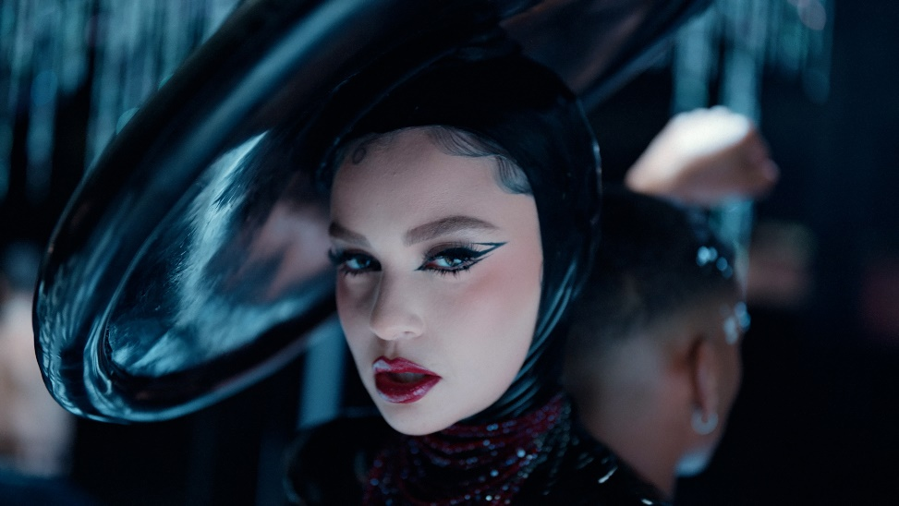
DOWNLOAD PHOTOS HERE

Critically acclaimed Puerto Rican/Cuban songstress Sabrina Claudio has shared her first dose of new music in almost two years. Produced by Jonah Christian (Lil Wayne, Nicki Minaj, 6LACK, Burna Boy, Normani, Anderson. Paak) with additional production from Sad Money (Khalid, Pink Sweat$, Chloe & Halle), the sultry and alluring single, “Put On Repeat” is available now HERE. Directed by WATTS (Katy Perry, Noah Cyrus, Steve Aoki), watch the incredibly stunning and avant-garde companion video on Sabrina’s official YouTube channel HERE.

“’Put On Repeat,’ both the song and visuals, are a perfect representation of the overall mood of the new music I'm excited to share this year,” Claudio says. “An obvious touch of sultriness that is risk taking and daring. The visual to ‘Put On Repeat’ personifies evolution.”

“Put On Repeat” follows Sabrina’s 2020 holiday album Christmas Blues, an eight-song collection highlighted by her Christmas favorites and A-list features from superstars, The Weeknd and Alicia Keys. Watch her beautiful performance of the lead single “Warm December” on Jimmy Kimmel Live! HERE.

DOWNLOAD ARTWORK HERE

ABOUT SABRINA CLAUDIO:
Sabrina Claudio has been garnering much attention from fans and critics alike since she independently unveiled her debut EP Confidently Lost in 2016 on Soundcloud. In under six months, she quietly amassed over 3 million cumulative plays. The EP was eventually released commercially and shot to No. 3 on the iTunes R&B chart sitting only behind Khalid and The Weeknd. This was only the beginning for the Puerto Rican/Cuban singer-songwriter whose breathy vocals immediately hypnotize and captivate. Sabrina would follow with a 12-song collection About Time, which featured the RIAA Gold Certified single “Belong to You” and charted in over 31 countries, hitting #1 on the iTunes R&B Chart while cementing Claudio as one to watch. On the heels of the new music, Sabrina was announced as Apple’s “Up Next” Artist and made her national TV debut with an alluring performance on The Late Late Show with James Corden. Audiences were treated to seeing Claudio’s sultry, beautiful live performances on her first ever-national tour as main support for 6LACK. Last year, Sabrina celebrated the breakthrough project with an extended vinyl reissue. The first-ever limited-edition baby pink-vinyl sold out instantly, twice. Claudio went on to perform the entirety of About Time (Extended Vinyl Reissue) during an enchanting livestream event, streaming now HERE.

In 2018, the ultra-talented artist released an eight-song collection No Rain, No Flowers which featured sonic highlights “Numb,” “Don't Let Me Down (ft. Khalid)," and “Messages from Her.” Upon release, Rolling Stone praised the project as “consistently suave, admirably steady” and “a soothing balm for whatever ails you.” Following the release, Sabrina traveled the country on her SOLD-OUT U.S. headline ‘No Rain, No Flowers Tour.’ She has played shows around the world and conquered the festival circuit, performing for massive crowds at Coachella, Lollapalooza, Outside Lands, Life Is Beautiful and more.

In 2019, Sabrina released her full-length LP Truth Is, marking the culmination of a three-year journey for Sabrina, from D.I.Y. bedroom singer and songwriter to prolific international headliner and, most importantly, a confident, conscious, and charismatic femme fatale. Having welcomed a myriad of co-writers and producers for the first time, the album sees Sabrina more vulnerable and collaborative than ever before.

CONNECT:
OFFICIAL | YOUTUBE | INSTAGRAM | TWITTER | FACEBOOK

CONTACT:
Andrew George // Andrew.George@atlanticrecords.com
Megan Rasmussen // Megan.Rasmussen@atlanticrecords.com

