FOR IMMEDIATE RELEASE
SEPTEMBER 19, 2019

SABRINA CLAUDIO ANNOUNCES COLLABORATIVE NEW ALBUM “TRUTH IS”
ARRIVING OCTOBER 4TH AND AVAILABLE FOR PRE-ORDER HERE

TITLE TRACK CO-WRITTEN BY JULIA MICHAELS OUT TODAY
ALONGSIDE RAW AND PERSONAL LYRIC VIDEO

LISTEN TO THE NEW SINGLE HERE
WATCH THE SELF-SHOT LYRIC VIDEO HERE

“TRUTH IS TOUR” OPENS WITH SOLD-OUT LA SHOW AT THE WILTERN ON SEPT. 21ST;
LARGEST HEADLINE TOUR INCLUDES A NIGHT AT HAMMERSTEIN BALLROOM IN NYC ON OCT. 18TH

LISTEN TO ADDITIONAL TRACKS FROM “TRUTH IS” NOW AVAILABLE ON DSPS
“HOLDING THE GUN” | “AS LONG AS YOU’RE ASLEEP” | “ON MY SHOULDERS”

Download high res artwork HERE

The critically acclaimed Puerto Rican/Cuban songstress Sabrina Claudio has officially announced the release date for her collaborative and empowered new body of work, “Truth Is.” Leading up to its highly-anticipated release on Friday, October 4th, “Truth Is” is available for pre-order HERE. Listen to the title track, which Sabrina co-wrote with Julia Michaels, HERE and watch the self-shot lyric video HERE.

“I wrote ‘Truth Is’ with Julia Michaels during our first time working together,” says Sabrina. “The song is about emotions we often think of but are afraid to voice – the feelings we try to convince ourselves we don’t actually feel. Those two words, Truth Is, symbolize everything this album is about.”

Sabrina’s forthcoming full-length marks the culmination of a three-year journey from D.I.Y. bedroom singer and songwriter to prolific international headliner and, most importantly, a confident, conscious, and charismatic femme fatale. Having welcomed a myriad of co-writers and producers for the first time, the album sees Sabrina more vulnerable and collaborative than ever before. Notable collaborators range from esteemed songwriters, Julia Michaels (Justin Bieber, Selena Gomez), Simon Wilcox (Nick Jonas, Camila Cabello), and Stephan Moccio to producers, Stint (Gallant, Demi Lovato) and Nolan Lombroza (Nick Jonas, DJ Khaled, Kehlani). To honor and celebrate the incredible impact these collaborators had on both the album, and Sabrina’s personal growth, their illustrations are prominently featured on the official album artwork created by Markedric.

Earlier this summer, Sabrina heralded the launch of “Truth Is” with her entrancing single “Holding The Gun” which arrived alongside a cinematic companion visual. Watch the Bonnie & Clyde inspired journey into madness and obsession, which premiered on PAPER, HERE. The track followed the seductive “As Long As You’re Asleep.” Most recently, Sabrina unveiled the incredibly sexy visual, which she co-directed for another new album track, “On My Shoulders” – watch HERE. Her friend Billie Eilish posted about the video, which features not one, but three breathtakingly gorgeous versions of Sabrina, saying, “this is the hardest shit ive ever seen in my life b @sabrinaclaudio how tf she do dat.” “Holding The Gun,” “As Long As You’re Asleep,” and “On My Shoulders” are all available on DSPs now – listen HERE.

This weekend, Sabrina will embark on her biggest North American headline run to date. The “Truth Is Tour” – featuring backing from her live band and support from Gallant – kicks off September 21st at The Wiltern in Los Angeles, CA and travels the U.S. and Canada through early November. Sabrina instantly sold out her London show at Brixton Electric on November 19th and high demand also led to the announcement of a second LA show at The Wiltern on September 22nd. See full itinerary below – for complete details and ticket information visit sabrinaclaudio.com/tour.

While releasing her own new music, Sabrina has also teamed up with her fall tour mate Gallant for his new single “Compromise” and is featured on SiR’s recent song “That’s Why I Love You.” These releases follow Sabrina’s collaborations with Wale on “All My Love” and BURNS and A$AP Rocky on “Energy” which arrived earlier this year. In April, Sabrina made her captivating debut Coachella performance impressively commanding attention from the festival’s main stage and garnering love from PAPER, Entertainment Weekly, Billboard, New York Mag and more.

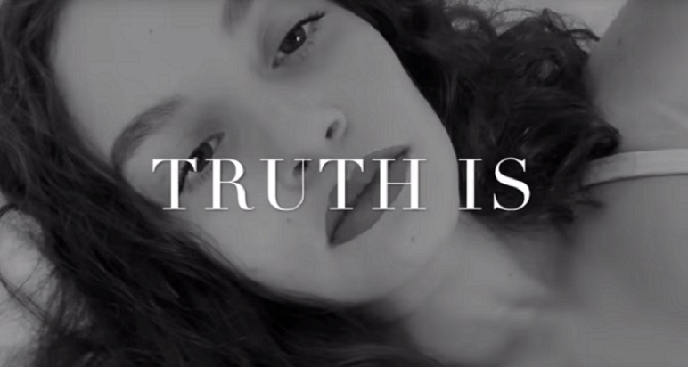

ABOUT SABRINA CLAUDIO:
Sabrina Claudio has been garnering much attention from fans and critics alike since she independently unveiled her debut EP Confidently Lost in 2016 on Soundcloud. In under six months, she quietly amassed over 3 million cumulative plays. The EP was eventually released commercially and shot to No. 3 on the iTunes R&B chart sitting only behind Khalid and The Weeknd. This was only the beginning for the Puerto Rican/Cuban singer-songwriter whose breathy vocals immediately hypnotize and captivate. Sabrina would follow with a 12-song collection About Time that shot to the top of R & B charts and continued to cement Claudio as one to watch. On the heels of the new music, Sabrina was announced as Apple’s “Up Next” Artist and made her national TV debut with an alluring performance on The Late Late Show with James Corden. Audiences were treated to seeing Claudio’s sultry, beautiful live performances on her first ever-national tour as main support for 6LACK. Sabrina was featured on the Fifty Shades Freed Original Motion Picture Soundtrack, with an original song called “Cross Your Mind.” Most recently, Claudio released the titillating new song “All To You.” MTV said the song is “so good that you might want to cancel your plans and go straight home, because it will leave you all hot and bothered.”

SABRINA CLAUDIO
ON TOUR FALL 2019

SEPTEMBER
21 - Los Angeles, CA - The Wiltern
22 – Los Angeles, CA – The Wiltern
24 – Phoenix, AZ – The Van Buren
25 - Anaheim, CA - House of Blues
26 - San Francisco, CA - The Masonic
28 - Sacramento, CA - Ace of Spades
30 - Portland, OR - Crystal Ballroom

OCTOBER
1 - Vancouver, BC - Vogue Theater
3 - Seattle, WA - Showbox at the Market
5 - Salt Lake City, UT - The Depot
6 - Denver, CO - Summit Music Hall
8 - Minneapolis, MN - The Varsity Theater
10 - Chicago, IL – House of Blues
12 - Detroit, MI - St. Andrews Hall
14 - Boston, MA - House of Blues
16 - Toronto, ON - Rebel Complex
17 - Montreal, QC - Corona Theatre
18 - New York, NY - Hammerstein Ballroom
19 - Philadelphia, PA - The Fillmore
21 - Silver Spring, MD - The Fillmore
22 - Charlotte, NC - The Fillmore
23 - Atlanta, GA - The Buckhead Theatre
25 - Fort Lauderdale, FL - Revolution
26 - Orlando, FL - The Becham Theatre
27 - Tampa, FL - The Ritz Theatre
29 - New Orleans, LA - House of Blues
30 - Austin, TX - Emo’s
31 - Dallas, TX - House of Blues

NOVEMBER
1 - Houston, TX - House of Blues
2 - San Antonio, TX - House of Blues
5 - Tucson, AZ - Rialto Theatre
6 - Phoenix, AZ - The Van Buren
7 - Las Vegas, NV - House of Blues
8 - San Diego, CA - Soma
17 - Manchester, UK - Academy 2
18 – London, UK – Electric Brixton
19 - London, UK – Electric Brixton
22 - Berlin, DE - Kesselhaus
24 - Paris, FR - Alhambra
25 - Amsterdam, ML - Melkweg (The Max)
26 - Antwerp, BE - Trix

CONNECT:
youtube.com/user/sabrinaclaudiomusic
instagram.com/sabrina_claudio
soundcloud.com/sabrina-claudio
twitter.com/sabrina_claudio
facebook.com/SabrinaClaudioMusic

CONTACT:
Chelsey Northern // chelsey.northern@atlanticrecords.com
Andrew George // andrew.george@atlanticrecords.com

