FOR IMMEDIATE RELEASE
NOVEMBER 27, 2020

SABRINA CLAUDIO RELEASES HOLIDAY ALBUM CHRISTMAS BLUES
INCLUDING FEATURES FROM THE WEEKND & ALICIA KEYS
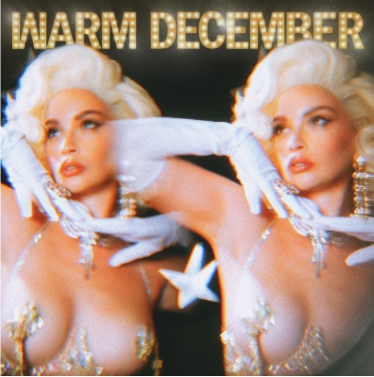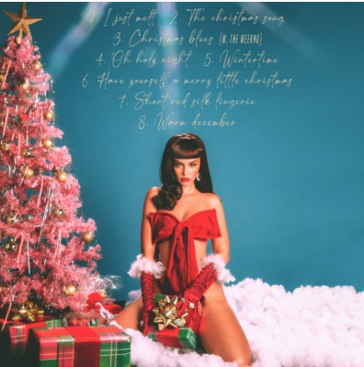
Click HERE to Buy/Stream/Download Christmas Blues
Click HERE To Download Christmas Blues Album Artwork
Click HERE Watch the Music Video for “Warm December”

Los Angeles, CA - November 27, 2020 - Today, critically acclaimed Puerto Rican/Cuban songstress Sabrina Claudio welcomes the season with the release of Christmas Blues. Stemming from her love of the holidays, this new record fuses Claudio’s Christmas favorites with instant hits like the sultry lead single “Warm December”. With A-list features from The Weeknd and Alicia Keys, the project offers a soulful soundtrack to the festive season with Claudio’s warming serenades that invite you to stay for a while. The tracklist features three holiday classics and five original songs that will raise your spirits and fold you into a blanket in front of the fire.

“My intention behind creating and indulging into a Christmas album was to attempt to shine a small light through an incredibly dark year for as many people as I can reach. If I have the opportunity to bring a sense of happiness, nostalgia, or calmness to someone with this album, that’s all I could ever ask for. I’m also just a sucker for Christmas time and Christmas music!” - Sabrina Claudio

Christmas Blues Tracklist:
- I Just Melt
- The Christmas Song
- Christmas Blues (with The Weeknd)
- Oh Holy Night
- Winter Time (with Alicia Keys)
- Have Yourself A Merry Little Christmas
- Short Red Silk Lingerie
- Warm December

About Sabrina Claudio:
Sabrina Claudio has been garnering much attention from fans and critics alike since she independently unveiled her debut EP CONFIDENTLY LOST in 2016 on Soundcloud. In under six months, she quietly amassed over 3 million cumulative plays. The EP was eventually released commercially and shot to No. 3 on the iTunes R&B chart sitting only behind Khalid and The Weeknd. This was only the beginning for the Puerto Rican/Cuban singer-songwriter whose breathy vocals immediately hypnotize and captivate. Sabrina would follow with a 12-song collection ABOUT TIME that shot to the top of R & B charts and continued to cement Claudio as one to watch. On the heels of the new music, Sabrina was announced as Apple’s “Up Next” Artist and made her national TV debut with an alluring performance on The Late Late Show with James Corden. Audiences were treated to seeing Claudio’s sultry, beautiful live performances on her first ever-national tour as main support for 6LACK. Sabrina was featured on the Fifty Shades Freed Original Motion Picture Soundtrack, with an original song called “Cross Your Mind.” Not to mention, she collaborated with everyone from Khalid and BURNS to A$AP Rocky and Wale.

In 2018,, the ultra-talented artist released an eight-song collection No Rain, No Flowers which featured sonic highlights “Numb” and “Messages from Her.” Upon release, Rolling Stone praised the project as “consistently suave, admirably steady” and “a soothing balm for whatever ails you.” Following the release, Sabrina traveled the country on her SOLD-OUT U.S. headline ‘No Rain, No Flowers Tour.’ She has played shows around the world and conquered the festival circuit, performing for massive crowds at Coachella, Lollapalooza, Outside Lands, Life Is Beautiful and more. Last year, Sabrina released her most recent full length LP Truth Is. Truth Is marks the culmination of a three-year journey for Sabrina, from D.I.Y. bedroom singer and songwriter to prolific international headliner and, most importantly, a confident, conscious, and charismatic femme fatale. Having welcomed a myriad of co-writers and producers for the first time, the album sees Sabrina more vulnerable and collaborative than ever before.

Click Here to View Sabrina Claudio Instagram
Click Here to View Sabrina Claudio Twitter
Click Here to View Sabrina Claudio Facebook
Click Here to View Sabrina Claudio YouTube

