FOR IMMEDIATE RELEASE
NOVEMBER 19, 2020

SABRINA CLAUDIO WELCOMES WINTER WITH “WARM DECEMBER” HOLIDAY SINGLE AND VISUAL

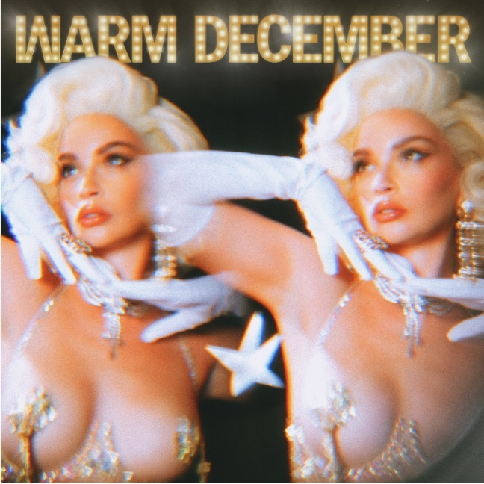

Click HERE to Buy/Stream/Download “Warm December”
Click HERE Watch the Music Video for “Warm December”
Click HERE To Download “Warm December” Single Artwork

Today, critically acclaimed Puerto Rican/Cuban songstress Sabrina Claudio returns with her original holiday single “Warm December” and an accompanying video.

With her festive new single, Sabrina has created a sultry modern-day ode to heat up the holiday season. Paying homage to old Hollywood glamour, the “Warm December” visual stars Sabrina front and center in a series of stunning ensembles.

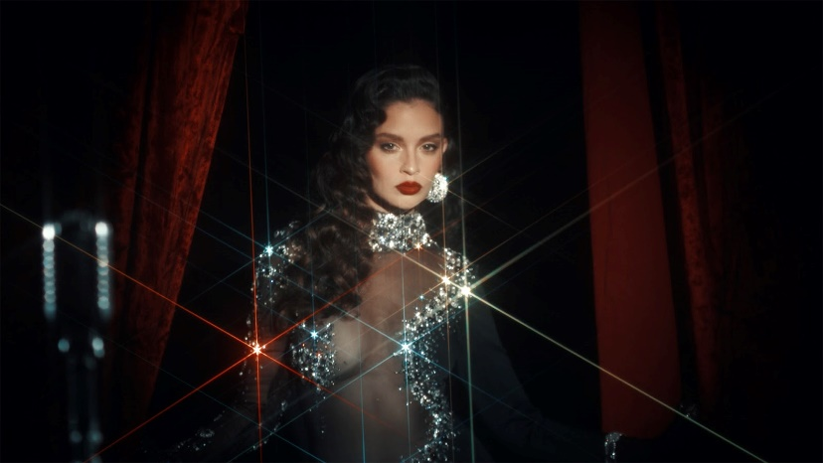

About Sabrina Claudio:
Sabrina Claudio has been garnering much attention from fans and critics alike since she independently unveiled her debut EP CONFIDENTLY LOST in 2016 on Soundcloud. In under six months, she quietly amassed over 3 million cumulative plays. The EP was eventually released commercially and shot to No. 3 on the iTunes R&B chart sitting only behind Khalid and The Weeknd. This was only the beginning for the Puerto Rican/Cuban singer-songwriter whose breathy vocals immediately hypnotize and captivate. Sabrina would follow with a 12-song collection ABOUT TIME that shot to the top of R & B charts and continued to cement Claudio as one to watch. On the heels of the new music, Sabrina was announced as Apple’s “Up Next” Artist and made her national TV debut with an alluring performance on The Late Late Show with James Corden. Audiences were treated to seeing Claudio’s sultry, beautiful live performances on her first ever-national tour as main support for 6LACK. Sabrina was featured on the Fifty Shades Freed Original Motion Picture Soundtrack, with an original song called “Cross Your Mind.” Not to mention, she collaborated with everyone from Khalid and BURNS to A$AP Rocky and Wale.

In 2018,, the ultra-talented artist released an eight-song collection No Rain, No Flowers which featured sonic highlights “Numb” and “Messages from Her.” Upon release, Rolling Stone praised the project as “consistently suave, admirably steady” and “a soothing balm for whatever ails you.” Following the release, Sabrina traveled the country on her SOLD-OUT U.S. headline ‘No Rain, No Flowers Tour.’ She has played shows around the world and conquered the festival circuit, performing for massive crowds at Coachella, Lollapalooza, Outside Lands, Life Is Beautiful and more. In 2019, Sabrina released her most recent full length LP Truth Is. Truth Is marks the culmination of a three-year journey for Sabrina, from D.I.Y. bedroom singer and songwriter to prolific international headliner and, most importantly, a confident, conscious, and charismatic femme fatale. Having welcomed a myriad of co-writers and producers for the first time, the album sees Sabrina more vulnerable and collaborative than ever before.

Click Here to View Sabrina Claudio Instagram
Click Here to View Sabrina Claudio Twitter
Click Here to View Sabrina Claudio Facebook
Click Here to View Sabrina Claudio YouTube

