PORTUGAL THE MAN & “WEIRD AL” YANKOVIC
HONOR INDIGENOUS PEOPLES DAY WITH
“WHO’S GONNA STOP ME”

GRAMMY WINNING ROCK BAND TEAMS UP WITH LEGENDARY ARTIST
TO CELEBRATE & RAISE AWARENESS ABOUT INDIGENOUS CULTURE

JEFF BHASKER-PRODUCED SONG RECEIVES STUNNING VISUAL DIRECTED BY AARON BROWN AND JOSUÉ RIVAS – STARRING INDIGENOUS ARTISTS AND LEADERS

PTM FOUNDATION PARTNERS WITH DIGDEEP TO LAUNCH
$20,000 MATCH PROGRAM TO BENEFIT THE NAVAJO WATER PROJECT

WATCH “WHO’S GONNA STOP ME” HERE

DONATE TO PTM FOUNDATION

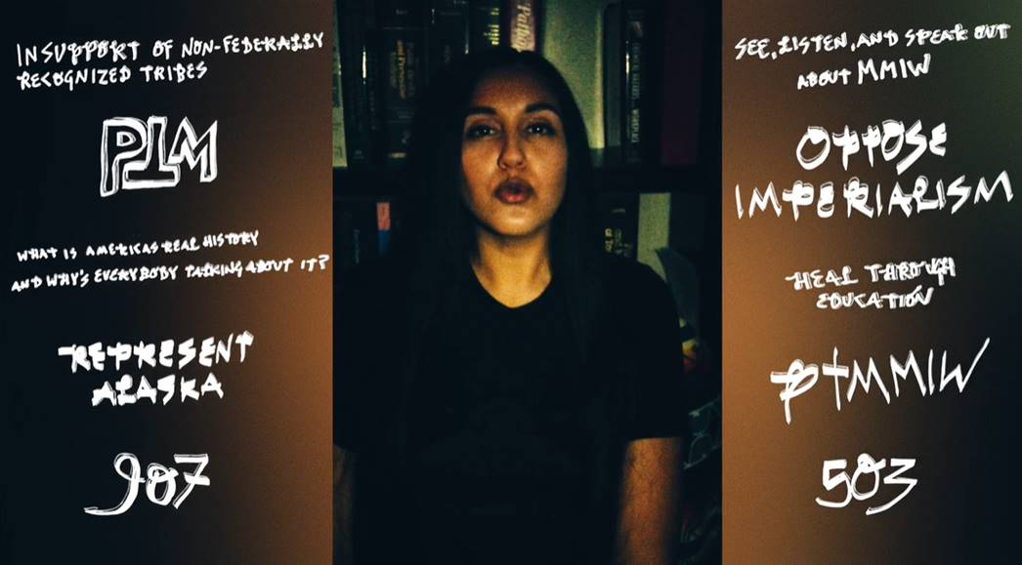

(New York, NY – October 12, 2020) GRAMMY award-winning rock band and social justice advocates PORTUGAL THE MAN have teamed up with “Weird Al” Yankovic and fellow Portland artist The Last Artful, Dodgr for “Who’s Gonna Stop Me,” out today via Atlantic Records. The song arrives on Indigenous Peoples Day and aims to honor and raise awareness about Indigenous culture and rights. “Who’s Gonna Stop Me” marks the first time Weird Al – who Portugal The Man has long cited as one of their biggest influences – has been credited as a featured artist; it also marks his first non-comedic release.

download artwork

“Who’s Gonna Stop Me” was produced by 5x-Grammy winner Jeff Bhasker (Kanye West, Harry Styles, Rihanna) and co-written by Paul Williams, one of the most respected songwriters of all time, whose songwriting credits include everyone from David Bowie and Helen Reddy to the Muppets and The Love Boat theme song, just to name a few. The song’s companion visual – directed by Aaron Brown and Josué Rivas – stars indigenous artists and leaders from around the country including world champion jingle dancer, Acosia Red Elk, of the Umatilla people of Oregon.

LISTEN TO “WHO’S GONNA STOP ME”

WATCH “WHO’S GONNA STOP ME” MUSIC VIDEO

Last week, PTM Foundation announced a fundraising campaign and $20,000 match program to support human rights nonprofit DigDeep’s Indigenous-led Navajo Water Project in expanding water access on the Navajo Nation across New Mexico, Arizona and Utah, where over 30% of residents are living without clean, running water in their homes. A limited-edition t-shirt with “Water is Life” messaging is now available for purchase on the band’s website, with all proceeds going towards fundraising efforts to be split between DigDeep’s Navajo Water Project and the Confederated Tribes of Warm Springs in the band’s home state of Oregon. The band will match fan donations up to $20,000.

THE SONG
Musically, “Who’s Gonna Stop Me” started a few years ago and took a while to find the voice of the song. PTM, Jeff Bhasker, and the legendary Paul Williams were reminiscing the feeling of youth and what freedom feels like when you are young. Of course, when PTM lead singer, John Gourley thinks about growing up, he thinks of “Weird Al.” Ironically, when the lyrics came together during quarantine, it only made sense to just ask Al if he wanted to sing on the song. He sang and nailed the second verse.

THE VIDEO
Directed by Aaron Brown and Josué Rivas (PTM, Artic Monkeys, Vic Mensa) and produced by W+K Studios, the video is conceptualized best as “where do we go from here?” in regard to topics of social unrest, the COVID-19 pandemic, etc. It was important to the band to highlight both the traditions and thinking of Indigenous Peoples and their ability to recognize the good and bad in themselves and move beyond it to find harmony. It fits hand in hand with the recent launch of the band’s PTM Foundation.

QUOTE FROM PORTUGAL THE MAN:
“They say barbwire was the death knell of the cowboy. It was the end of the open range and the end of open pastures. Before the cowboys, for time immemorial, the indigenous peoples of the Americas looked to the earth as their spiritual authority. They did not parcel the earth any more than Christians, Muslims, or the Jewish faith would parcel out God. That would be sacrilege. But along came the colonists and they did just that. After the genocide of the indigenous peoples, once our white picket fences and barbwire and border walls were erected, the ancestors of the colonists made a lot of technological progress. We invented cars, skyscrapers, cheeseburgers, and smartphones! And yet now, at the dawn of the 21st century, mother earth is reacting to the past few hundred years of neglect. The earth is sending out pandemics, fires, hurricanes, and so on. The indigenous say that it’s the earth’s immune system calibrating itself. The indigenous people of the Americas, and the rest of the world, have stewarded their sacred planet for tens of thousands of years of recorded history--likely more. The PTM Foundation turns a conscious heart to the ancestral youth of the indigenous elders to shepherd our sacred planet and peoples through this time of difficulty.

The PTM Foundation is a platform for artistic collaboration between materialist culture, the arts, and indigenous paradigms. For the video for “Who’s Gonna Stop Me” we created a collaboration between indigenous artists, friends, artistic collaborators, ‘Weird Al’ Yankovic, and Indigenous organizations to explore the possibilities of collaboration in this new time. To us ‘Weird Al’ Yankovic has always been a figure of playful boundary-breaking. His work makes us take less seriously, the things that we take so seriously, like what’s cool, or what’s trendy. ‘Weird Al’ Yankovic has been an inspiration for Portugal The Man since their inception until now. In the tradition of the indigenous cultures of the western North American territories, the Coyote represents the trickster and the maker of new worlds. The trickster is an archetype that can be found in nearly all indigenous and ancient cultures; the trickster not only is playful and a comedian but through their playfulness, they connect people. PTM Foundation sees music and art as a similar tool to make new connections and we consider this video to be the beginning of a campaign of many collaborations to come. PTM Foundation strives to forge bridges between the materialist contemporary culture in which we are immersed and the indigenous stewards to whom we strive to give a larger voice.”

QUOTE FROM “WEIRD AL” YANKOVIC:
“I’ve jammed with them at Bonnaroo, I’ve produced remixes for two of their songs, and now I’m doing vocals on “Who’s Gonna Stop Me." Portugal The Man are not only my friends, but they’re one of my favorite bands in the world, and I’m thrilled to be featured on their new single.”

For more information on Portugal The Man, please visit: www.portugaltheman.com and http://www.ptmfoundation.org/.

For all press inquiries, please contact: Jason Davis – Jason.Davis@atlanticrecords.com & Libby Kober – Libby.Kober@atlanticrecords.com.

# # #

ABOUT PORTUGAL THE MAN: Composed of band members John Gourley, Zach Carothers, Kyle O’Quin, Eric Howk, Jason Sechrist and Zoe Manville, Portugal The Man soared to new heights in 2017 with the release of their RIAA certified-gold album, Woodstock, and the astounding success of their infectious single, “Feel It Still,” which earned the rock band from Alaska by way of Portland, OR a plethora of new accolades. However, beneath the shine of their GRAMMY award for “Best Pop Duo/Group Performance,” a 5X RIAA platinum single certification, a mind-blowing 20-week residency at #1 on alternative radio and an inescapable presence in the Top 40 airwaves, lies the group’s long-standing passion for social justice; that is the intersection on which Portugal The Man thrives. Throughout their career, the band has consistently exemplified how to deeply commit to both artistry and activism. This dynamic is what inspired them to publicly launch their own PTM Foundation this year, which is focused on universal issues related to human rights, community health and the environment, with an emphasis on causes directly impacting Indigenous Peoples. Their continued passion for activism has since led to partnerships with various other organizations as well such as Keep Oregon Well (Mental Health), March for Our Lives (Gun Reform) and Protect Our Winters (Climate Change).

ABOUT PTM FOUNDATION: Launched earlier this year, PTM Foundation serves as the band’s primary vehicle to engage, advocate for, and reinvest in the communities they grew up in and currently belong to and care for. PTM Foundation’s work is focused on universal issues related to human rights, community health and the environment, with an emphasis on causes directly impacting Indigenous Peoples. They have previously contributed to efforts for Get Out the Native Vote and COVID-19 Relief Native Community Relief Grant Program.

ABOUT “WEIRD AL” YANKOVIC: With a career spanning four decades as the world’s premier song parodist, “Weird Al” Yankovic is the biggest-selling comedy artist of all time. The recipient of five Grammy awards (out of sixteen total nominations), Weird Al’s 2014 album, Mandatory Fun, became the first comedy album in history to debut at #1 on the Billboard Top 200 chart, and the first to reach the top of the chart in over 50 years. In addition, the single “Word Crimes” from that album debuted in the Billboard Top 40, making Yankovic one of only five artists to have had Top 40 singles in each of the last four decades (the other four being Michael Jackson, Madonna, U2 and Kenny G). In 2019, Weird Al performed in 64 cities to packed, multi-generational audiences with his massive Strings Attached Tour, where he was accompanied at every show by his long-time, original band members, background singers, and a full symphony orchestra. His remarkable recording career was recently commemorated by the release of Squeeze Box: The Complete Works of “Weird Al” Yankovic, a remastered 15-disc box set housed in a replica of Weird Al’s trademark accordion.

ABOUT DIGDEEP: DigDeep is a human rights nonprofit working to ensure that every American has access to clean, running water. DigDeep is the winner of the 2018 US Water Prize for its indigenous-led Navajo Water Project, which has installed solar-powered running water systems in nearly 300 homes on the Navajo Nation. In November 2019, DigDeep and the US Water Alliance co-released the “Closing the Water Access Gap in the United States: A National Action Plan” report, which revealed that over 2.2 million people in the USA are living without running water or sanitation inside their homes. This report was the culmination of 2 years of research, and the first-ever nationwide look at water poverty in the USA. For more information on DigDeep or its regional projects, please visit digdeep.org, appalachiawaterproject.org or navajowaterproject.org, and follow on Twitter (@DigDeepH2O), Facebook and Instagram (@DigDeepWater). For media inquiries, please contact: Alyssa Musket
alyssa@upcausepr.com.

ABOUT W+K STUDIOS:
W+K Studios develops and creates content for film, TV, digital platforms and brands.

