PORTUGAL THE MAN LAUNCHES GROUNDBREAKING CRYPTOCURRENCY PRE-SAVE CAMPAIGN FOR NEW SINGLE,
“WHAT, ME WORRY?” OUT FEBRUARY 9

FOR A LIMITED TIME, FANS WHO PRE-SAVE “WHAT, ME WORRY?” WILL BE GIFTED PTM COIN, THE BAND’S VERY OWN COMMUNITY-BUILT SOCIAL TOKEN

GRAMMY-WINNING BAND SET TO MAKE TRIUMPHANT RETURN WITH
JEFF BHASKER-PRODUCED NEW SINGLE

“What, Me Worry?” marks first official single off forthcoming album due this June

Acclaimed rockers kick off 34-date tour alongside alt-J on Feb 25

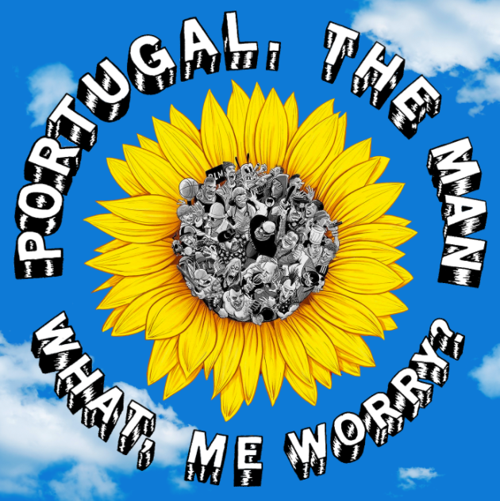
DOWNLOAD SINGLE ART

(New York, NY – January 31, 2022) Multi-platinum, GRAMMY Award-winning alternative rock band Portugal The Man have announced their highly-anticipated return with the forthcoming single, “What, Me Worry?” set for release next Wednesday, February 9.

In announcing the new single, the band is launching a groundbreaking campaign to reward fans who pre-save the track with 1 $PTM of PTM Coin, the band's very own community-built social token (a type of cryptocurrency). To participate, create a free account on Rally, a platform where artists and their fan communities build shared digital economies powered by social tokens and digital goods and services.

PTM Coin provides fans with a number of exclusive perks and experiences, including access to concert pre-sale codes, events hosted by the band, and hundreds of live show recordings, B-sides, and demos housed within the PTM Archives, as well as potential shared value created by the PTM economy. Additional exclusive opportunities will become available for coin holders.

Alongside the debut of the coin last year, the band penned an op-ed for Rolling Stone detailing the motivations behind developing their own unique cryptocurrency. Read that here.

Produced by Jeff Bhasker (Kanye West, Harry Styles, Beyoncé), “What, Me Worry?” is the first single from the band’s long-awaited 9th studio album, due out this June.

The new single arrives as the Alaska-born, Portland-based rockers prepare for their upcoming 34-date tour alongside alt-J, set to kick off Feb 25 with support from Sir Chloe and Cherry Glazerr (full tour itinerary below). The tour includes a stop at LA’s Crypto.com Arena on March 27 as well as a show at New York’s legendary Madison Square Garden on April 11.

All the above arrives following the stellar success of the band’s 2017 RIAA gold-certified album, Woodstock, highlighted by the inescapable, 6x platinum-certified hit, “Feel It Still,” which earned the band their first GRAMMY Award for “Best Pop Duo/Group Performance” and dominated airwaves – hitting #1 at Top 40 radio and breaking the Alternative radio record for longest running number #1 of all time at 20 weeks. Woodstock also delivered the Gold-certified single “Live In The Moment,” which also hit #1 at Alternative radio and broke the record for most plays in a single week at the format.

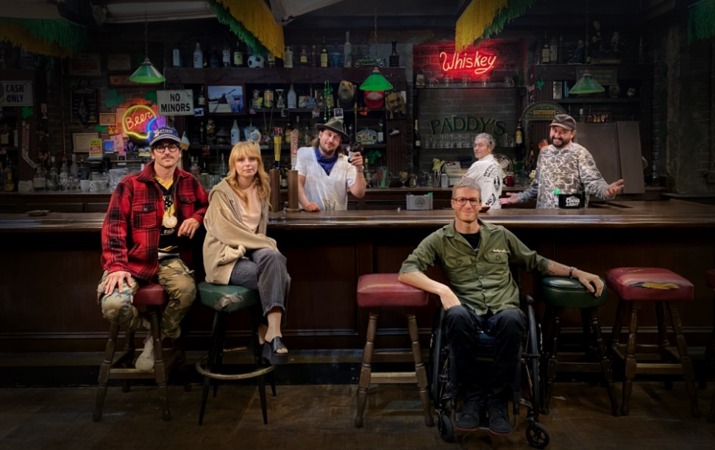
download hi-res press image here | credit: Henry Ramsey

Portugal The Man & alt-J Tour Routing:

February 25, 2022 – Pittsburgh, PA – Petersen Events Center *
February 26, 2022 – Washington, DC – The Anthem *
February 27, 2022 – Washington, DC – The Anthem *
March 1, 2022 – Nashville, TN – Nashville Municipal Auditorium *
March 2, 2022 – Atlanta, GA – State Farm Arena *
March 4, 2022 – Tampa, FL – Yuengling Center*
March 5, 2022 – Fort Lauderdale, FL – Hard Rock Live*
March 6, 2022 – Orlando, FL – Central Florida Fairgrounds *
March 9, 2022 – Dallas, TX – The Factory in Deep Ellum *
March 12, 2022 – Austin, TX – Germania Insurance Amphitheater *#
March 13, 2022 – Houston, – White Oak Music Hall *
March 15, 2022 – St Louis, MS – Chaifetz Arena *
March 16, 2022 – Detroit, MI - Masonic Temple Detroit *
March 19, 2022 – Chicago, IL – Credit Union 1 Arena at UIC *
March 20, 2022 – Minneapolis, MN – The Armory *
March 23, 2022 – Denver, CO – 1STBANK Center *#
March 25, 2022 – San Diego, CA – Pechanga Arena San Diego *#
March 26, 2022 – Santa Barbara, CA – Santa Barbara Bowl *#
March 27, 2022 – Los Angeles, CA – Crypto.com Arena *#
March 29, 2022 – Seattle, WA – WAMU Theater *#
March 30, 2022 – Vancouver, VA – Pacific Coliseum *#
April 1, 2022 – San Francisco, CA – Bill Graham Civic Auditorium #
April 3, 2022 - Las Vegas, NV – The Theater at Virgin Hotels Las Vegas #
April 5, 2022 – Salt Lake City, UT – UCCU Center #
April 7, 2022 – Kansas City, KS – Cable Dahmer Arena #
April 8, 2022 – Cincinnati, OH – PromoWest Pavillion at Ovation #
April. 9, 2022 – Columbus, OH – Schottenstein Center #
April 11, 2022 – New York, NY – Madison Square Garden #
April 13, 2022 – Philadelphia, PA – TD Pavilion at the Mann #
April 14, 2022 – Boston, MA – Agganis Arena #
April 15, 2022 – Montreal, QC – Place Bell #
April 17, 2022 – Toronto, ON – Coca-Cola Coliseum #
* Dates with Sir Chloe
# Dates with Cherry Glazerr

Press Contacts:
Jason Davis | Jason.Davis@atlanticrecords.com
Libby Kober | Libby.Kober@atlanticrecords.com

* * *

ABOUT PORTUGAL THE MAN:
Over the past decade, Portugal The Man has established themselves as one of rock’s most prized possessions and a live phenomenon, with over 1,600 shows under their belts and a storied reputation as festival favorites.
Originally heralding from Alaska, the Portland-based band – comprised of John Gourley, Zach Carothers, Kyle O’Quin, Eric Howk, Jason Sechrist and Zoe Manville – soared to new heights in 2017 with the release of their RIAA certified-gold album, Woodstock. The album was marked by the astounding success of their infectious single, “Feel It Still,” which earned the group a plethora of new accolades – including a GRAMMY award for “Best Pop Duo/Group Performance,” a 6x RIAA platinum certified single certification, a record setting 20-week residency at #1 on alternative radio, and an inescapable presence on the Top 40 airwaves.
Alongside the shine of their myriad musical accomplishments lies the group’s long-standing passion for social justice. In fact, this is precisely the intersection on which Portugal The Man thrives; throughout their career, the band has consistently exemplified how to deeply commit to both artistry and activism. This dynamic inspired them to officially launch their PTM Foundation in 2020, focused on universal issues related to human rights, community health, and the environment, with an emphasis on causes directly impacting Indigenous Peoples.
Their continued passion for activism has also led to recent partnerships with organizations such as the National Coalition Against Censorship, The Skatepark Project (helping communities build public skate parks for youth in underserved communities), March for Our Lives (Gun Reform), Keep Oregon Well (Mental Health), and Protect Our Winters (Climate Change), to name just a few.

# # #

