**Plan B Unveils Cinematic, Future-Facing New Video for Standout Album Track, “Guess Again”**

[**Watch it HERE**](https://www.youtube.com/watch?v=vv3VfXZtus4)

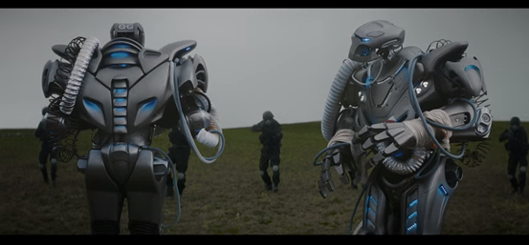

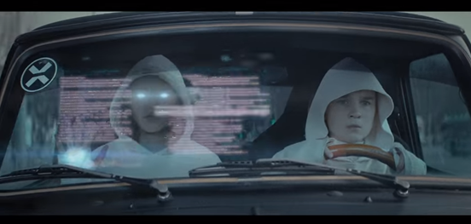

**Follows the Release of Plan B’s UK Top 5 Album, ‘Heaven Before All Hell Breaks Loose’ and a Sold-Out Headline UK Tour**

*“A rip-roaring 21st century pop album” – The Arts Desk (★★★★★)*

*“…proof of a complex, inspirational figure in full command of his many gifts” – The Telegraph (★★★★)*

*“A blessed return and his strongest work yet” – The Metro (★★★★)*

*“...a beautifully-composed and welcome comeback” – The Independent (★★★★)*

Following the release of his critically-acclaimed fourth studio album, ‘Heaven Before All Hell Breaks Loose,’ **Plan B** has unveiled a hyper-futuristic, cinematic new video for the LP’s standout track, [“Guess Again.”](https://www.youtube.com/watch?v=vv3VfXZtus4)

Entering the UK album chart this month at #5, ‘Heaven Before All Hell Breaks Loose’ forms a fiery riposte to the demands of the world we live in and the future we’re creating for ourselves, as visualized by Plan B. Bound together by the classic sci-fi imagery of world-renowned illustrator **John Harris,** the album lands as his first full-length since 2012’s BRIT-nominated UK #1 album, ‘iLLManors,’ which accompanied Plan B’s gritty, critically-acclaimed directorial debut of the same name.

The official video to “Guess Again,” one of the album’s most powerful and immediate tracks, zeroes in on Plan B’s bleak, dystopian view of the future, as a group of people follow mysterious, drone-like projections across a graying city-sphere to a dark and ominous end. Directed by Andrew Donoho, who has recently worked on official videos for Janelle Monáe, Vic Mensa and 6Lack, the video concludes with a stark reminder of the overarching, inescapable reach of those in power.

“You have no idea how hard it’s been for me knowing that I had this concept for the new album and not being able to share it with you or talk about it in any interviews during the run up to album release,” Plan B explains. “But I knew without any visual context, talking about the concept of the new album would only have confused you all. For now, please enjoy the world premiere of ‘Guess Again’ and look forward to the next installment, which will be on its way very soon.”

**About Plan B**

A truly defiant figure in the world of music, Ben Drew’s diverse creativity is inexhaustible. His raw, incendiary debut album, ‘*Who Needs Actions When You Got Words’* broke new ground for UK hip hop in 2006, a loud, proud, obscenity-riddled scream of anger and pride from the streets of East London. But a part of Ben always stayed faithful to the soul he’d first heard as a child, and his sophomore album ‘*The Defamation Of Strickland Banks’*saw him marry the two together with astounding success, achieving quadruple-platinum status, and hitting the #1 album spot, selling over 1.4 million copies in the UK alone, plus seeing him win both a BRIT and three Ivor Novello’s. His 2012 directorial debut (and accompanying album) ‘*iLLManors’* saw him smashing boundaries with his creative style of overlapping stories and interweaving rap-narrative, boldly addressing socio-political issues with his often brutal cultural commentary, seeing Ben nominated for his fifth BRIT Award, being nominated for his first Mercury Music prize, and once again hitting #1 in the UK album chart.

Buy/Stream new album ‘Heaven Before All Hell Breaks Loose’: <https://atlanti.cr/planb-hbahbl>

**CONNECT WITH PLAN B**

[**Official Website**](http://www.time4planb.co.uk/)

[**Facebook**](https://www.facebook.com/planbmusic/)

[**Twitter**](https://twitter.com/4PlanB)

[**YouTube**](https://www.youtube.com/user/planbuk)

Press inquiries: Corey Brewer – [Corey.Brewer@atlanticrecords.com](mailto:Corey.Brewer@atlanticrecords.com)