FOR IMMEDIATE RELEASE
OCTOBER 27, 2017

PnB ROCK IS READY TO CATCH THESE VIBES

PHILADELPHIA SUPERSTAR’S NEW PROJECT WILL ARRIVE NOVEMBER 17TH
NEW SONG “ISSUES FEAT. RUSS” AVAILABLE NOW
PREORDER CATCH THESE VIBES HERE
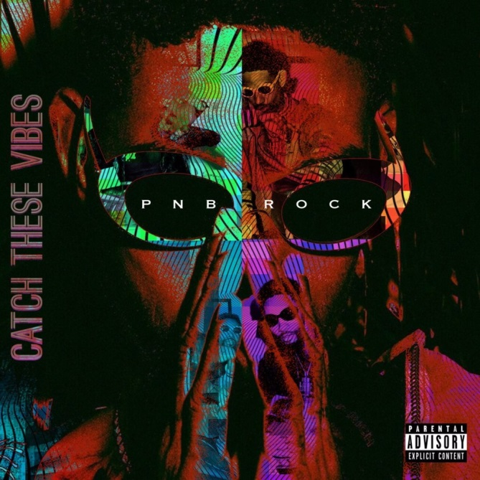
Atlantic Recording artist PnB Rock returns with his new project, CATCH THESE VIBES, available at all digital retailers and streaming partners on November 11th, via Atlantic Records.
PnB’s newest project arrives on the heels of GTTM: GOIN THRU THE MOTIONS which was released in January of 2017. His major label debut included tracks such as the RIAA certified platinum “Selfish” with nearly 300M streams. He’s also been featured on a number of fan favorites this year including YFN Lucci’s certified gold “Everyday We Lit” which they performed live at the 2017 BET Awards Pre-Show and Kodak Black’s certified gold “Too Many Years.”
The rap heavyweight has been trailblazing onto a path of his own after being recognized by Billboard as the “the soulful R&B crooner who is bringing romance back to the streets” and praised by The FADER for his “tight grasp on indelible hooks” and “affinity for filling up stories with small, specific details, resulting in some of the most feel-good, relatable R&B out right now.” He was also hailed as one of the Top 10 Artists You Need to Know by Rolling Stone in 2016 and later graced the cover of XXL’s 2017 Freshman cover.
In the midst of widespread success the Philadelphia rapper has not forgotten about the very city that raised him. PnB Rock has partnered with Discovery Charter School to donate over 700 backpacks filled with school supplies in honor of National Bullying Prevention Month. He’ll also be hosting a mini concert for the students of the charter school. Earlier this year PnB was seen participating in a special back to school event which brought together approximately 100 local business men, educators and community members in effort to highlight the importance of male role models within the education system.
“Philly raised me so to be able to partner with the Discovery Charter School is very important to me. I want these kids to have the tools to succeed and follow their dreams,” adds PnB Rock.
Download/stream “Issues feat. Russ” here. CATCH THESE VIBES will available everywhere November 17th. Pre-order here.
# # #
Press Contact:
Jason Davis/Atlantic Records
Jason.Davis@AtlanticRecords.com

