FOR IMMEDIATE RELEASE
NOVEMBER 17, 2017

PnB ROCK INTRODUCES CATCH THESE VIBES

AVAILABLE EVERYWHERE TODAY
PROJECT INCLUDES “ISSUES FEAT. RUSS” AND “SCRUB”
ADDITIONAL APPEARANCES FROM WIZ KHALIFA, JUICY J, LIL YACHTY,
A BOOGIE WIT DA HOODIE AND MORE
ANNOUNCES “CATCH THESE VIBES” TOUR KICKING OFF FEBRUARY 7TH
DOWNLOAD/STREAM CATCH THESE VIBES HERE
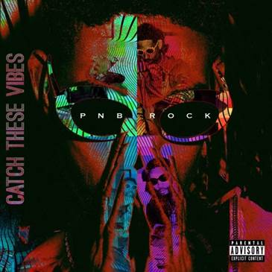
Atlantic Recording artist PnB Rock returns with his new project, CATCH THESE VIBES, available today via all digital retailers and streaming partners. Download/stream the mixtape here. He’s also announced his “Catch These Vibes” Tour which will begin February 7th and carry on throughout March 16th. Official locations for the 30 city tour will be announced on a later date.
CATCH THESE VIBES includes already released tracks “Issues feat. Russ” and “Scrub.” XXL has deemed the PnB and Russ collab to be “about as seamless as it gets because both artists have a knack for melody and their voices blend perfectly with the mellow instrumental.” In addition to Russ, fans can also expect guest appearances from Wiz Khalifa, Juicy J, Lil Yachty, A Boogie Wit Da Hoodie, Roy Woods, Ugly God, 24hrs, NGHTMRE and SmokePurpp.
This project marks PnB’s first return since his major label debut, GTTM: GOIN THRU THE MOTIONS which included tracks such as the RIAA certified platinum “Selfish”. He also partnered with Kodak Black for the certified gold “Too Many Years” and YFN Lucci for the certified gold “Everyday We Lit” which they performed live at the 2017 BET Awards Pre-Show.
PnB Rock is determined to continue his reign after gracing the cover of XXL’s 2017 Freshman cover and being dubbed as one of the Top 10 Artists You Need to Know by Rolling Stone in 2016. He’s also been recognized by Billboard as the “the soulful R&B crooner who is bringing romance back to the streets” and praised by The FADER for his “tight grasp on indelible hooks” and “affinity for filling up stories with small, specific details, resulting in some of the most feel-good, relatable R&B out right now.”
Last month PnB was also seen partnering with Discovery Charter School to donate over 700 backpacks filled with school supplies in honor of National Bullying Prevention Month and additionally held a mini concert. Earlier this year he hosted a special back to school event and gathered nearly 100 local business men, educators and community members to promote the importance of male role models within the education system.
Download/stream CATCH THESE VIBES here.
CATCH THESE VIBES
1. Friends
2. London
3. Face
4. Scrub
5. Lovin' feat. A Boogie Wit Da Hoodie
6. Issues feat. Russ
7. Lowkey feat. Roy Woods and 24hrs
8. iRun feat. Lil Yachty
9. TTM feat. Wiz Khalifa & NGHTMRE
10. WTS
11. 3X feat. SmokePurpp
12. VOICEMEMOWAV.4
13. Pressure
14. Coupe
15. Confide feat. Juicy J
16. 1Day feat. Ugly God
17. Feelins
18. Rewind

# # #
Press Contact:
Jason Davis/Atlantic Records
Jason.Davis@AtlanticRecords.com

