PNB ROCK & TEE GRIZZLEY “GO TO MARS” IN FUTURISTIC NEW MUSIC VIDEO

RELEASES DELUXE VERSION OF ACCLAIMED DEBUT ALBUM, TRAPSTAR TURNT POPSTAR, WITH FIVE NEW TRACKS AND ADDITIONAL FEATURES FROM LIL WAYNE, YOUNGBOY NEVER BROKE AGAIN, AND RODDY RICCH

TRAPSTAR TURNT POPSTAR HITS #1 ON ALL GENRES AND HIP HOP/RAP ON APPLE MUSIC

CURRENT SINGLE “I LIKE GIRLS” FEAT. LIL SKIES BECOMES ONE OF THIS WEEK’S MOST ADDED AT URBAN RADIO WITH EARLY SUPPORT FROM THE TOP TWO STATIONS IN THE NATION

WATCH/SHARE: https://youtu.be/sZ5u3h4k-OQ
BUY/STREAM TRAPSTAR TURNT POPSTAR: https://PNBrock.lnk.to/TSTPS

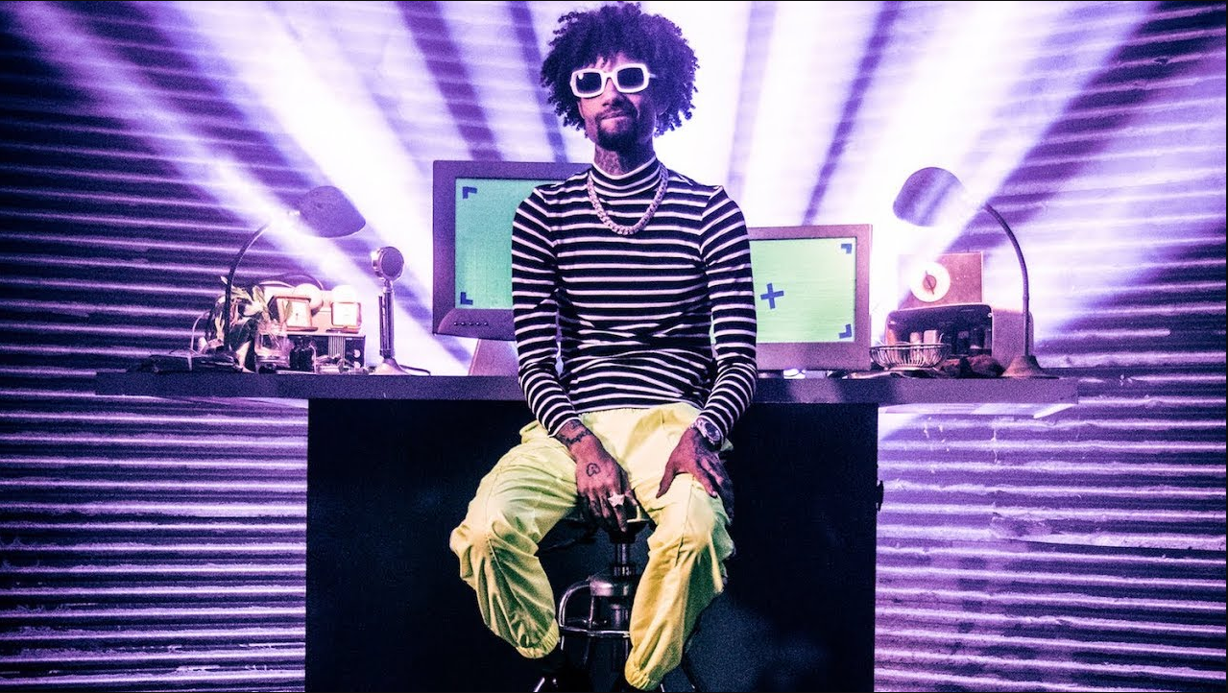

“PnB Rock puts his past as a trapper and his current status as a hitmaker
on full display with his new album…” -XXL

“PnB Rock showcases his range…” -Complex

“This spotlight moment is the result of years of building his foundation, brick by brick.” -Billboard

“You won’t want to miss out on this one.” -Hypebeast

“…dropping one of the more enjoyable projects of the entire year so far.”- Hot New Hip Hop

Atlantic Records’ melodic heavyweight PnB Rock takes us on a futuristic ride in his innovative music video for “Go To Mars” (feat. Tee Grizzley), watch HERE! The visual sees PnB Rock and Tee Grizzley performing in outer space - complete with spaceships and aliens. “Go To Mars” is taken off of PnB Rock’s full-length debut TrapStar Turnt PopStar, which was released last week. The double album highlights PnB Rock’s trap beginnings (The TrapStar) and what we can expect from him in the future (The PopStar). The album has debuted at #1 on all genres and Hip Hop/Rap on Apple Music. PnB Rock’s current single “I Like Girls” (feat. Lil Skies) is one of this week’s most added songs at Urban Radio with strong early support from the top two stations in the country, Power 105.1 & Hot 97. “I Like Girls” is available for streaming and download HERE; the track is accompanied by an official video featuring Rock and Lil Skies, streaming HERE.

TrapStar Turnt PopStar sees the Philadelphia-based rapper/singer joined by a stellar lineup of featured guests – including the late XXXTentacion, Quavo, Tory Lanez, A Boogie Wit Da Hoodie, Lil Skies, Tee Grizzley, Lil Durk, and Mally Mall – with production from such studio superstars as Diplo, Hitmaka, ProLogic, 7evn Thomas, OG Parker and many more. This week, Rock released a deluxe version of the album with five new tracks and additional features from Lil Wayne, YoungBoy Never Broke Again, and Roddy Ricch.

On the album, PnB Rock says, “This has been a two-year process. I’ve re-imagined this album 4x because one day I read on Twitter that people wanted the old PnB. They wanted that pain and struggle TrapStar life. Well I’m not in pain or struggling no more. I’m happy and living a PopStar life. So, I made a double disk and gave them TrapStar Turnt PopStar.”

The album’s “Trap” side pays homage to Rock’s gritty trap roots and the loyal fanbase who have been with him since Day One. The future-facing “Pop” side of TrapStar Turnt PopStar then offers a glimpse of where the artist is headed, as heard on tracks such as the Diplo-produced anthem, “Swervin’,” and the acclaimed first single, “I Like Girls (Feat. Lil Skies).”

Named among XXL Magazine’s “XXL 2017 Freshmen Class,” PnB Rock has become one of the leading voices of contemporary hip-pop. A self-described “problem child,” he began focusing his talents while incarcerated, releasing his acclaimed debut mixtape, FLEEK, in 2014. A series of highly praised mixtapes followed, including 2017’s GTTM: GOIN THRU THE MOTIONS, highlighted by the RIAA platinum certified smash, “Selfish,” now boasting close to 470 million worldwide streams and counting. That same year also saw the release of Artist Partner Group, Atlantic Records and Universal Pictures’ THE FATE OF THE FURIOUS: THE ALBUM, showcasing PnB Rock on two hit tracks: Young Thug, 2 Chainz, Wiz Khalifa & PnB Rock’s “Gang Up“ and PnB Rock, Kodak Black & A Boogie’s “Horses.” 2017 concluded with the release of PnB Rock’s debut LP, CATCH THESE VIBES, which made a top 20 debut on the Billboard 200 fueled by the streaming smash, “Lovin (Feat. A Boogie Wit Da Hoodie).”

A 2018 ASCAP Rhythm and Soul Music Awards winner for YFN Lucci’s “Everyday We Lit (Feat. PnB Rock),” the Philadelphia-based artist is also featured on a number of current blockbuster singles and tracks, including Meek Mill’s #1 Urban Radio smash, “Dangerous (Feat, Jeremih & PnB Rock)“ – found on last year’s chart-topping album, CHAMPIONSHIPS – and “Uptown/Bustdown (Feat. Lil Durk & PnB Rock),” found on Atlantic labelmate A Boogie Wit Da Hoodie’s #1 LP, 2018’s HOODIE SZN.

CONNECT WITH PNB ROCK
OFFICIAL I INSTAGRAM I TWITTER I YOUTUBE I FACEBOOK I PRESS SITE

* * * *
PRESS CONTACT: corey.brewer@atlanticrecords.com

PnB ROCK
TRAPSTAR TURNT POPSTAR
(ATLANTIC RECORDS)
TRACKLISTING
TrapStar
SIDE 1
1. Dreamin’
2. I Need More
3. Deez Streetz feat. Lil Durk
4. Go To Mars feat. Tee Grizzley
5. Penny Proud
6. MIDDLE CHILD (PnB Rock w/XXXTENTACION)
7. Fuck Up The City feat. Quavo and Mally Mall
8. Nowadays
9. Now Or Never 2.0

PopStar
SIDE 2
1. Swervin’ feat. Diplo
2. I Like Girls feat. Lil Skies
3. All These Bandz feat. Tory Lanez
4. Put You On feat. A Boogie Wit Da Hoodie
5. Stage Fright
6. Choosin
7. My Ex
8. ABCD (Friend Zone)
9. How It Feels

Deluxe Edition
1. T-Shirt feat. Lil Wayne
2. Me & U
3. Evolved feat. Roddy Ricch
4. Take My Soul feat. YoungBoy Never Broke Again
5. HMP

