FOR IMMEDIATE RELEASE

MARCH 22, 2021

**PTM FOUNDATION LAUNCHES WORLD WATER DAY FUNDRAISER IN SUPPORT OF INDIGENOUS PEOPLES**

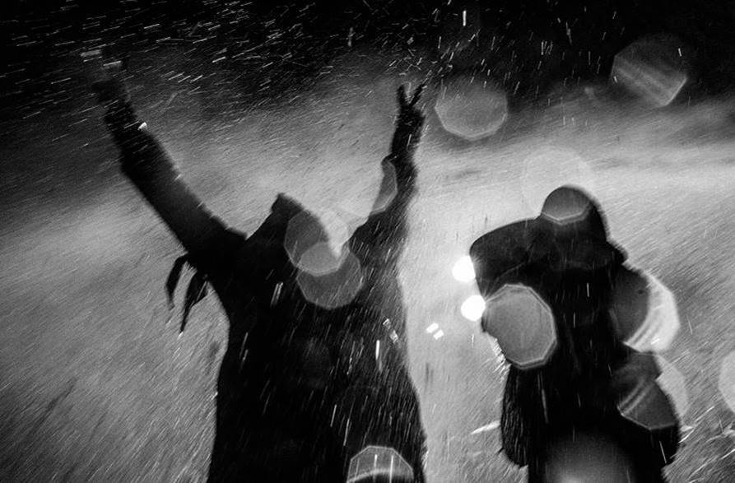

Today, Monday, March 22nd, is World Water Day 2021. Building on the momentum of PTM Foundation’s “Water Is Life” grant program to help raise awareness and crucial funding for communities of Indigenous Peoples experiencing an ongoing water crisis, the organization has just announced a new fundraiser and commemorative t-shirt in support of DigDeep’s Navajo Water Project and the Confederated Tribes of Warm Springs.

“*Through the Navajo Water Project, DigDeep had already installed running water in nearly 300 homes across the Navajo Nation prior to the pandemic. In an emergency response to the COVID crisis, we've had to pivot our work on the Navajo Nation, providing life-saving water donations by deploying water tanks and providing bottled water to those in need*," says Emma Robbins, Diné (Navajo) activist and Executive Director of DigDeep’s Navajo Water Project. "*Donations from donors such as PTM Foundation are integral in continuing our mission to help the over 30% of residents on the Navajo Nation don’t have running water in their homes, and we're so grateful for their continued partnership.*”

World Water Day celebrates the value of water and raises awareness for the global water crisis. In the United States alone, there are over 2.2 million people living without running water in their homes.

*“PTM Foundation’s Community Advisory Board and the band continue to lean into Land and Water rights as core pillars of our work because we all understand that ‘Water is Life’ is not just a catchy slogan,”* said Rich Holtzman, PTM Foundation Board Chair and Portugal. The Man Band Manager. *“We know Communities of Indigenous Peoples are 19 times less likely to have running water than non-Natives, and over 2 million Americans still have no access to running water. It’s an emergency, and it’s more pronounced than ever because of the global pandemic.”*

Women disproportionately shoulder this burden, as they are more often the ones tasked with hauling water, and caring for family members, elders, and other households. This sentiment is reflected in the design of the fundraiser t-shirt, as well.

*“The re-imagining of Portugal. The Man into Portugal The Women is in honor of the matriarchal role in our lives that water plays. More than any other substance, we are made of water, each and every one of us,”* writes Portugal. The Man. *“Like a mother, water nourishes and heals us, unprejudiced and restorative. We are in service to the education and activism on behalf of the protection and celebration of our waters.”*

This commemorative World Water Day shirt features a photograph by Josué Rivas (Mexica and Otomi). Josué is an Indigenous Futurist, creative director, visual storyteller, and educator working at the intersection of art, technology, journalism, and decolonization. His work aims to challenge the mainstream narrative about Indigenous peoples, co-create with the community, and serve as a vehicle for collective healing.

*“This image was made at Standing Rock in 2016 when thousands of Water Protectors gathered at The Oceti Šakowiŋ Camp to stop the construction of the DAPL.”* said Rivas, *“The multi-million dollar project was illegally approved by the Trump administration in 2017 and currently sits under the Missouri River. If a major spill was to happen under the river, 18 million people would lose access to clean water. This image represents the courage and dignity of those that stood up to defend the spirits of the land, water, and all our relations.”*

PTM Foundation’s World Water Day shirt retails for $30, and is available at PTM Foundation’s online store, beginning on Monday March 22nd (World Water Day) for as long as inventory lasts*.* Proceeds from t-shirt sales will be split between DigDeep’s Navajo Water Project and the Confederated Tribes of Warm Springs. Artists featured in PTM Foundation merch drops are also compensated for their work.

**Press Contacts:**

Jason Davis | [Jason.Davis@AtlanticRecords.com](mailto:Jason.Davis@AtlanticRecords.com)

Libby Kober | [Libby.Kober@AtlanticRecords.com](mailto:Libby.Kober@AtlanticRecords.com)

**Purchase PTM Foundation’s 2021 World Water Day T-Shirt:**

[*https://ptmfoundation.myshopify.com/products/portugal-the-women-protect-the-water-tee*](https://nam04.safelinks.protection.outlook.com/?url=https%3A%2F%2Fptmfoundation.myshopify.com%2Fproducts%2Fportugal-the-women-protect-the-water-tee&data=04%7C01%7CBrian.Sommer%40atlanticrecords.com%7Ce2a7a97cc6cd4e82156008d8ed3cb08a%7C8367939002ec4ba1ad3d69da3fdd637e%7C0%7C0%7C637520192198829377%7CUnknown%7CTWFpbGZsb3d8eyJWIjoiMC4wLjAwMDAiLCJQIjoiV2luMzIiLCJBTiI6Ik1haWwiLCJXVCI6Mn0%3D%7C1000&sdata=XmNXMzTQ%2Fta77%2FKRTzNwjfhwn3ReWD43qAAeQe5wSxY%3D&reserved=0)

**Learn more about DigDeep’s Navajo Water Project:**

[*https://www.navajowaterproject.org*](https://nam04.safelinks.protection.outlook.com/?url=https%3A%2F%2Fwww.navajowaterproject.org%2F&data=04%7C01%7CBrian.Sommer%40atlanticrecords.com%7Ce2a7a97cc6cd4e82156008d8ed3cb08a%7C8367939002ec4ba1ad3d69da3fdd637e%7C0%7C0%7C637520192198839377%7CUnknown%7CTWFpbGZsb3d8eyJWIjoiMC4wLjAwMDAiLCJQIjoiV2luMzIiLCJBTiI6Ik1haWwiLCJXVCI6Mn0%3D%7C1000&sdata=tc3XKDsZ64NxPe%2B8GxzFwiiv6JzZWHQhuo3H9gPB7wk%3D&reserved=0)

**Learn more about the Confederated Tribes of Warm Springs:**

[*https://warmsprings-nsn.gov*](https://nam04.safelinks.protection.outlook.com/?url=https%3A%2F%2Fwarmsprings-nsn.gov%2F&data=04%7C01%7CBrian.Sommer%40atlanticrecords.com%7Ce2a7a97cc6cd4e82156008d8ed3cb08a%7C8367939002ec4ba1ad3d69da3fdd637e%7C0%7C0%7C637520192198839377%7CUnknown%7CTWFpbGZsb3d8eyJWIjoiMC4wLjAwMDAiLCJQIjoiV2luMzIiLCJBTiI6Ik1haWwiLCJXVCI6Mn0%3D%7C1000&sdata=Rnqx%2Bl9RVoKZCc2XGnlgzv7n8IOfs%2FiRfC6eRz%2FB%2FbY%3D&reserved=0)

**Learn more about Josué Rivas:**

[*https://www.josuerivasfoto.com*](https://nam04.safelinks.protection.outlook.com/?url=https%3A%2F%2Fwww.josuerivasfoto.com%2F&data=04%7C01%7CBrian.Sommer%40atlanticrecords.com%7Ce2a7a97cc6cd4e82156008d8ed3cb08a%7C8367939002ec4ba1ad3d69da3fdd637e%7C0%7C0%7C637520192198849364%7CUnknown%7CTWFpbGZsb3d8eyJWIjoiMC4wLjAwMDAiLCJQIjoiV2luMzIiLCJBTiI6Ik1haWwiLCJXVCI6Mn0%3D%7C1000&sdata=wiwPF2E8cQ5KPnt0dVuOz9NbP%2FhcUxNnAZ1DHOvi26w%3D&reserved=0)

**Learn more about PTM Foundation:**

[*www.PTMFoundation.org*](https://nam04.safelinks.protection.outlook.com/?url=http%3A%2F%2Fwww.ptmfoundation.org%2F&data=04%7C01%7CBrian.Sommer%40atlanticrecords.com%7Ce2a7a97cc6cd4e82156008d8ed3cb08a%7C8367939002ec4ba1ad3d69da3fdd637e%7C0%7C0%7C637520192198849364%7CUnknown%7CTWFpbGZsb3d8eyJWIjoiMC4wLjAwMDAiLCJQIjoiV2luMzIiLCJBTiI6Ik1haWwiLCJXVCI6Mn0%3D%7C1000&sdata=O%2Bn%2BkU4aff%2FcP3gDro4LtZEht5FIHsqD28keNNZWDsk%3D&reserved=0)

*# # #*