SABRINA CLAUDIO x WALE
UNVEIL NEW COLLABORATION
“ALL MY LOVE”

LISTEN HERE
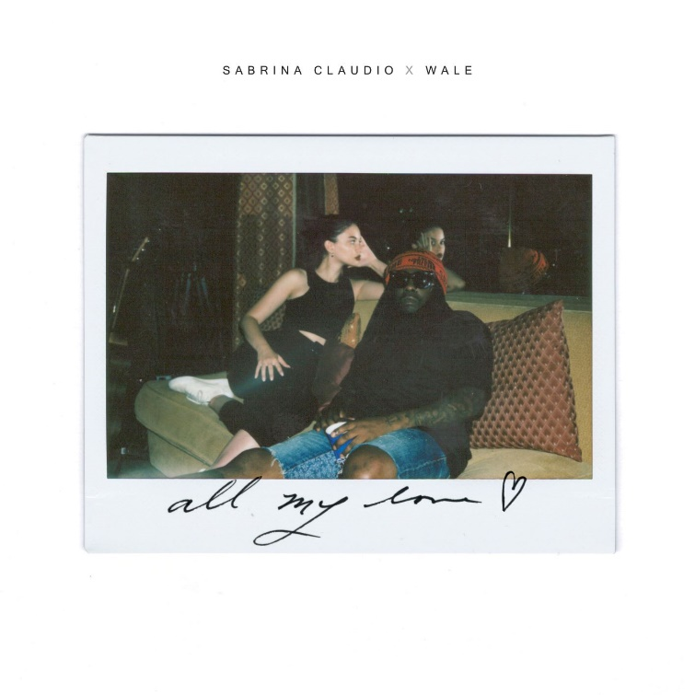
Download high res artwork + additional press photos HERE

Critically acclaimed singer/songwriter Sabrina Claudio and Wale have released their new song “All My Love” – the collaboration is available now via Atlantic Records. Listen HERE.

“All My Love” comes on the heels of Sabrina’s captivating debut Coachella performance in April where the songstress impressively commanded attention from the festival’s main stage, garnering love from PAPER, Entertainment Weekly, Billboard, New York Mag and more. Sabrina also recently teamed up with BURNS and A$AP Rocky to deliver their song “Energy” which was instantly praised by publications including FADER, Complex, Rap-Up and more.

This past fall, the ultra-talented artist traveled the country on her SOLD-OUT U.S. headline ‘No Rain, No Flowers Tour’, after conquering the festival circuit, performing for massive crowds at Lollapalooza, Outside Lands, Life Is Beautiful and more. No Rain, No Flowers was released on August 15th and features sonic highlights “Numb” and “Messages from Her.” Upon release, Rolling Stone praised the project as “consistently suave, admirably steady” and “a soothing balm for whatever ails you.” HYPEBAE also applauded Sabrina writing, “It’s rare for an artist to have a gravitational effect, but Claudio expertly manages to draw listeners in time and time again.”

More new music from Sabrina will be coming very soon.

***

ABOUT SABRINA CLAUDIO:
Sabrina Claudio has been garnering much attention from fans and critics alike since she independently unveiled her debut EP Confidently Lost in 2016 on Soundcloud. In under six months, she quietly amassed over 3 million cumulative plays. The EP was eventually released commercially and shot to No. 3 on the iTunes R&B chart sitting only behind Khalid and The Weeknd. This was only the beginning for the Puerto Rican/Cuban singer-songwriter whose breathy vocals immediately hypnotize and captivate. Sabrina would follow with a 12-song collection About Time that shot to the top of R & B charts and continued to cement Claudio as one to watch. On the heels of the new music, Sabrina was announced as Apple’s “Up Next” Artist and made her national TV debut with an alluring performance on The Late Late Show with James Corden. Audiences were treated to seeing Claudio’s sultry, beautiful live performances on her first ever-national tour as main support for 6LACK. Sabrina was featured on the Fifty Shades Freed Original Motion Picture Soundtrack, with an original song called “Cross Your Mind.” Most recently, Claudio released the titillating new song “All To You.” MTV said the song is “so good that you might want to cancel your plans and go straight home, because it will leave you all hot and bothered.”

CONNECT:
youtube.com/user/sabrinaclaudiomusic
instagram.com/sabrina_claudio
soundcloud.com/sabrina-claudio
twitter.com/sabrina_claudio
facebook.com/SabrinaClaudioMusic

CONTACT:
Chelsey Northern // Chelsey.Northern@atlanticrecords.com
Andrew George // Andrew.George@atlanticrecords.com

