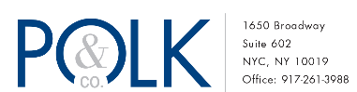
Contact: Polk & Co. – Matt Polk, Wayne Wolfe, Molly Wyatt (molly@polkandco.com) Thursday, August 19
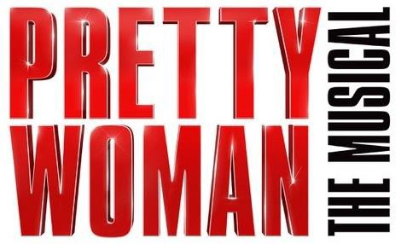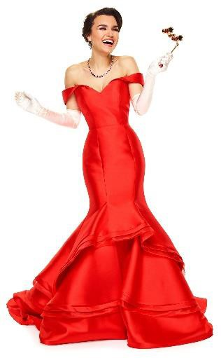For immediate release, please

BROADWAY PERFORMANCES BEGIN FRIDAY, JULY 20, 2018 STARRING SAMANTHA BARKS AND ANDY KARL

ATLANTIC RECORDS TO RELEASE PRETTY WOMAN: THE MUSICAL

ORIGINAL BROADWAY CAST RECORDING
FEATURING A NEW ORIGINAL SCORE BY BRYAN ADAMS AND JIM VALLANCE

Watch Samantha Barks perform “ I Can’t Go B ack” from PRETTY WOMAN: THE MUSICAL

(New York, NY) PRETTY WOMAN: THE MUSICAL, with original music and lyrics by Grammy Award winner Bryan Adams and his longtime songwriting partner Jim Vallance, a book by Garry Marshall and the film’s screenwriter J.F. Lawton, and direction and choreography by two-time Tony Award winner Jerry Mitchell, will begin performances at Broadway’s Nederlander Theatre (208 West 41st Street) on Friday, July 20, 2018. Starring Samantha Barks and three-time Tony Award nominee and Laurence Olivier Award winner Andy Karl, PRETTY WOMAN: THE MUSICAL will open Thursday, August 16, 2018.

Atlantic Records and PRETTY WOMAN: THE MUSICAL producer Paula Wagner have announced their partnership for the upcoming release of the Original Broadway Cast Recording of PRETTY WOMAN: THE MUSICAL, the official companion to the new musical based on Garry Marshall’s beloved romantic comedy. The original cast recording is produced by Bryan Adams and Jim Vallance. The pre-order for PRETTY WOMAN: THE MUSICAL (Original Broadway Cast Recording) will be available on August 9th. For more information and to sign-up for updates on PRETTY WOMAN: THE MUSICAL (Original Broadway Cast Recording), visit PrettyWomanTheMusical.com.

"I am so incredibly proud to be working with Atlantic Records on the original Broadway cast album of PRETTY WOMAN: THE MUSICAL. The quality and artistic integrity of Atlantic is a perfect match for the original score created for the stage by Bryan Adams and Jim Vallance,” said producer Paula Wagner, “I have wanted to work with Craig Kallman and Pete

Ganbarg for some time. Their expertise in the field of music is unrivaled and they have an appreciation and understanding of the theatrical process which brings added value.”

“We are thrilled to be part of the PRETTY WOMAN community,” said Atlantic Records Co-Chairman & CEO Craig Kallman. “Bryan Adams and Jim Vallance have written a powerhouse, moving set of songs that bring this beloved story to life on the stage and on the album. The vitality of the current Broadway scene is unprecedented, and PRETTY WOMAN is a fantastic addition to the Great White Way. All of us at Atlantic are proud to bring this brilliant musical to theatre-goers and music fans everywhere.”

“It’s been a tremendous experience working with the entire PRETTY WOMAN music team -- Bryan, Jim, Paula, Will Van Dyke, and of course the magnificent PRETTY WOMAN company led by the amazing Samantha Barks and Andy Karl,” said Atlantic President of A&R Pete Ganbarg. “I’m very happy to say the music of PRETTY WOMAN not only drives the action on stage, but stands on its own as an outstanding collection of songs.”

“It’s fantastic to be working with Atlantic Records on the Original Broadway Cast Recording for PRETTY WOMAN: THE MUSICAL,” said Bryan Adams. “I’m a huge fan of the label and its incredible legacy, and what they’ve been doing in the Broadway arena over the past few years has been extraordinary.”

"It's no small thing putting 30 people in a studio and recording an entire cast album while performing eight shows a week!” said Jim Vallance. “Our Atlantic Records team is incredibly experienced and knowledgeable, and they’ve been a dream to work with throughout the whole process.”

PRETTY WOMAN: THE MUSICAL (Original Broadway Cast Recording) continues Atlantic Records’ recent string of landmark Original Broadway Cast Recordings, including 2015’s Grammy Award-winning, chart-topping milestone, HAMILTON (Original Broadway Cast Recording), this year’s Grammy Award-winning DEAR EVAN HANSEN (Original Broadway Cast Recording), and MEAN GIRLS (Original Broadway Cast Recording).

PRETTY WOMAN: THE MUSICAL had its world premiere at Chicago’s Oriental Theatre in March 2018, with Chris Jones
from The Chicago Tribune raving, “A shrewd and savvy retooling of the blockbuster by maestro Jerry Mitchell.”

PRETTY WOMAN: THE MUSICAL stars Samantha Barks as ‘Vivian’ opposite three-time Tony Award nominee and Laurence Olivier Award winner Andy Karl (Groundhog Day, Rocky) as ‘Edward,’ with Tony Award nominee Orfeh (Legally Blonde) as ‘Kit,’ Eric Anderson (Waitress) as ‘Mr. Thompson,’ Jason Danieley (The Full Monty) as ‘Philip Stuckey,’ and Ezra Knight (Cymbeline) as ‘James Morse’ in a company of 25 that includes Allison Blackwell, Tommy Bracco, Brian Calì, Robby Clater, Jessica Crouch, Nico DeJesus, Anna Eilinsfeld, Matt Farcher, Lauren Lim Jackson, Renée Marino, Ellyn Marie Marsh, Jillian Mueller, Jake Odmark, Jennifer Sanchez, Matthew Stocke, Alex Michael Stoll, Alan Wiggins, Jesse Wildman Foster and Darius Wright.

Based on one of the most beloved romantic comedies of all time, this modern spin on Cinderella is the story of Vivian, a spirited diamond in the rough who dreams of a better life. A star-crossed meeting with Edward, a shrewd corporate raider from New York who is lost in Hollywood, turns a simple business deal into a week of romance and a journey of self- discovery for both Vivian and Edward. This contemporary theatrical take on the iconic love story will sweep a new generation off their feet and make them believe in the power of “Happily Ever After.”

PRETTY WOMAN: THE MUSICAL has scenic design by David Rockwell, costume design by Gregg Barnes, lighting design by Kenneth Posner & Philip S. Rosenberg, sound design by John Shivers, hair design by Josh Marquette, and music supervision, arrangements and orchestrations by Will Van Dyke.

Tickets for PRETTY WOMAN: THE MUSICAL are now on sale at the Nederlander Theatre box office and at www.ticketmaster.com (877.250.2929). Tickets range from $99 - $169. The playing schedule for PRETTY WOMAN: THE MUSICAL is: Monday through Saturday at 8pm, with matinees Saturday at 2pm. Beginning August 6, 2018, the playing schedule is as follows: Tuesday and Thursday at 7pm, Wednesday, Friday and Saturday at 8pm, matinees Wednesday and Saturday at 2pm and Sunday at 3pm. Please note the Thursday, August 2 performance will begin at 6:30pm.

PRETTY WOMAN: THE MUSICAL is produced by Paula Wagner, Nice Productions, LPO, New Regency Productions, Caiola Productions & Co., James L. Nederlander, Roy Furman, Hunter Arnold, Graham Burke, Edward Walson, deRoy Kierstead, Michael Cassel Group, Stage Entertainment, Ambassador Theatre Group and John Gore Organization. 101 Productions, Ltd is the Executive Producer and General Manager.

Samantha Barks is appearing with the support of Actors' Equity Association. For more information visit: PrettyWomanTheMusical.com
# # #

