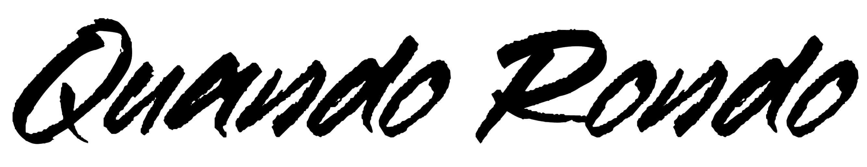
Music endures long after we do. Quando Rondo cements his legacy in ironclad bars and hazy hooks, building out a prolific body of work meant to last. The platinum Savannah, GA rapper spits with classic dexterity as he spouts off modern melodies with emotional precision and a head-nodding bounce. Since 2017, he has consistently amplified the spirit of the streets throughout the mainstream on his own terms, translating the struggles of Savannah (and hoods everywhere) into a dynamic documentary-style sound.

Along the way, he logged a couple of platinum singles with “ABG” and “I Remember” [feat. Lil Baby], and multiple gold singles— “Imperfect Flower,” “Scarred From Love,” and YoungBoy Never Broke Again’s “I Am Who They Say I Am” with Kevin Gates. In between a string of critically acclaimed mixtapes and sold out tour dates, he served up his 2020 full-length debut album, QPac, and bowed in the Top 25 of the Billboard Top 200. At the same time, he collaborated with everyone from Polo G and Lil Durk to G-Eazy, 2 Chainz, and A Boogie Wit Da Hoodie. Beyond posting up hundreds of millions of streams, he scored tastemaker praise from the likes of Pitchfork, HYPEBEAST, and The FADER.

However, he continues to set his legacy in stone on the 2021 album Still Taking Risks [Never Broke Again LLC, Atlantic Records] and much more to come.

“Rapping is life,” he explains. “The world listens to music, no matter if it’s gospel, rap, pop, or rock. Everybody needs it like a drug. You’re going to listen to music until the day you die, because it captures your memories and who you are. I’m trying to make something you’ll remember.”

Throughout 2020 and 2021, Quando focused on his craft more than ever. He dropped Diary of a Lost Child and Before My Time Up, recording at home in the middle of the Global Pandemic. At the same time, his approach evolved. Though he primarily freestyled, he also occasionally wrote by hand. Quando Rondo tapped into pain and spontaneity all at once as he typically spent all day and night rapping. Turning up the heat, He dropped anthems such as “Soul Reaper,” “Red Eye,” “Okay,” and “Angel Wings,” setting the stage for Still Taking Risks.

“I’m at a point in my life where it’s like I’ve got nothing else to do but come up with raps,” he admits. “I rap 24/7. I’m making a rap about everything I do and think about. Because of that, I used my whole mindset on this project.”

Now, he goes harder than ever on Still Taking Risks. On the single “Purple Baby,” he leans into a trap beat, cutting through the cymbals with a razor-sharp flow. “There’s some pain in there,” he says. He cites “Still Doing Wrong” as his personal “favorite” with its combination of introspective rhymes and key-laden percussion. Everything culminates on “Street Life.” He opens up like never before over piano and guitar as his voice rings out on the hook, “Street life, street life, street life…you might lose your life to the trenches…you might lose your life to prisons.”

“I look at these projects like books,” he says. “There’s a beginning and an end. ‘Street Life’ is the last chapter of the book.”

In the end, Quando Rondo’s legacy will never die.

“We all take risks everyday when we wake up,” he leaves off. “I’m never going to stop, man. This is what I was meant to do.”

BOILER
Quando Rondo cements his legacy in ironclad bars and hazy hooks, building out a prolific body of work meant to last. The platinum Savannah, GA rapper spits with classic dexterity as he spouts off modern melodies with emotional precision and a head-nodding bounce. Since 2017, he has consistently amplified the spirit of the streets throughout the mainstream on his own terms, translating the struggles of Savannah (and hoods everywhere) into a dynamic documentary-style sound. Along the way, he logged a couple of platinum singles with “ABG” and “I Remember” [feat. Lil Baby], and multiple gold singles –
“Imperfect Flower,” “Scarred From Love,” and YoungBoy Never Broke Again’s “I Am Who They Say I Am” with Kevin Gates. In between a string of critically acclaimed mixtapes and sold-out tour dates, he served up his 2020 full-length debut album, QPac, and bowed in the Top 25 of the Billboard Top 200. At the same time, he collaborated with everyone from Polo G and Lil Durk to G-Eazy, 2 Chainz and A Boogie Wit Da Hoodie. Beyond posting up hundreds of millions of streams, he scored tastemaker praise from the likes of Pitchfork, HYPEBEAST, and The FADER. However, he continues to set his legacy in stone on the 2021 album Still Taking Risks [Never Broke Again LLC, Atlantic Records] and much more to come.

